BUDGET FACT SHEET

Child Welfare Services – Training and Workforce Development
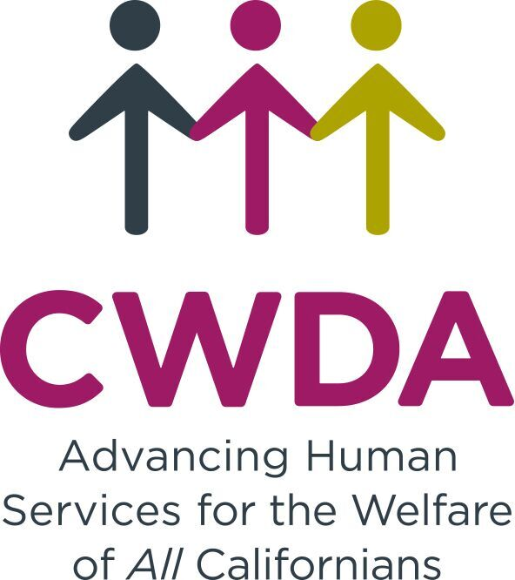

PURPOSE:
The child welfare service (CWS) and foster care programs are administered by county child welfare agencies and provide critical protective services to children, youth and young adults who have experienced abuse and neglect. California’s child welfare social workers respond 24 hours a day, 7 days a week to reports of abuse and neglect, investigating allegations of maltreatment and when necessary, bringing children into the foster care system. Social workers are responsible for the overall safety and daily care of foster children and youth and ensure families receive the services they need to successfully reunify, or when reunification is not possible, pursue guardianship or adoption for the foster child/youth.

This complex work requires a skilled workforce to meet ever-changing federal and state legislative mandates and high expectations from the community to keep California’s children safe from harm and provide trauma-informed care and services.

PROPOSED SOLUTION:
Strengthen the capacity of California’s child welfare social workers, supervisors and leadership to serve children, youth and families through new investment of $10 million for training and workforce development. The funding can be leveraged with federal funds to potentially yield a total of $22 million new investment.

BACKGROUND:
Child welfare service social workers bear a tremendous responsibility to provide for the safety and protection of children and youth who have experienced abuse and neglect. They must assess safety and risk, determining if abuse or neglect occurred, or is likely to occur in the future. When children and youth come into care, social workers assume the care and custody of the child or youth and, at the direction of the juvenile court system, identify strengths and needs, search and secure placements, and coordinate care and services with resource parents, attorneys, treatment providers, service agencies, education, health and mental health providers, and many others. High quality supervision is essential to provide social workers with the supports necessary to perform this complex work.

Federal and state laws require social workers to support the safety, permanency and well-being of children and youth in the foster care system. These desired outcomes are reinforced through the federally- and state-mandated Child Welfare Outcomes and Accountability System. Failure to make improvements in these outcomes can result in fiscal penalties levied by the federal government.

The Current Training System:
California’s current child welfare training system is nationally-recognized for its innovations and has many strengths. Newly-hired child welfare workers and supervisors receive classroom-based training delivered through one of four Regional Training Academies (RTAs) in partnership with higher education. Los Angeles County Department of Child and Family Services (LA DCFS) directly provides training to its staff in partnership with local universities. Some additional training is delivered by the Resource Center for Family Focused Practice. A limited amount of advanced classroom-based and web-based training is available to address changes in legislative mandates or new practices. To ensure statewide consistency in training, the curriculum development is coordinated by the California Social Work Education Center (CalSWEC), an organization which partners educators and practitioners to promote workforce excellence in human services and specifically in child welfare, behavioral health and aging.

Federal and state policy makers have recognized the importance of a trained child welfare workforce and invest in an infrastructure for training new staff and on-going staff. When 2011 Realignment was passed, state policy makers deliberately left the responsibility for administering the Child Welfare Training Program with the California Department of Social Services (CDSS), to promote statewide consistency in training across all 58 counties. As of fiscal year 2018-19, Legislature currently allocates $10.3 million GF ($26.4 million total funds) to train over 11,000 child welfare social workers and supervisors.

The Need:
Although our training system has many strengths, it is insufficiently resourced to meet the current growing demands from the child welfare system. The are three major areas of concern:
- Antiquated Infrastructure:
- All training is either classroom or web-based, despite research showing this is insufficient to leverage training as a driver of practice change.

- Topics fail to keep up with changes in federal and state laws, regulations, and best practices.

- Advanced trainings are very limited. Due to static funding, often trade-offs must be made between desired trainings.

- Training is fragmented across the counties, as some counties have used funding intended for direct services to support training their staff while others have not. This can result in disparate services for children, youth and families.

- Current funding is insufficient to develop skills for all staff beyond new workers to meet comprehensive workforce and organizational development needs, leaving family service workers who provide critical transportation and visitation support to youth and families lacking critical knowledge and skills.

- California’s training system assumes a “one and done” approach – the system is only resourced to provide new training once a law is passed, but can rarely provide additional training

- There is no “feedback loop” to learn whether or not training actually impacts child and family outcomes, nor is there capacity to re-tool training to ensure training results in practices implemented to fidelity.

- Disconnected with Major Practice Changes in Child Welfare: Several major new laws have changed social work practice and created new expectations for teaming, engagement and partnership in supporting youth and families. These include AB 12 (foster care to age 21), Child and Family Teaming (CFTs) and services to youth who are commercially sexually exploited. These new initiatives require training and re-training, as laws change and as practices evolve. CDSS issues guidance to counties to support the implementation of new laws, and while this is well-intentioned, it is not effective in ensuring that new mandates are implemented as envisioned by stakeholders and policy makers. Standardized curriculum is revised as resources permit for new social workers, but resources are limited to train existing staff and supervisors on new practices and legal changes.

- Stakeholder Engagement is Lacking: Lastly, child welfare does not, and should not, do its work in isolation from the children and families who benefit from its services. Current funding does not support involvement of stakeholders in workforce and organizational development activities, such as current and former foster youth and mental health agency staff who increasingly called upon to jointly serve foster youth. Those served by the child welfare and foster care systems should also be part of the decision-making process when prioritizing needed areas of training investment.

The Research:
The research is clear that classroom-based training alone is unlikely to lead to practice changes and desired improvements. To achieve the best outcomes, research has found:
- Coaching is key: Effective implementation of practice requires post-training support that is competency-based, provides feedback, and is ongoing. This is best accomplished through “coaching services” that include observation, feedback, emotional and practical support.

- Supervisors play a pivotal role: Multiple studies in of child welfare workforce development demonstrate the important role of social work supervisors in mitigating job stress, providing guidance, creating a supportive environment, and ultimately helping to reduce social worker burnout and improve staff retention.

Knowledge and skills learned in the classroom are not effective if not supported by on-the-ground skill development (including coaching) to the key staff who can drive practice change among front line social workers. Workforce development requires a focus beyond classroom training on innovative, evidence-based activities that are currently not funded with non-realigned dollars, such as coaching, field-based training, simulations, and peer mentoring.

THE SOLUTION:
A $10 million GF investment would leverage an additional $12 million Title IV-E funding for a total of $22 million to build a training and workforce development infrastructure that will improve practice and support desired outcomes for youth and families. Following are the key activities:

- Develop skill-based learning outside of the classroom, through evidence-based workforce development strategies that include coaching and mentoring of supervisors and manager, and simulation labs such as those recently added by the Los Angeles County Department of Child and Family Services. This would also include coaching for supervisors so that they can provide effective guidance and support to child welfare staff to meet desired outcomes.

- Expand opportunities for cross-training with partner agencies and stakeholders, including mental health, education systems, health care, resource families, current and former foster youth, attorneys and others, to build shared understanding and partnership in delivering services.

- Improve the existing training and infrastructure, by updating and expanding advanced training offerings to respond to changes in federal and state laws and current research on best practice (for example, engaging non-minor dependents in the Extended Foster Care program). This would also include evaluation of training outcomes to ensure training leads to desired practice changes that improve outcomes for children, youth and families.

- Ensure meaningful stakeholder involvement to build a robust training and workforce development system by establishing a Child Welfare Workforce Development Board, which would include representation from current and former foster youth, resource families, state and local partner agencies and advocates and state and county representatives. The Board would be charged with setting statewide priorities for training and workforce development, identifying strategies for more meaningful engagement of stakeholders in the training system, developing strategies to maximizing federal matching funding, and improving accountability, coordination and oversight of the training system.

For More Information:
Frank J. Mecca, Executive Director, CWDA
fmecca@cwda.org

Cathy Senderling-McDonald, Deputy Director, CWDA
csend@cwda.org
(916) 443-1749

Federal matching for federally-eligible expenditures is 50-75%, the State Training program currently averages 63% federal matching.

