SFI- DISCUSSION QUESTIONS

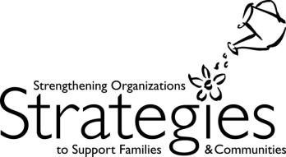
IN ORDER TO BEGIN YOUR AGENCY ACTION PLANNING, CONSIDER THE FOLLOWING QUESTIONS:

1. What STRENGTHS AND OPPORTUNITIES ARE EVIDENT IN THE ORGANIZATIONAL SELF-ASSESSMENT?

2. What DO WE KNOW ABOUT FATHERS IN OUR agency /COMMUNITY? Where are they? what do they do? where do they go for recreation, socializing, employment, education, spiritual pursuits, family time?

3. what do fathers need? what does our agency/community provide? where are the gaps?

4. what is our agency’s vision for father involvement?

5. WHAT SPECIFIC OUTCOMES GRAB OUR INTEREST? WHERE DO WE WANT TO FOCUS OUR ENERGY AND RESOURCES?

6. WHAT CHALLENGES DO WE ANTICIPATE? WHAT OBSTACLES DO WE NEED TO OVERCOME?

7. WHO CAN PARTNER WITH US TO SUPPORT FATHERS IN OUR COMMUNITY?

