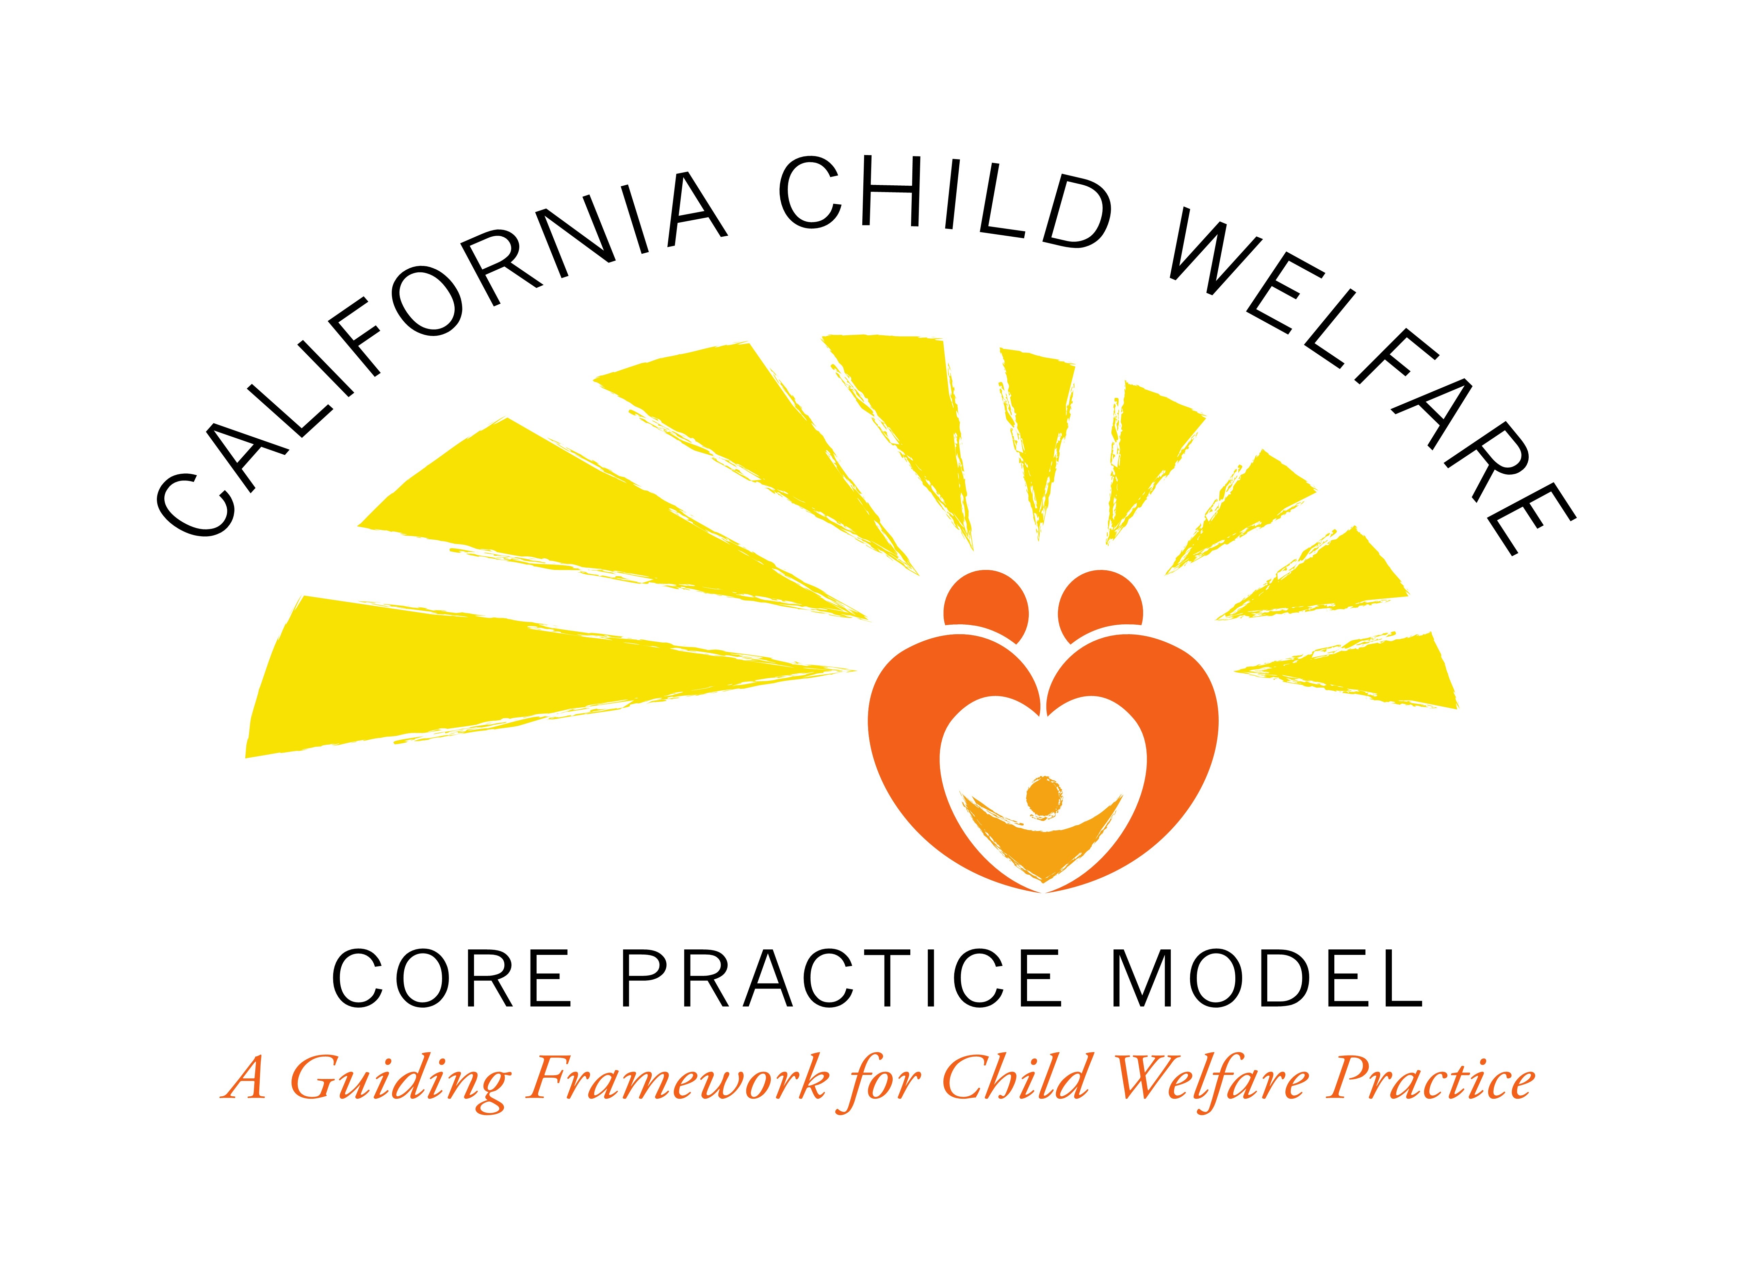

Job Preview Letter – Guide for use

This job preview letter you will find on the next page is designed to be used to share the ‘real life’ experiences of social workers in child welfare. It is intended to be used once a list of candidates has been developed and one is at the stage of inviting potential candidates to interview for selection.

The letter has suggested language and is meant to be adapted for specific needs in each county.

Dear Child Welfare Services Social Worker Candidate:

Thank you for your interest in a Social Worker position with Child Welfare Services (CWS). Child welfare provides opportunities for some of the most interesting, rigorous and rewarding work in the field of social work. You will have the opportunity to work with children, teenagers and families struggling with abuse and neglect, poverty, drug and alcohol addiction, mental health issues, homelessness, and trauma. Many children and families experience their social worker as the one person in their life who made a difference, sometimes altering or impacting the course of generational or historical trauma experienced.

As a field, child welfare work is extremely challenging and highly stressful. Often child welfare workers are exposed to painful and sometimes tragic circumstances for children and families that can result in secondary trauma. Social workers have to practice healthy boundaries and self-care. CWS social workers work in conjunction with the juvenile dependency court, writing court reports, testify at court hearings, and working with attorneys and other advocates. At times the process can be challenging. CWS social work is incredibly complex and complicated, with many conflicting demands on your time. Outstanding organizational, time management and writing skills are absolutely critical to your success as a child welfare worker. The reality is that a significant percentage of your time will be spent on the phone, the computer, doing paperwork, documentation, and court reports. There is always too much to do, and never enough time to do it all.

With all of that said, child welfare also presents many wonderful opportunities: a climate where you will be learning and growing professionally, work that can be deeply meaningful, and a chance to make a difference in the lives of children and families. While these children and families seem to have overwhelming challenges, they are also resilient, and are part of extended families, communities and Tribes who care greatly about them. You will receive training and support to do this work. If you are ready to commit to this great and challenging work we welcome your interest in this field.

Questions? Please call (XXX) XXX-XXXX and ask to speak to XXXXXXXXXXXXXX. We will be happy to speak with you further. Again, thank you for your interest in this position.

