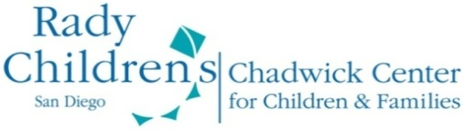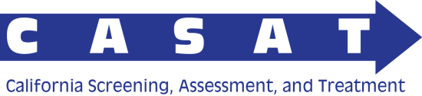

Chadwick Center for Children and Families
Rady Children’s Hospital-San Diego
List of Potential Resources to Support
Child Welfare/Mental Health Learning Collaborative

In October 2012, the Chadwick Center for Children and Families at Rady Children’s Hospital – San Diego received funding from the Administration on Children, Youth and Families – Children’s Bureau to establish the California Screening, Assessment and Treatment (CASAT) Initiative. The overarching goal of the CASAT Initiative is to assist individual counties and regions in California to create a comprehensive system of screening for social and emotional strengths and needs to identify and maximize use of community resources known to enhance resilience, conducting a comprehensive, trauma-informed assessment when indicated, and using the results of this subsequent assessment to ensure that the youth and family are referred to evidence-based or evidence-informed treatments and interventions. This funding allows the Chadwick Center at Rady Children’s Hospital – San Diego to provide training and technical assistance and create tools and resources that can assist the regional learning collaboratives in their efforts.

The following tools and resources may be provided through periodic newsletters, option papers, decision-making tools, presentations, in-person or tele-consultations, or other methods to be determined collaboratively with the regions seeking the specific resources or tools.

Tools and Resources to Support Regional Learning Collaboratives
Learning Collaborative Methodology
- Information and clarification regarding learning collaborative methodology
- Consultation regarding strategies that the RTAs can use to integrate the Model for Improvement into their Learning Collaboratives, including sharing of information across teams and small tests of change.
- Access to tools and resources to the regional training academies to help them in their efforts to develop the learning collaborative within their specific region.
Screening
- Information on key conceptual approaches for mental health and trauma screening
- Information regarding best practices and available research on implementing mental health and trauma screening approaches
- Review of child and adolescent trauma screening tools
- Review of child and adolescent mental health screening tools
- List of suggested evidence-based screening tools
- Targeted consultation on specific measures under consideration by regional LCs
- Detailed information and additional consultation regarding implementing of screening tools already developed within CASAT team
Assessment
- Information on key conceptual approaches for mental and behavioral health assessment
- Information regarding best practices and available research on implementing mental and behavioral health assessment
- List of key domains to target in mental and behavioral health assessment
- List of suggested evidence-based assessment tools for mental and behavioral health assessment
- Targeted consultation on development of specific assessment batteries under consideration by regional LCs
- Information on use of assessment tools to triage, treatment plan development, promoting engagement, treatment monitoring, and system-wide evaluation
- Detailed information and additional consultation regarding pathway approach to assessment, including the Trauma-Informed Mental Health Assessment Pathway (TI-MHAP)
Treatment
- Information on key conceptual considerations for trauma-informed mental and behavioral health treatment
- Information regarding best practices and available research on mental and behavioral health treatments
- List of evidence-based, trauma-informed mental and behavioral health treatments
- Targeted consultation on scaling up evidence-based, trauma-informed mental and behavioral health treatments
Implementation Science
- Information on key conceptual considerations for implementation and cross-system collaboration
- Information regarding best practices and available research on implementation science and cross-system collaboration
- List of key domains relevant to implementation
- List of tools to assess key domains relevant to implementation
- Consultation for regional LCs on community assessment process
- Consultation for Regional LCs on screening, assessment, or treatment implementation plan
Trauma-Informed Practices
- Consultation for regional LCs on further developing a trauma-informed system
- Child Welfare Trauma Training Toolkit
- Guides/manuals for trauma-informed care in MH and CW systems
- Training for regional or county trainers on Child Welfare Trauma Training Toolkit

