Child and Family Teaming

Module 1
Version 1.0 | May 2016

Developing an Effective Child and Family Team

Trainer’s Guide

Table of Contents

Table of Contents 1
Background and Context 2
Child and Family Teaming 4
Tips for Training This Curriculum 5
Agenda 7
Learning Objectives⎯Module 1 8
Lesson Plan 9
Segment 1: Welcome and Introductions 12
Segment 2: Learning Objectives: Knowledge, Skills, and Values 15
Segment 3: How are Child and Family Teams Unique? 16
Segment 4: A Framework for Understanding 18
Segment 5: Benefits of Child and Family Teaming 24
Segment 6: Initial Steps in the Teaming Process 26
Segment 7: Engagement 27
Segment 8: Recap and Evaluation 30
Participant Handouts 31
Glossary 43
References 48

Audience

The intended audiences for The Child and Family Teaming Modules I and II are supervisors and line staff in child welfare and children's behavioral health departments throughout California, as well as community partners who have interest in teaming with families and county agencies to serve the mental health needs of children and youth in the child welfare system.

Background and Context

This Child and Family Teaming curriculum has been developed in response to the Settlement Agreement for the Katie A. v. Bonta class action lawsuit. The Settlement Agreement requires county behavioral health and child welfare agencies to develop and implement sustainable infrastructure to coordinate and integrate the delivery of community-based behavioral health services for children involved in the child welfare system. The Settlement Agreement also mandates that a subclass of children in the child welfare system with intensive mental health needs receive medically necessary mental health services in their own home or in a homelike setting. This objective is being accomplished through the introduction of three new mental health service components covered under County Medi-Cal Mental Health Plans: Intensive Care Coordination (ICC) and Intensive Home Based Services (IHBS), which were implemented effective January 1, 2013, and Therapeutic Foster Care, which is currently under development. In addition, Intensive Care Coordination and Intensive Home Based Services are allowable as medically necessary services under the Medicaid Act as a benefit of the Early and Periodic Screening, Diagnosis, and Treatment (EPSDT) services for all children and youth under age 21 who are eligible for the full scope of Medicaid services. Consequently, it is not necessary for a child or youth to be a member of the Katie A. class or subclass in order to qualify for ICC and IHBS (Department of Health Care Services, MHSUDS Information Notice No.: 16-004, February 5, 2016).

In 2013, the California Department of Social Services (CDSS) and the Department of Health Care Services (DHCS) facilitated large-scale, institutional changes by issuing the Pathways to Mental Health Services Core Practice Model (CPM) Guide, http://www.childsworld.ca.gov/res/pdf/CorePracticeModelGuide.pdf, and its companion guide, the Medi-Cal Manual for Intensive Care Coordination (ICC), Intensive Home Based Services (IHBS) & Therapeutic Foster Care (TFC) for Katie A. Subclass Members. The Medi-Cal Manual is currently under revision. After the new edition is issued, this curriculum will be updated accordingly.

At the time of this writing, the California Department of Social Services is engaged in the development of the California Child Welfare Core Practice Model, which subsumes the Pathways to Mental Health Services Core Practice Model within a larger practice framework that integrates the child welfare system with other child- and family-serving systems in the public sector and their partners. In turn, the California Child Welfare Core Practice Model is part of a tripartite “Shared Approach to California’s Children, Youth, and Families” with the public systems of behavioral health and juvenile justice, which are also in process of developing practice models for their respective agencies. An “Integrated Statewide Training Plan” is currently underway which will reflect the practice and service delivery environments of the child welfare, behavioral health, and juvenile justice systems under the “Shared Approach.” This curriculum is congruent with the developing California Child Welfare Core Practice Model and with the forthcoming “Integrated Statewide Training Plan.”

For simplicity, this curriculum refers directly to the Pathways to Mental Health Services Core Practice Model which is described in the guide of the same name mentioned above and referenced throughout as the “CPM.” The CPM sets the foundation for a common practice framework that integrates behavioral health screenings, referrals, service planning, service delivery, and overall coordination and case management among all those involved in working with children who receive services from child welfare and behavioral health systems in the public sector. The effective engagement of families in the referral and treatment process for their children is integral to this mission. The CPM describes standards and expectations for practice behaviors by child welfare and behavioral health staff that ensures and supports meaningful participation by families in the care and treatment of their children.

Each county in California has progressed with the implementation of infrastructure, staffing, and training necessary for local child welfare and behavioral health agencies and service providers to work together with the families they serve to address children’s mental health needs and related concerns. Child and family teaming is a service requirement for all children and youth in the subclass and all who qualify for Intensive Care Coordination. For all other children and youth with identified mental health issues, child and family teaming is strongly recommended.

Child and Family Teaming

The Child and Family Team (CFT) is the fundamental practice modality for accomplishing the goals of the CPM. Under CPM guidelines, each child who enters the child welfare system will be screened to identify possible mental health issues. Mental health concerns identified by screening will necessitate a referral for further assessment by a behavioral health provider. The identification of a mental health issue initiates the formation of a Child and Family Team responsible for developing, coordinating, and monitoring treatment plans and behavioral health service delivery.

Child and Family Teams are comprised of the child/youth, parents and/or caregivers, extended family members and other supportive people from the family’s community who agree to come together to create, implement, and refine a behavioral health plan with the child/youth (as developmentally appropriate) and the family. The plan builds on the strengths of the child/youth and family and addresses their immediate and long-term needs and aspirations. The primary focus of the CFT is always the safety and well-being of children and youth.

The concept of the Child and Family Team reflects the historical, family-centered philosophy common to family group conferencing and related teaming modalities such as Team Decision Making (TDM), foster education teams (FET), wraparound services, Structured Decision Making (SDM), and others. Adoption of the CFT as a core practice element builds on the success of these ventures. As a family-focused practice, Child and Family Teaming reflects the belief that families and youth benefit when they are respectfully and meaningfully engaged in the service planning process through ongoing opportunities to add their perspectives and exercise genuine leadership to choose among options, while receiving agency support to achieve their goals.

The CFT curriculum provides:
- An overview of the teaming process of the CFT to meet the needs of the family;
- Guidance for preparing parents and youth for participating on CFTs and in CFT meetings;
- Guidance for preparing professionals for participation on CFTs and in CFT meetings (e.g., behavioral health providers, school personnel, doctors, juvenile probation officers, CASAs, and other individuals in the family support network such as coaches, clergy, etc.);
- Basic structure and guidance for facilitating CFT meetings; and
- Guidance for handling challenges that may arise in the teaming process or in team meetings.

While this curriculum provides a basic introduction to facilitation for CFT meetings, it is recommended that professionals obtain advanced instruction through workshops that provide additional opportunities for building facilitation skills.

This curriculum is developed with public funds and intended for public use. Use of curriculum content should be cited as: California Social Work Education Center. (Ed.). (2016). Child and family teaming, modules 1 and 2. Berkeley, CA: California Social Work Education Center.

For questions regarding the curriculum, contact Phyllis Jeroslow, pjero@berkeley.edu, or Melissa Connelly, mconnelly@berkeley.edu, or call CalSWEC at 510-642-9272.

Tips for Training This Curriculum

Module 1 Duration: 3 hours, 30 minutes
Module 2 Duration: 3 hours, 30 minutes
(If both modules are provided on the same day, then Module 2 can be shortened a few minutes by skipping the brief review of Module 1 in Segment 3.)

The trainer should be familiar with the Pathways to Mental Health Services Core Practice Model Guide (http://www.childsworld.ca.gov/res/pdf/CorePracticeModelGuide.pdf) and the Medi-Cal Manual for Intensive Care Coordination (ICC), Intensive Home Based Services (IHBS) & Therapeutic Foster Care (TFC) for Katie A. Subclass Members (currently under revision), issued jointly by the California Department of Social Services (CDSS) and the California Department of Health Care Services (DHCS). The guide and manual set forth the framework for implementation and practice. Further, the trainer should re-read the sections in the Core Practice Model Guide that pertain to Child and Family Teaming, such as “What Children, Youth and Parents/Families Can Expect in Their Interactions with Child Welfare and Mental Health” (pg. 6) and the section on “Teaming” (pgs. 12-16). (As needed, adjustments will be made to this curriculum to reflect applicable changes pursuant to the revised Medi-Cal Manual.)

The trainer should be familiar with the CDSS Letters and Notices to counties (http://www.childsworld.ca.gov/PG3346.htm) and the DHCS Mental Health Information Notices (http://www.dhcs.ca.gov/Pages/KatieAImplementation.aspx).

Implementation varies across counties. Know the specifics for the county for which you are providing training. Trainers should be familiar with county protocols, procedures, forms, and tools related to the provision of behavioral health services for children in foster care, and be able to answer the following questions:
- Has the county identified and implemented an evidence-based screening tool?
- Does the county have designated staff to handle screening and assessment?
- What are the local county policies regarding the designated roles for child welfare and behavioral Health staff?
- Which agency is responsible for the initial screening?
- Has the county developed protocols for behavioral health referrals and a referral form?
- Which agency(ies) are responsible for which types of assessment(s)?
- What written policies, procedures and other infrastructure supports has the county developed regarding implementation of Child and Family Teams and CFT meetings?
- When does the formation of the Child and Family Team begin?
- Who facilitates the CFT meeting?
- What documentation is required for CFT meetings?
- Who does the documentation for CFT meetings?
- How are other tasks related to the work of the CFT designated?
- How are authority and accountability addressed by the county agencies?
- How does the county handle domestic violence issues as related to the CFT process?
- How does the county address parental/caregiver substance abuse as related to the CFT process?

Child welfare agencies in California have historically used other teaming modalities that involve the participation of families and youth. It would be helpful for the trainer to know the types of teaming that have been previously practiced by the child welfare or public mental health agency in the county where this training is being delivered, and to understand the distinctions between those teaming modalities and the Child and Family Team. For example, families and staff may be familiar with team decision-making (TDM) meetings. While both CFT meetings and TDM meetings include the perspectives of youth and families, there are differences between them. Some differences include:
- TDM meetings address issues related to placement at a single point in time and are available to all foster youth with placement concerns. In contrast, Child and Family Teams are formed to address the mental health needs and services of children and youth on an ongoing basis, with the CFT meeting providing a forum for team discussions and decision-making. The work of the Child and Family Team extends beyond the CFT meeting.
- TDM meetings are initiated by the child welfare agency. TDM meetings strive for consensus. However, if consensus is not achievable, the social worker and/or social work supervisor retain decision-making authority. In comparison, Child and Family Teams are family centered. Family needs and preferences guide team composition, team meeting schedules and locations, and the decision-making process is agreed upon by team members, provided that it does not conflict with agency mandates.
Additional Resources
- CalSWEC hosts a toolkit for the child welfare/mental health learning collaborative that has an array of training and implementation resources regarding the delivery of behavioral health services to children in foster care. The toolkit also provides contact information for partnering organizations that provide training and technical assistance. The toolkit was designed for use by California counties and regions, and is also accessible by the public: http://calswec.berkeley.edu/toolkits/child-welfare-mental-health-learning-collaborative-katie. Within this toolkit, the trainer may have particular interest in the resources found in the web pages for “Teaming Tools” and “Engagement Tools.”
- The California Institute for Behavioral Health Solutions (CIBHS) offers training resources that support Katie A. implementation, including webinars for preparing youth, parents, and professionals for participation in the Child and Family Team (CFT) and team meetings: http://www.cibhs.org/katie-implementation-technical-assistance-and-training

Agenda

Segment 1 | Welcome and Introductions | 9:00–9:15 am
Segment 2 | Learning Objectives: Knowledge, Skills, and Values | 9:15–9:25 am
Segment 3 | How Are CFT Meetings Unique? | 9:25–9:40 am
Segment 4 | A Framework for Understanding | 9:40–10:10 am
BREAK |  | 10:10–10:25 am
Segment 5 | Benefits of Child and Family Teaming | 10:25–10:40 am
Segment 6 | Initial Steps in the Teaming Process | 10:40–11:10 am
Segment 7 | Engagement | 11:10 am–12:20 pm
Segment 8 | Recap and Evaluation | 12:20–12:30 pm

Learning Objectives⎯Module 1

Knowledge
K1. The participant will understand the key values and principles underlying the Child and Family Team.
K2. The participant will be able to identify at least three (3) benefits of the Child and Family Team.
K3. The participant will be able to identify the elements of successful teaming as applied to the Child and Family Team.
K4. The participant will be able to describe how to develop a team in partnership with the child and family.
K5. The participant will be able to describe the differences between a Child and Family Team and a CFT meeting.

Skills
S1. Through a case scenario, the participant will be able to demonstrate the ability to engage, collaborate, and team with a child and family, based on their strengths and needs.

Values
V1. The participant will be able to speak about the benefits of working as part of a team to support the behavioral health and well-being of children and families.
V2. The participant will recognize the importance of the self-identity of individual family members in the teaming process, encompassing, for example, race, ethnicity, class, culture, sexual orientation, and gender.
V3. The participant will be aware of the impact of trauma and historical trauma on the child and family within the context of the teaming process.
V4. The participant will be able to discuss the value of including the social support networks of children, youth and families in the Child and Family Team and how the networks can enhance the behavioral health of family members.

Lesson Plan

Segment | Methodology and Learning Objectives
Module 1, Segment 1  15 min  9:00–9:15 am  Welcome and Introductions | Activity 1A: Before training begins, use place cards to direct social workers and behavioral health clinicians to sit next to one another. Welcome participants and introduce yourself.  Activity 1B: Participant introductions – simple self-introductions that include the unit or division where participants work. Consider asking participants to state their preferred gender pronouns (PGP).  Activity 1C (optional): Facilitate group agreements.  Activity 1D: What are a Child and Family Team and a CFT meeting?  PowerPoint slides: 1,2  Learning Objective: K5
Module 1, Segment 2  10 min  9:15–9:25 am  Learning Objectives: Knowledge, Skills, and Values | Activity 2A: Ask for volunteers from among the participants to read one or two objectives until all objectives have been read. Engage participants in prioritizing the learning objectives.  PowerPoint slides: 3–5  Learning Objective: K1
Module 1, Segment 3  15 min  9:25–9:40 am  How Are CFT Meetings Unique? | Activity 3A – Discussion  Review PowerPoint slide 6 regarding teaming  Activity 3B- Group participants in twos or threes with their neighbors, ensuring that child welfare and behavioral health staff are mixed. Ask them to list as many types of team meetings as they can in 3 minutes.  PowerPoint slide: 7  Activity 3C – Discussion – Participants share types of team meetings; trainer facilitates the report out and writes ideas on an easel pad.  PowerPoint slide: 8  Activity 3D – Discussion that distinguishes CFT and CFT meetings from other teaming modalities.  PowerPoint slide: 8  Learning Objective: K1
Module 1, Segment 4  30 min  9:40–10:10 am  A Framework for Understanding | Activity 4A: Lecture on the legislative and conceptual framework for Child and Family Teaming, emphasizing mandates for those who qualify for Intensive Care Coordination (ICC). (Specifics may be revised in the forthcoming edition of the Medi-Cal Manual.)  PowerPoint slides: 9,10  Activity 4B: Lecture on eligibility and mandated services for the subclass and others who qualify. (To be revised per the forthcoming edition of the Medi-Cal Manual. Consequently, the trainer may elect to skip PowerPoint slides 12 and 13)  PowerPoint slides: 11–13  Activity 4C: Lecture on child and family teaming: building the team; basics of the teaming process; and key principles.  PowerPoint slides: 14–20  Learning Objectives: K1, K3, V1, V2, V3
10:10–10:25 am
15 min
BREAK
Module 1, Segment 5  15 min  10:25–10:40 am  Benefits of Child and Family Teaming | Activity 5A: Exercise – In small groups, ask participants to list benefits of Child and Family Teaming and the CFT meeting process. Facilitate a group report out of the ideas and chart answers on an easel pad in front of the room.  PowerPoint slide: 21  Activity 5B: Review PowerPoint slides 22 and 23, highlighting ideas that may not have been mentioned by participants.  PowerPoint slides: 22, 23  Learning Objectives: K2, V1
Module 1, Segment 6  30 min  10:40–11:10 am  Initial Steps in the Teaming Process | Activity 6A: Interactive lecture, reviewing handout, “Eight Steps to Building a Child and Family Team and Preparing for a Team Meeting.” Focus on Steps 1-6. Steps 7 and 8 are covered in Module 2.  PowerPoint slide: 24  Learning Objective: K4, V1
Module 1, Segment 7  70 min  11:10 am –12:20 pm  Engagement | Activity 7A: In preparation for the role play exercise in Activity 7B, review the slides about engaging and preparing members for participation on the team.  PowerPoint slide: 25  Activity 7B: Facilitate group role play activity. The role plays concern building an effective Child and Family Team.  PowerPoint slide: 26  Activity 7C: Process the role play activity with the large group. Use questions indicated in Item #8 of Activity 7B.  Learning Objectives: K3, K4, S1, V1, V2, V3, V4
Module 1, Segment 8  10 min  12:20–12:30 pm  Recap and Evaluation | Activity 8A: Ask participants to summarize the key points they learned from this module. Supplement with other take-aways that will link Module 1 with Module 2 (i.e., linking teaming with the CFT meeting process).  PowerPoint slide: 27

Segment 1: Welcome and Introductions

Segment Time: | 15 minutes
Trainee Content: | Agenda
Slides: | 1–2

Description of Activity
The trainer conducts an introductory activity that includes a review of the Agenda.

Before the Activity
- Activity 1A: Before training begins, use place cards to arrange the seating so that social workers and behavioral health clinicians sit next to each other.
- Activity 1C: (Optional). Decide whether or not you will establish Group Agreements as part of this activity. If you plan to develop Group Agreements, prepare your easel pad in advance with some initial guidelines, such as starting and ending on time, sharing the floor, etc. Leave space for the group to develop their own agreements.

During the Activity

- Activity 1A
Welcome the participants to the training, introduce yourself, and review the Agenda. If this is the first training for a cohort, you may wish to spend some time on logistics related to the training site (parking, restrooms, schedule, etc.).
- Activity 1B
Conduct participant introductions. Introductions should be simple self-introductions that include the unit or division where participants work. Consider inviting participants to state their preferred gender pronouns.
- Activity 1C (Optional)
Facilitate Group Agreements. The process of developing Group Agreements reinforces a productive and respectful learning environment. This activity provides a model for social workers and behavioral health clinicians for the work they do with Child and Family Teams, which is a connection that you can note for the group.

Suggested Group Agreements
- Collaboration: Partnership and trust are fundamental to engagement. Families need to have a sufficient level of trust before they can sincerely engage in addressing family problems through self-reflection. Participants may want to agree to avoid blaming or shaming others, and instead focus on the common concern for the safety and well-being of children. Remind participants that this approach is essential when working with families. Social workers and behavioral health clinicians need to be skilled in fostering collaboration in order to perform meaningful assessments.
- Ask questions: Point out that the trainer needs the involvement of participants in the learning process in order to make the training relevant, given that people in the room have different experiences and learning needs. Asking questions allows participants to take responsibility for their learning and to benefit from the training.
  - Enjoy and have fun: Explain that being relaxed and present facilitates the group process and individual learning, which makes the day more meaningful and productive.
  - “What the heck” attitude: As professionals, we generally feel more comfortable and competent sticking to what we know. Sometimes it feels uncomfortable to consider new ideas. We may think about someone, “She doesn’t know what she’s talking about...she has never worked in our community...” But to learn something new, we may need to step out of our comfort zone. With this “What the heck!” agreement, participants become more willing to explore new ideas and approaches.
  - Make mistakes: As professionals, we don’t like to make mistakes. When we make mistakes, we feel discouraged and become self-deprecating. But mistakes are informative and an inherent part of the learning process. This agreement gives participants permission to make mistakes while exploring new territory.
  - Confidentiality: This is just a reminder that information about families or participants shared in the training room is confidential.

- Activity 1D  Review the descriptions of a Child and Family Team (CFT) and CFT meeting listed below.  - What is a Child and Family Team?  A team of people comprised of the child/youth and family; professionals in social work, behavioral health, and other disciplines; and persons in the family’s support network who help the family to attain their mental health and well-being goals in order to transition successfully out of the child welfare system.  - What is a CFT meeting?  A CFT meeting is the modality used by Child and Family Team members to coordinate and plan their work within the context of a Child and Family Team approach. | 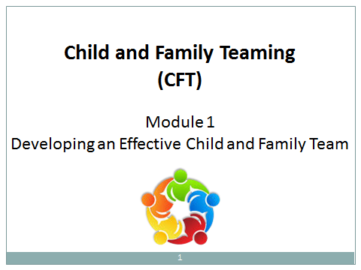  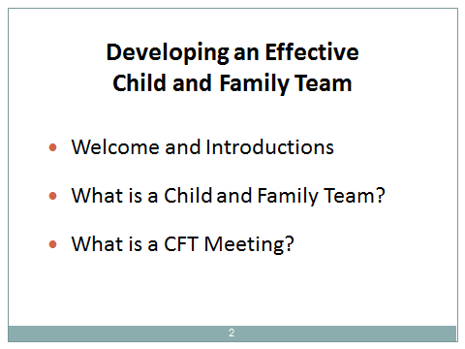

Segment 2: Learning Objectives: Knowledge, Skills, and Values

Segment Time: | 10 minutes
Trainee Content: | Learning Objectives
Slides: | 3–5

Description of Activity
The trainer facilitates a discussion about the Learning Objectives.

During the Activity

- Activity 2A  Ask for volunteers from among the participants to read one or two objectives until all the objectives have been read.  - Facilitate conversation about prioritizing the Learning Objectives. | 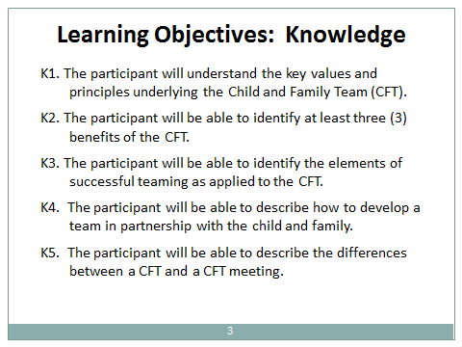  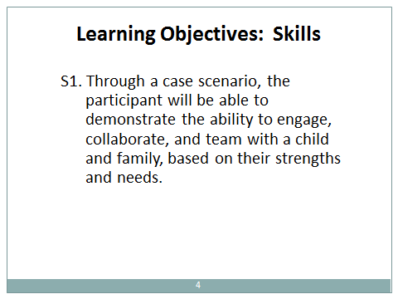  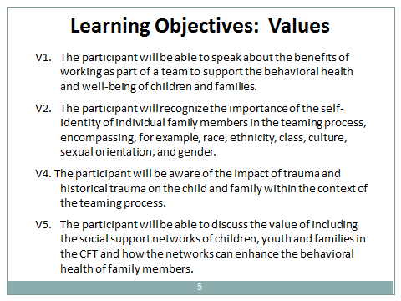

Segment 3: How are Child and Family Teams Unique?

Segment Time: | 15 minutes
Slides: | 6–8

Description of Activities
The trainer discusses how Child and Family Teams differ from other forms of teaming through a brief lecture and by engaging participants in a brainstorming activity.

During the Activity

- Activity 3A  Explain that teaming is a practice of collaborating and partnering with family, youth and community members through communication and mutual engagement. Team meetings are used to facilitate conversations about goals and develop shared agreements and action plans, while teaming involves ongoing collaborative relationships that transcend the meetings. The practice of inquiry is integral to meaningful understanding among all parties.  - The purpose of Child and Family Teaming is to promote child and family well-being, with an emphasis on the child’s behavioral health, by including family members and their support networks in making decisions, planning, and monitoring.  - Teaming ensures that interventions and proposed solutions are customized for the family, their culture, community and tribe.  - The inclusion of multiple parties involves sharing risk and accountability among team members.  - The team’s overall process and coordinated work during meetings build on the family’s functional strengths, involve informal and professional supports, and ensure that children stay safe.  - The purpose of the Child and Family Team Meetings is to provide a forum where the team can discuss, plan, and monitor treatment interventions in order to reach shared goals for mental health and well-being. | 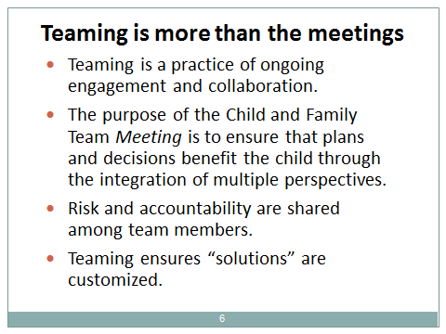
- Activity 3B  Assemble participants into groups of 2 or 3 from those seated at each table or nearby, ensuring that each group is comprised of behavioral health and child welfare staff. Instruct the groups to list as many types of team meetings as they can. Allow 3 minutes for the activity. | 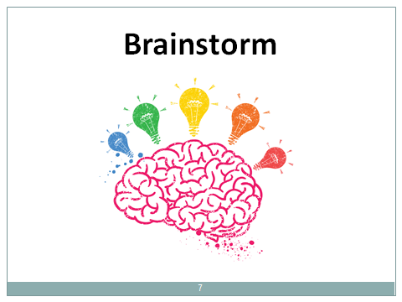
- Activity 3C  Facilitate a report out from each group. Chart answers on an easel pad at the front of the room. Possible answers may include: Team Decision Making meetings, Wraparound meetings, Family Group Decision Making meetings, and Multi-disciplinary Team meetings. | 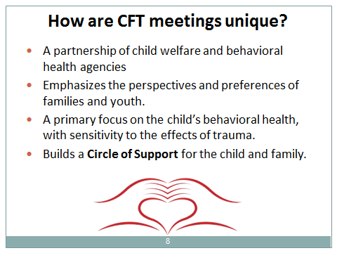
- Activity 3D
Draw some contrasts between the types of meetings that were mentioned and Child and Family Team meetings:
  - Traditionally, other forms of team meetings often stemmed from a single-agency approach, while the Child and Family Team requires a partnership between child welfare and behavioral health agencies. Child and Family Team meetings differ from other forms of team meetings that are driven somewhat exclusively by priorities and methods identified by the child welfare agency. While safety remains the highest priority, the CFT meeting is an interagency family meeting.
  - CFT practice recognizes that child welfare and behavioral health agencies have agency-specific responsibilities, roles, and accountability as providers of public services to children and families.
  - CFT practice aims to ensure access to behavioral health services by every child in the child welfare system with an identified mental health concern, and to integrate the coordinated provision of community-based behavioral health services across the child welfare and behavioral health agencies.
  - Child and Family Teams are a family-led, youth-guided, and agency-supported process. Child and Family Team meetings emphasize the perspectives and preferences of families and youth.
  - The CFT is a group process with a stated shared goal ⎯ neither a one-time conversation, nor merely a set of meetings.
  - The primary focus of the CFT and CFT meetings is the child’s behavioral health, with particular attention and sensitivity to the effects of trauma ⎯ at the level of individual experience and from historically-based trauma related to the family’s race, ethnicity, religion, or political or other social status.
  - The Child and Family Team aims to enhance a family’s “Circle of Support” to insure the child’s safety and promote the attainment of developmental goals.

Segment 4: A Framework for Understanding

Segment Time: | 30 minutes
Materials: | Handout 4A-1: Service and Activities for Intensive Care Coordination (ICC)  Handout 4A-2: Duties of the Intensive Care Coordinator
Slides: | 9–20

Description of Activity
The trainer provides the legislative background and a framework for understanding Child and Family Teaming as indicated in the Pathways to Mental Health Services Core Practice Model Guide and the Medi-Cal Manual (currently under revision from the initial release in 2013). The trainer also discusses details regarding eligibility requirements for Intensive Care Coordination (ICC) and Intensive Home Based Services (IHBS). Lastly, the trainer discusses how the teaming process begins, team formation, and teaming principles. Note that a child or youth under age 21 may qualify for ICC and IHBS due to medical necessity under the Early and Periodic Screening, Diagnosis, and Treatment (EPSDT) benefit for beneficiaries of full-scope Medi-Cal – without being a member of the Katie A. class or subclass (DHCS MHSUDS Information Notice No.: 16-004, February 5, 2016).

During the Activity

- Activity 4A  Review slides and discuss the points covered in slides 9-10.  The lecture includes the following points regarding the Katie A. v. Bonta lawsuit and mandates of the Settlement Agreement, with particular attention to subclass members (as explained below).  - The Settlement Agreement of the Katie A. class action lawsuit calls for strengthening the integration of the public child welfare and behavioral health systems in California in order to improve access, quality, and family preferences in the provision of community-based behavioral health services to children in the foster care system, or who are at imminent risk of foster care placement (as defined in the Settlement Agreement). (See the Pathways to Mental Health Services Core Practice Model Guide, page 51, for background information on the Katie A. Settlement: http://www.childsworld.ca.gov/res/pdf/CorePracticeModelGuide.pdf.)  - Child and Family Teaming is the heart of the Core Practice Model. Under the guidelines for the Core Practice Model for Pathways to Mental Health Services, Child and Family Teaming is recommended for all youth and families as a best practice, and required for children who qualify as subclass members of the Settlement Agreement or who qualify for ICC or IHBS due to a medically-determined need for Specialty Mental Health Services under the provisions of full-scope Medi-Cal.  - The Child and Family Team (CFT) is the primary entity tasked with planning, delivering, and monitoring behavioral health services and treatment goals for children in the child welfare system.  - Child and Family Teaming is required for all children and youth who receive Intensive Care Coordination. In addition to subclass members, children and youth under age 21 may qualify by medical necessity for ICC or IHBS through the EPSDT benefit under full-scope Medi-Cal. Service components for Intensive Care Coordination include: | 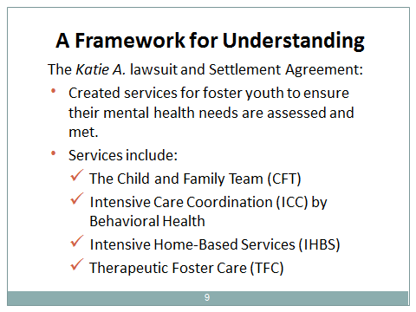  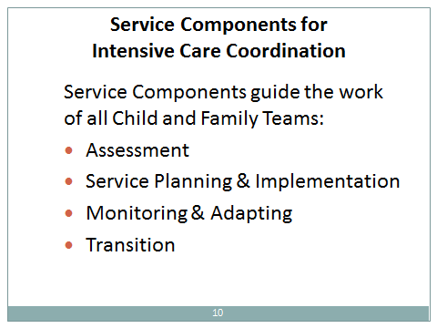
- Assessing
- Service Planning and Implementation
- Monitoring and Adapting
- Transition
Note that these components also guide the work of Child and Family Teams for children and youth with mental health needs who are not members of the subclass or who do not qualify for Specialty Mental Health Services.
Refer to Handout #4A-1, “Service Components and Activities for Intensive Care Coordination (ICC),” for further details that describe the activities associated with each of the service components.
  - Subclass members are entitled to receive behavioral health services in the child’s home or in a setting as homelike as possible. The services for children in the subclass are: Intensive Care Coordination (ICC), Intensive Home-Based Services (IHBS), and Therapeutic Foster Care (TFC). All members of the subclass must receive Intensive Care Coordination. When medically necessary, subclass members will additionally receive IHBS and/or other behavioral health services.
Specific duties assigned to the ICC Coordinator are found in the Core Practice Model Guide (2013, p. 27) and reproduced in Handout #4A-2, “Duties of the Intensive Care Coordinator.”
- “Intensive home-based mental health services (IHBS) are mental health rehabilitation services provided to members of the Katie A. Subclass. IHBS are individualized, strength-based interventions designed to ameliorate mental health conditions that interfere with a child/youth’s functioning and are aimed at helping the child/youth build skills necessary for successful functioning in the home and community and improving the…[family’s] ability to help the child/youth…” (Medi-Cal Manual, 2013 [currently under revision], p. 26).
- Based on medical necessity, subclass members are eligible for treatment options available from an array of more intensive mental health services, which:
- “Assist, support and encourage each eligible child/youth to achieve and maintain the highest possible level of health, well-being and self-sufficiency;
- Reduce timelines to permanency and lengths of stay within the child welfare system; and
- Reduce reliance on congregate care” (Medi-Cal Manual, 2013, p. 2; currently under revision).

- Activity 4B  Review and discuss the criteria for eligibility for the Katie A. subclass:  - Be under age 21  - Be eligible for “full scope” Medi-Cal (Title XIX)  - Meet medical necessity criteria for Specialty Mental Health Services  - Have an open child welfare case (in foster care or relative care; or involved in a voluntary family maintenance case)  - Described by either A or B:  - A:  - Is currently in or being considered for at least one of the following:  -- Wraparound  -- Therapeutic foster care  -- Specialized care rate due to behavioral health needs or other intensive Early and Periodic Screening, Diagnosis, and Treatment (EPSDT) services, including but not limited to therapeutic behavioral services or crisis stabilization/intervention;  Or  - B:  - Is currently in or being considered for at least one of the following:  - Group home (RCL 10 or above)  - Psychiatric hospital  - A 24-hour mental health treatment facility  - Has experienced at least three placements within 24 months due to behavioral health needs | 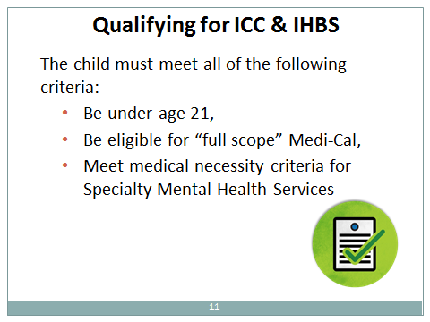  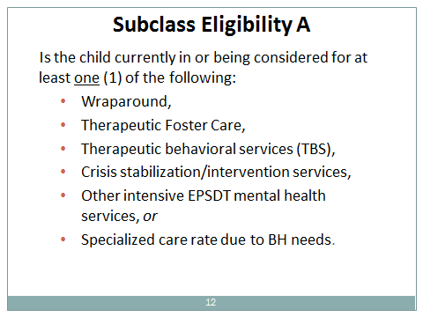  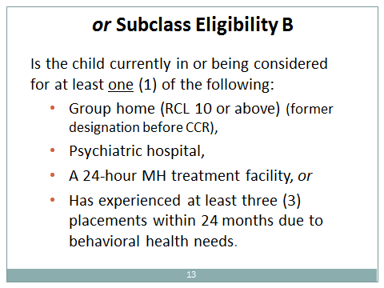
Reminder: Per MHSUDS Information Notice No. 16-004 (February 5, 2016), children and youth under age 21 may qualify by medical necessity for ICC and IHBS as EPSDT beneficiaries through full-scope Medi-Cal without being a member of the Katie A. class or subclass.

- Activity 4C  This section covers the process and key principles of Child and Family Teams and team meetings. The lecture includes the following points:  - Building the team and beginning the teaming process  - Team formation begins informally with initial interactions between families and the child welfare or behavioral health system. The small, informal team of social worker and family can begin to expand when a mental health concern has been identified. (Counties likely differ in the timing and protocols for beginning cross-system collaboration.) Unless a child is already receiving mental health services, potential mental health needs are flagged through a behavioral health screening. If the screening indicates a potential mental health need, a referral is made to behavioral health staff for a more in-depth behavioral health assessment.  - During the referral process followed by your county for a comprehensive behavioral health assessment, the social worker from child welfare and clinical staff from behavioral health can begin to communicate about the strengths, underlying needs, and concerns of the family regarding mental health and overall well-being.  - The social worker and behavioral health clinician should each cultivate their respective relationships with the child/youth and family, and engage them in discussing their family history, strengths, needs and concerns; how they have come to services; and their goals for the future.  - The social worker, behavioral health clinician, and family can then identify additional prospective members for their Child and Family Team. Team composition is guided by the family’s preferences. The team may be comprised of additional professionals, service providers, and natural support persons, such as clergy, Tribal elders, coaches, and friends whom the family trusts and who care about the family. Natural support persons should always be explored. Membership of the team may change over time as needs are resolved and new concerns are identified. At a minimum, the team must include the child and family, staff from agencies and providers involved in service delivery, and a family support partner or youth specialist. For the subclass, or for any child or youth receiving ICC or IHBS services, the team must also include a mental health ICC coordinator.  - Recall that the purpose of the Child and Family Team is to plan, deliver, and monitor behavioral health services and treatment goals for children in the child welfare system that promote their development and well-being. | 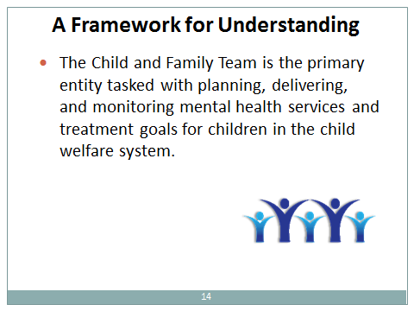  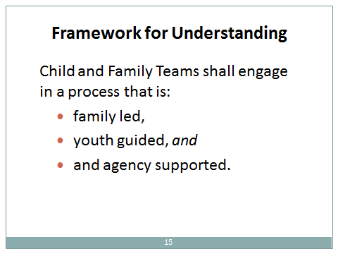  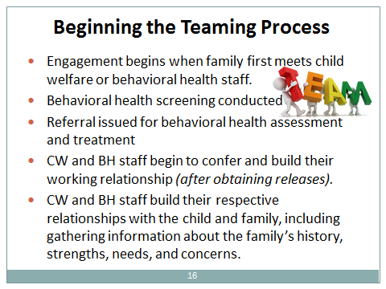  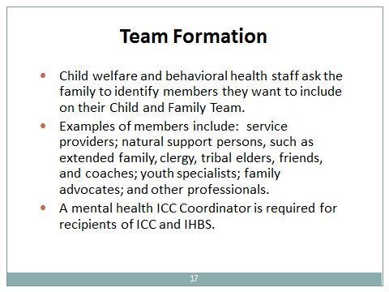  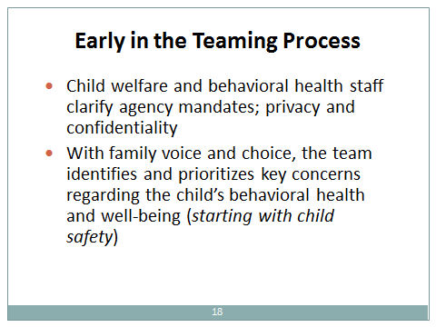  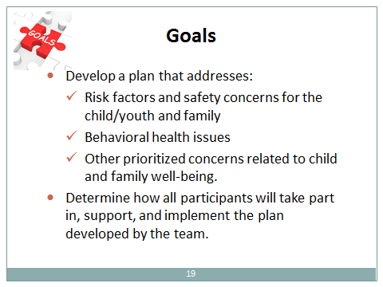

- At the start of team formation, key concerns regarding behavioral health and other related life domains should be identified and prioritized by the family, social worker, and behavioral health clinician. Due to the overarching concern regarding child protection, safety issues should be prioritized first.  - The behavioral health clinician, social worker, and family should be clear about how all participants will take part in, support, and implement the plan developed by the team. While Child and Family Teaming emphasizes family voice and choice, families and youth should be informed about what is and is not in their control with respect to determining treatment and services. (See Core Practice Model Guide 2013, p. 20).  - At the inception of the team, the behavioral health clinician and social worker (and other service providers on the team) must discuss issues of privacy and confidentiality with family members, and all consent and release forms must be reviewed with the child, youth and family. It is critical for youth and family to understand what information should be shared with other individuals on the team and during team meetings.  - The behavioral health clinician, social worker, family members, and other team members need to maintain communications and in-person contact on an ongoing basis. Teaming is not limited to discussions that take place in Child and Family Team meetings. Ongoing communication across agencies and with the family allows team meetings to be more productive. Each team member should have the information necessary for making informed decisions.  - Key Principles of the Child and Family Team  - “…it takes a team of people to ensure that children, youth and families successfully transition out of the child welfare system and achieve positive outcomes” (Core Practice Model Guide, 2013, p. 13).  - Child-centered and family-focused. Services and informal supports should promote a child’s right to be safe, loved, and nurtured in a permanent family setting.  - Respect. Youth, families, and members of their support network are engaged as partners in the team environment.  - Collaboration. Team members work together on shared goals and a common understanding of the team’s plans to achieve them.  - Empowerment. Decision making is accomplished through a team process (except as required by legal obligations and agency mandates). | 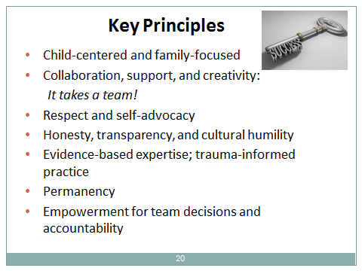
    - Accountability. Each team member has a unique role and accompanying responsibilities. Individual team members are held accountable for their respective responsibilities. The team as a whole is accountable for ensuring access by the child and family to needed services, and follow-through toward the attainment of identified goals.
    - Cultural Humility. Family culture and values are explored and respected, and services and meeting arrangements are harmonious with the family’s cultural orientation.
    - Self-Advocacy. Parent support persons, youth advocates, and other team members encourage and assist youth and family to voice their opinions and advocate for themselves.
    - Support. Team members assist the family to enhance their circle of support.
    - Creativity. Team members should be creative in devising interventions and solutions that emphasize reliance on informal supports, peer services, and paraprofessionals.
    - Honesty. Within the scope of confidentiality rights and informed consent, honesty is essential to the healthy functioning of the team.
    - Transparency. The rationale, options, and actions related to planning, treatment, and service delivery should be fully explained in language that is comprehensible to families and their support network.
    - Evidence-based Expertise. Based on extensive research concerning the effects of trauma on child development and later outcomes over the lifespan, trauma-informed practice provides the evidence-based approach that underlies Child and Family Teams. Trauma-informed practice facilitates and supports resiliency and recovery among children and families who have experienced trauma. Physical and psychological safety for children and families should be maximized. When operationalized in the team process, knowledge and skills derived from trauma-informed practice direct team members to focus on services and informal interventions that will promote healing and health.
    - Permanency. In addition to the legal definition of permanency, the Child and Family Team should identify for youth at least one individual who can provide a sustained relationship built on unconditional positive commitment and support.

Segment 5: Benefits of Child and Family Teaming

Segment Time: | 15 minutes
Materials: | Easel pad and markers
Slides: | 21–23

Description of Activity
This segment covers the benefits of Child and Family Teams and the CFT meeting process.

During the Activity

- Activity 5A  Instruct participants to reassemble in the same small groups of 2 and 3 as in Activity 3B. Ask participants to list benefits of Child and Family Teaming and the CFT meeting process. Facilitate a group report out of the ideas and chart answers on the easel pad in the front of the room. List the same or similar ideas only once. | 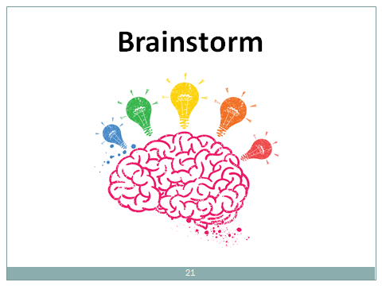
- Activity 5B  Review slides 22 and 23, highlighting any answers that the group did not list in the activity.  - Uses trauma-informed practice ⎯ an evidence-based approach ⎯as a means for improving the child’s mental health, in addition to attending to safety, permanency, and other aspects of well-being.  - Generates a larger and more diverse set of options for solutions that reflect the various perspectives of team members.  - Expands the ability to consider how to match functional strengths and needs with appropriate services or resources.  - Empowers families to be invested in planning and participating in treatment, services, and informal interventions.  - Customizes planning to identify solutions that are respectful of the family’s culture and preferences.  - Eliminates duplication and conflicting service intentions.  - Connects families to services in their communities.  - Creates and strengthens a system of support for the long term.  - Improves communication among agency staff from multiple agencies and fosters a shared perspective about goals and needs. | 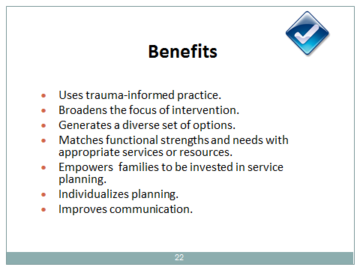  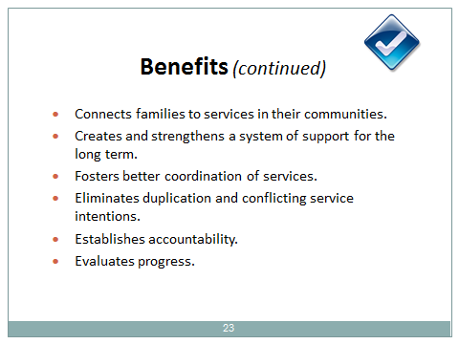

  - Fosters better coordination of services.
  - Establishes accountability for implementation of interventions and services by assigning actions to individuals within a timeframe.
  - Routinely evaluates the progress of the plan, and makes adjustments based on learning what works and what doesn’t work.

Segment 6: Initial Steps in the Teaming Process

Segment Time: | 30 minutes
Materials: | Handout 6A: Eight Steps to Building a Child and Family Team and Preparing for a Team Meeting
Slide: | 24

Description of Activity
This segment discusses how to build a Child and Family Team.

Context
The steps in developing the team may differ from county to county. Each county determines policies concerning how their agencies and staff will work together to implement the teaming process. This includes policies regarding how and when staff collaborate and communicate (whether by phone, email, and/or in person meetings), and the primary focus of interest for each agency. The county determines the roles and responsibilities of each agency’s staff, who may facilitate CFT meetings, how decisions will be made and by whom, and tools that will be utilized. The county may also identify potential CFT meeting sites and define procedures for scheduling. (Trainers are advised to become familiar with county-specific policies and procedures for their audiences before delivering this training. See the section “Tips for Training This Curriculum” at the beginning of this module.)

Before the Activity
- Activity 6A: Be thoroughly familiar with Steps 1-6 of the handout, “Eight Steps to Building a Child and Family Team and Preparing for a Team Meeting” so that you can encapsulate the main points in an interactive lecture/Q&A discussion session.

During the Activity

- Activity 6A  Distribute the handout, “Eight Steps to Building a Child and Family Team and Preparing for a Team Meeting.” Inform the participants that Steps 1-6 will be discussed in depth in this module, and Steps 7-8 will be covered in Module 2.  - The goal of this activity is to convey in sufficient detail the main points of Steps 1-6 in the handout. While this is predominantly a lecture, structure your points so that you allow for questions and answers and some discussion time in the large group. Stick to the topic of collaboration, teaming, and team formation, since details about CFT meetings (Steps 7 and 8) will be covered in Module 2.  - Note that the handout can be used as an on-the-job aid. | 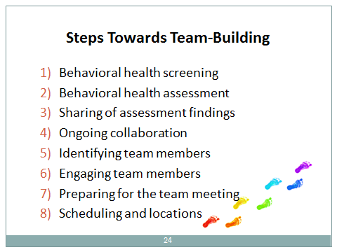

Segment 7: Engagement

Segment Time: | 70 minutes
Materials: | Handout 7B: Skill Practice for Engaging Team Members: Role Play Examples
Slides: | 25–26

Description of Activities
This segment is largely experiential. In small groups, participants practice a series of role plays to learn how to engage and prepare team members so they can maximize their contributions to the team and team meetings.

Before the Activity

- Activity 7B: Prepare a sufficient number of copies of the role plays and observer worksheets for distribution to small groups of participants, according to the number of roles in the scenarios. Plan in advance the scenarios you are most likely to use.

 |  | During the Activity
 | - Activity 7A  Review slide 25 about engaging and preparing members of a Child and Family Team. This slide and its “notes” provide the context for the role play activities that follow.  - Engagement begins with your first contact with the child, youth, or family.  - In order for teams to be successful, youth and parents need to be fully and meaningfully engaged as pivotal and respected team members. Mere “lip service” about engagement is not sufficient. Youth and parent leaders and advocates can play a critical role in the team process.  - As with all direct service provision, children, youth, and families should be treated with respect as individuals embedded within their cultures, communities, and histories, imbued with dignity and civil rights. Practitioners need to be cognizant of life experiences that often include trauma and microaggressions, and they are called upon to bring compassion to their expertise. |  |  | 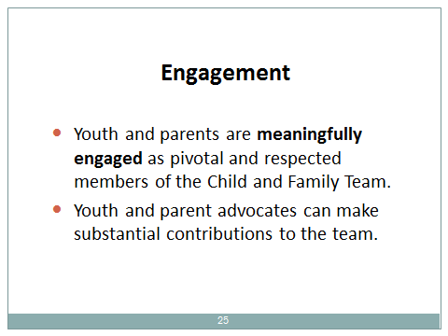
 | - Activity 7B  The trainer instructs participants to conduct a series of role plays, using the steps detailed below. The role plays concern how to build an effective Child and Family Team. Encourage participants to refer to the Handout, “Eight Steps to Building a Child and Family Team…” to help them with ideas for their roles. |  | 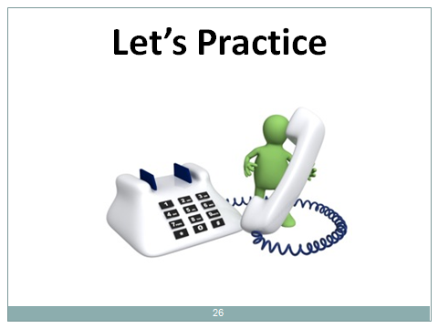
Trainer Tips:
- Provide instructions in about 5 minutes. Allow 10 minutes for each role play, 5 minutes for debriefing in the small groups, 2-3 minutes for rotating roles, and 15 minutes to debrief with the large group. This time structure will allow 3 role plays for each group.
- Introduce the activity and explain the role-play instructions. Emphasize that role-playing provides participants with an opportunity to apply their new knowledge, skills, and tools in situations that simulate actual family interactions. Inform participants that the lead role has been designated “coordinator.” Even if they never act as the team coordinator, communication skills practiced by the coordinator are critical for all child welfare and behavioral health staff.
- Select the scenarios you will use. Each scenario has different denominations for role-play participants. Direct the members of each group to choose who will play each role in the scenario, including one “observer.” Instruct the groups that each participant will play each role during the activity. Review basic expectations for each role with the participants. Most role plays include two actors and one observer, and one role play allows for three actors.
- Distribute role-play materials to the actors and observer. Give each participant a copy of the description for the scenario. Give “observers” the role play observation worksheet describing the case-specific issues they should identify.
- Give the groups 10 minutes to conduct the role play. Circulate among the groups to answer any questions that may arise and provide guidance as needed.
6. Instruct each group to discuss the role play. After the small groups have finished, ask the groups to spend five minutes discussing what happened during the role play. Encourage participants to provide constructive criticism during their discussions. The groups should discuss the following questions:
- What transpired between the coordinator and team participants?
- What did the coordinator do that was effective?
- What might the coordinator consider doing differently?
7. Rotate roles and repeat steps 1-6. Participants should rotate roles within their small groups or substitute a new role scenario. If each of the small groups works on different role plays, the groups can pass their role play materials to a neighboring group. In either case, it is important that each participant has a chance to play the role of coordinator during the activity.
8. Process the activity. After the groups have completed three rounds of role plays by using the rotation scheme in item 7 above, conduct a discussion in the large group for the remaining 10 minutes using the following questions:
While playing the role of the coordinator:
- How did it feel to integrate new content and communication techniques into your interactions?
- What worked well? What still feels awkward and requires more practice?
- Did the family or team participants raise issues or questions that you did not know how to answer?
While playing the role of a family member or team participant:
- Were you able to understand and use the information the coordinator gave you?
- Did the coordinator adequately address your questions related to Child and Family Teaming?
- Were you comfortable asking questions?
- Did you feel safe, respected, and heard?
While playing the role of the observer
- Did the coordinator create a comfortable environment?
- Did the coordinator build adequate engagement with the team participants?
- Can you share some examples of interesting interactions and creative solutions that you observed in the role plays?
- Activity 7C
Process the activity with the participants after the groups have completed three rounds of role plays, and conduct a discussion in the large group using the questions indicated in Item #8 in Activity 7B above.

Segment 8: Recap and Evaluation

Segment Time: | 10 minutes
Slide | 27

Description of Activity
This activity will highlight main take-away points of today’s training and prepare participants for the next module.

During the Activity

- Activity 8A  Review slide 27.  - Using the CFT meeting approach is not just about the practice of teaming; it is also about building a Circle of Support that can continue to assist a family after closure of the child welfare case to ensure child safety and promote child health, development, and well-being.  - Conduct a quick 10-minute round of people’s main take-aways from today’s module and draw some linkages to CFT meetings that will be covered in Module 2. | 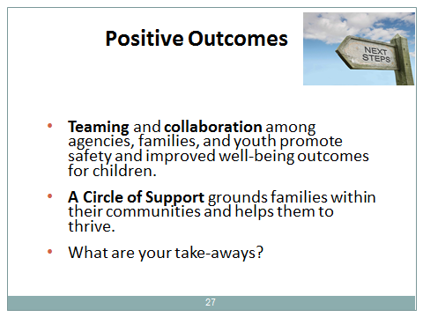

Trainee Handouts

- Activity 4A-1: Service Components and Activities for Intensive Care Coordination (ICC)
- Activity 4A-2: Duties of the Intensive Care Coordinator
- Activity 6A: Eight Steps to Building a Child and Family Team and Preparing for a Team Meeting
- Activity 7B: Skill Practice for Engaging Team Members (CFT Role Plays, Observer Worksheet)

Handout 4A-1 for Activity 4A

Service Components and Activities for Intensive Care Coordination (ICC)

(These service components also apply to children who are not members of the Katie A. v. Bonta subclass or who otherwise qualify for ICC and IHBS)
Assessing
- Assessing client’s and family’s needs and strengths.
- Assessing the adequacy and availability of resources.
- Reviewing information from family and other sources.
- Evaluating effectiveness of previous interventions and activities.

Service Planning and Implementation
- Developing a plan with specific goals, activities, and objectives.
- Ensuring the active participation of client and individuals involved and clarifying the roles of the individuals involved.
- Identifying the interventions/course of action targeted at the client’s and family’s assessed needs.

Monitoring and Adapting
- Monitoring to ensure that identified services and activities are progressing appropriately.
- Changing and redirecting actions targeted at the client’s and family’s assessed needs, not less than every 90 days.

Transition
- Developing a transition plan for the client and family to foster long-term stability including the effective use of natural supports and community resources.

Handout 4A-2 for Activity 4A

Duties of the Intensive Care Coordinator (ICC)

An Intensive Care Coordinator (ICC) serves as the single point of accountability to:
- Ensure that medically necessary services are accessed, coordinated, and delivered in a strength-based, individualized, family/youth driven, and culturally and linguistically relevant manner, and that services and supports are guided by the needs of the child/youth.
- Facilitate a collaborative relationship among the child/youth, his/her family, and involved child-serving systems.
- Support the parent/caregiver in meeting their child/youth’s needs.
- Help establish the CFT and provide ongoing support.
- Organize and match care across providers and child-serving systems to allow the child/youth to be served in his/her home community.

Handout for Activity 6A

Eight Steps to Building a Child and Family Team and Preparing for a Team Meeting
Step 1: Screening
All children entering the child welfare system will be screened for mental health needs. This initial screening does not need to be administered by a behavioral health clinician and can be conducted by child welfare practitioners. The screening is used to indicate a possible need for a more in-depth behavioral health assessment that is conducted by a behavioral health professional. Each county decides which evidence-based screening tool to use for this purpose. After the initial screening, a mental health screening tool should be administered at least annually for all children with open cases.

If a mental health need is identified by the screening tool, a referral is made to county behavioral health staff for additional behavioral health assessment services. The social worker engages the family in a discussion about the results of the mental health screening and the need for a referral for further assessment by a behavioral health professional. Protocols and procedures for referrals vary among counties. At this time, the social worker may introduce the concept of the Child and Family Team to the family and may also encourage them to begin thinking about potential members for their team if behavioral health services should be needed.

If a child is already known to be receiving behavioral health services, the social worker engages the family to obtain the necessary releases required before contacting the behavioral health provider.

(Note that the screening for mental health needs upon entry into the child welfare system is done in conjunction with an overall initial child welfare assessment to identify strengths and needs, and issues that affect the safety, permanency, and well-being of children.)

Step 2: Behavioral Health Assessment
If the initial screening indicates that behavioral health services may be needed, a behavioral health clinician conducts a more comprehensive and in-depth, strength-based assessment of the child and family. The assessment addresses underlying needs and mental health concerns, as well as a broad assessment of psychosocial risk factors related to the child’s environment. The assessment should include a trauma component and a clinical evaluation of current functioning. The clinical assessment establishes the medical necessity for Specialty Mental Health Services (SMHS), which is required as a criterion for eligibility for intensive behavioral health services (and classification as a member of the Katie A. subclass).

The behavioral health practitioner explains the assessment process to the youth and family so that they know what to expect. Pursuant to ethical and legal mandates, the behavioral health clinician also discusses confidentiality, privacy, mandated reporting and releases of information. During the course of the behavioral health assessment, the behavioral health clinician promotes understanding of the Child and Family Team approach and encourages the family/youth to share information with the social worker and other members of the team (once formed) in order to attain goals for mental health and well-being and transition out of the child welfare system.

Step 3: Sharing of Assessment Findings
The results of the assessment and recommendations for treatment and/or services will be discussed with the child/youth and family, the social worker (pending releases of information) and the behavioral health clinician assigned to the case. These discussions give the family an opportunity to voice their ideas and perspectives about treatment and services to the social worker and clinician in preparation for drafting an initial plan with all members of the Child and Family Team.

During this phase, the behavioral health professional provides introductory information to the child and family regarding the potential goals of treatment, what to expect generally in the treatment process, and all mandated and customary explanations about legal and ethical issues related to therapy.

The behavioral health clinician also informs the social worker and the youth/family if the in-depth behavioral health assessment and other criteria indicate that the child qualifies for receipt of Intensive Care Coordination (ICC) and, if medically necessary, Intensive Home Based Services (IHBS) and/or other behavioral health services, such as Day Treatment Rehabilitative or Day Treatment Intensive, Group Therapy, or Therapeutic Behavioral Services (TBS). In addition, protocols for the provision of Therapeutic Foster Care (TFC) are currently under development as another treatment option. With the family’s permission (as granted by written releases of information), the clinician may also discuss the results with other agency representatives and team members who participate on the Child and Family Team.

Tip: The social worker and behavioral health clinician should:

- State to family members the importance of meeting the full array of the child’s/youth needs.
- Reiterate the intent to assist the child and family in meeting those needs.
- Inform the family that referrals will be made to the appropriate health care provider or other service provider(s).
- Ask the family and child or youth (if developmentally appropriate) to confirm their understanding of the process for receiving services, and invite them to ask questions.
Step 4: Ongoing Collaboration Between Child Welfare and Behavioral Health Staff
In preparation for the teaming process (and after obtaining the necessary releases of information), the social worker and clinician confer about priorities and concerns for the child and family, based on what each has learned to date through casework and clinical information obtained by their respective agencies. The caseworker and treating clinician confer as needed throughout the teaming process. Their contact is not limited to Child and Family Team meetings.

In addition, child welfare and behavioral health staff each work independently and collaboratively to:

- Establish trusting, helping relationships with and among team members
- Engage the participation, commitment, and accountability of team members
- Engage child and family strengths
- Demonstrate genuine interest in the diverse perspectives and narratives of team members
- Demonstrate respect for the child’s and family’s culture and values
Step 5: Identifying Team Members
The social worker and clinician each work with the youth and family to identify supportive individuals in their social network who would be available and motivated to participate as members of their Child and Family Team. For example, team members may be drawn from maternal and paternal relatives, Tribal members, resource families, school personnel, clergy, parent/family support partners, friends, neighbors, CASAs, substance abuse counselors, youth specialists, and other service providers. Of many possible types of team participants, it is essential to have a coordinator, a facilitator for team meetings, and a family support partner or family specialist for youth. (The coordinator and facilitator may be the same person.) As appropriate, agency staff and the family may also consider inviting team participation from representatives of other child- and family-serving systems, such as education, medical care, developmental disabilities, and juvenile justice. Ask the family and children/youth to state the individuals they want on their team, and how to get in touch with them.

If the child qualifies for Intensive Care Coordination (ICC) services, such services must be managed by a mental health ICC coordinator. Intensive Care Coordination is fully integrated into the Child and Family Teaming process. The Child and Family Team serves as the primary vehicle for delivering services in accordance with the Pathways to Well-Being Core Practice Model (Medi-Cal Manual, 2013, p. 20; currently under revision). ICC services include active participation of ICC staff on the team and oversight of the team’s planning and monitoring process to ensure that the mental health needs of the child or youth are met.

The ICC coordinator secures the participation of the child or youth, family or caregiver, and significant others, and upholds the values and philosophy of the Pathways to Well-Being Core Practice Model in the assessments and planning conducted by the team. The ICC coordinator is skilled at engaging individuals, inspiring the commitment of team members, and identifying resources that will be of assistance to the family. Depending on county protocols, the ICC coordinator may have the chief responsibility for creating the team. The ICC coordinator may also serve as the team’s facilitator. The facilitator must be a mental health provider, social worker, or probation officer. The necessity for a specially trained facilitator is dictated by the needs of the child and family.

Step 6: Engaging Team Members
For all children in need of behavioral health services, a designated coordinator or facilitator ensures that all team participants, including family members, providers, and new team members, are contacted and provided with an overview of the teaming process. (County procedures may vary regarding which staff are responsible for this task.) During these introductory conversations, agency staff and members of the family’s support network begin building the trusting relationships needed to sustain the Child and Family Team over time.

Team members are informed about their respective roles, the structure of CFT meetings, the decision-making process, and the means for achieving transparent communication within the team. In this initial contact and throughout the teaming process, the importance of drawing on the child’s and family’s strengths and needs is emphasized. An explanation is provided to new team members about how strengths and needs are integrated into planning goals, interventions, and services for the child and family. The process of developing, monitoring and adapting service plans is also discussed. New members are also briefed about the priority for building the family’s informal, community-based support network.

Child and Family Team members “work to reach agreement about services, safety, well-being (e.g., meeting critical developmental, health, education, and mental health needs), and permanency” (Medi-Cal Manual, 2013, p. 8; currently under revision). An effective Child and Family Team communicates in a transparent manner and ensures that services are well coordinated. Ongoing communication among team members may be conducted through telephone calls, conference calls, and/or emails, in addition to in-person meetings (according to confidentiality standards, the Health Insurance Portability and Accountability Act (HIPPA), Protected Health Information (PHI) and Public Information standards) (Core Practice Model Guide, 2013).

Step 7: Preparing for the Child and Family Team Meeting
(CFTs & CFT meetings are mandated for children who qualify for ICC and IHBS)

Cross-agency Collaboration
In preparation for the first Child and Family Team meeting, and as representatives of their respective agencies, the social worker and behavioral health clinician communicate about priorities and concerns to be addressed by the team. County agencies should have clear guidelines about decision-making authority within the team when there is a lack of consensus among team members. The social worker and clinician need to be aware of their county’s policies regarding decision-making authority and how it may manifest among team relationships and during CFT meetings. The social worker and clinician should also communicate with the coordinator or facilitator, if the coordinator or facilitator is another individual.

Meeting Frequency, Format, and Facilitator Choice
Meetings are held on a regular basis, or as frequently as necessary, in order to integrate the work of team members, ensure accountability, and adjust service plans and interventions according to the current situations and assessed needs of the child and family. Service and treatment plans for members of the Katie A. subclass are required to be revisited at least every 90 days.

Counties may have a preferred meeting structure drawn from other models of family teaming such as team decision-making, family group conferencing, wraparound, or other teaming formats. In general, family meetings often include agenda components that address child and family strengths, needs and concerns, goal-setting, and conducting a brainstorming session in order to develop a plan to meet the identified goals. The plan specifies informal interventions as well as provider services. In all cases, the plan indicates who is responsible for each aspect of the plan, and the timelines involved – in short, who will do what, and when.

Family needs will also inform the level of formality and structure of team meetings, and the need for a specially trained meeting facilitator. All team members may not need to attend all meetings, providing that the work of the team is not hindered and partnership is sustained among team members. In general, Katie A. subclass members presumably require more structured, formal meetings, while team meetings for children and families with less complex needs may be less formal. For subclass members, meeting facilitators must be a behavioral health provider, social worker, or probation officer.

Meeting Preparation
The CFT meeting coordinator or facilitator contacts team members in advance to explain the meeting process, guidelines, and format of Child and Family Team meetings, as well as key issues that will be addressed. Team members should understand that goals and plans are developed from discussions at CFT meetings, and that timeframes are set for evaluating progress and adapting or modifying plans. Team members are also informed about the decision-making process for Child and Family Teams that is followed in their county. The agenda for the CFT meeting is distributed in advance.

Below are several explanatory points to cover with team members about the meeting process:

- Each meeting has a clearly defined purpose, goal, and agenda.
    - Family strengths and needs are identified.
    - Meeting participants follow an agreed-upon decision-making process.
    - Meetings include time for brainstorming and generating options for interventions, services, and goal achievement.
    - Meetings involve the development of action plans and timelines using the best ideas of the child/youth, family, and other team members that address:
      - Concerns regarding safety and risk
      - Treatment and services for behavioral health needs
      - Other prioritized concerns related to the well-being of the child/youth and family
      - Alignment of goals with the family and among the service providers
      - Informal interventions and enhancement of the family’s natural support network
      - Supporting the family in the operationalization of the action plan
      - Monitoring progress towards goals and revising action plans accordingly
      - Reunification or other forms of permanency, and the transition out of the child welfare system, with community supports in place
As part of the explanation of the CFT meeting, the coordinator or facilitator engages team members by inquiring about their perspectives regarding the child’s and family’s well-being. The coordinator/facilitator also addresses any concerns that a team member may have about the meeting process.

During the meeting preparation phase, the family and agency staff decide whether or not a young child who is the focus child (or another young family member) should be included in the meeting. This judgment is based on a consideration of the child’s developmental level, the child’s preferences, and whether or not the child would benefit from participating in the meeting. In general, adolescents should be active participants in CFT meetings, providing there is no outstanding concern that meeting participation would be detrimental to the youth. Children and youth who are expected to benefit from meeting participation should be included in the CFT meeting in a way that fits their individual developmental level.

Some questions that a coordinator/facilitator (and the social worker and clinician) can use to engage family members, youth, and caregivers to prepare for a meaningful meeting are provided below. (Staff may want to add other questions that are specific to a family’s situation.) In order to identify the youth’s concerns about the meetings, separate and individualized conversations with the youth are advised. The purpose of having such discussions before the meeting is two-fold: (1) to provide the team member a chance to articulate her/his viewpoints in advance and become acquainted with the purpose and process of the meeting; and (2) to provide the staff with important information that can raise their sensitivity and compassion to the needs and concerns of the child and family and promote the effectiveness and efficiency of the meeting process. These preliminary conversations are valuable.

Questions for family members and caregivers (adaptable for youth):

- What do you see as [your] [child and family] strengths?
- What concerns do you have [about the child or family]?
- What types of assistance and support do you think is needed [by the child or family]?
- What would you like team members to know about your family’s experiences, culture and values?
- What would you need in order to feel safe participating in this meeting?
- What results would you like to see from this meeting?
- Describe what success is for your family. What would [a specific family member or support person] be doing differently when you achieve success?
- What are the best place and time to hold the Child and Family Team Meeting (for convenience, comfort, etc.)?

Additional questions for youth are:

- What do you need [from family, support network, or other resources]?
- What do you want team members to know about you?
- If we invited all the people who care about you to come to the meeting, what would be some good results that might come from their participation?
Step 8: Scheduling and Locations for CFT Meetings
The coordinator/facilitator is responsible for scheduling the time and place of the meeting in accordance with the family’s preferences. Arrangements should take into account team members’ schedules and time constraints to the greatest extent possible in order to maximize participation. The meeting space should be comfortable, welcoming, and large enough to accommodate the team.

Handout for Activity 7B
Skill Practice for Engaging Team Members: Role Play Examples

1. Role Play – Introducing the CFT Process to a New Team Member
Goal – Engage a new team member while explaining Child and Family Teaming
3 participants (including observer)

Roberto Beneto (age 12) appears socially withdrawn in school. His teacher notes that he seems to avoid mentally challenging tasks, doesn’t remember her instructions, and is often forgetful about homework assignments. Based on his behavioral assessment, the coordinator is in the process of convening the Child and Family Team.

Roberto’s parents Luisa and Javier Beneto get along well with Roberto’s foster mother, Josie. They have asked the coordinator if Josie could join their team. The coordinator is now meeting with Josie to introduce the teaming process and Josie’s potential role on the team. Josie is not sure if she wants to join the team.

Enact this conversation between the coordinator and Josie, including the issues that will be addressed; roles of team members; and how strengths and needs will be incorporated in the planning process. The coordinator also discusses how plans are developed; timelines for action steps and evaluating progress, and when/how to adapt or modify the plan. The process for communicating information among team members is also addressed. The coordinator wants to engage Josie in the conversation, encourage her participation on the team, and clearly convey the information. (Assume that the required releases have been obtained.)

2a and 2b. Role Play – Child and Family Teaming: Explaining Principles and Roles
Goal – Explain the principles of Child and Family Teaming and the roles of team members
4 participants (including observer), but could be modified for 3 participants

The coordinator is convening a team for the Johnson family which incorporates the family’s preferences in the identification of members for their support network. In the Johnson family are Jody (mother), Joseph (father), and Paul (age 8). Paul presents with behavioral challenges that have been intensifying in recent years. Paul is reported to act aggressively with other children at school and with his sister and brother at home. The in-depth behavioral assessment conducted by the county’s behavioral health services indicates that he may have a previously undiagnosed learning disability. The team includes Paul’s school psychologist, Matt, and Parent Partner, Cindy, who has recently been assigned to the family.

The goal of this role play is for the coordinator to engage team members in a conversation about the principles of Child and Family Teaming and the roles of each team member, including those of the child welfare and behavioral health staff, in relationship to Paul’s difficulties. The coordinator also needs to address any questions or concerns voiced by team members. (Assume that all necessary releases of information have been obtained.)

Group for 2a: The role play includes only the coordinator, and parents Jody and Joseph.
Group for 2b: The role play is a conference call that includes only the coordinator, school psychologist Matt, and parent partner Cindy.

3. Role Play – Engaging Fathers
Goal – Explain the purpose and goals of the Child and Family Team in relation to the child’s needs, and the father’s role as a team member.
3 participants (including observer)

Iris’s father Steve has been estranged from the family for the past year. Iris just turned 13. For the past six months, Iris’s mother Bonnie has been receiving in-patient substance abuse treatment and counseling for depression. During this time, Iris has been living with a resource family. Iris continues to fall behind in school and remains unable to make friends. In addition to feeling abandoned by her mother, Iris misses her father and has asked her therapist if her father could join her team. The team’s coordinator must now call Steve and explain why he is invited to the team and how he could contribute to a positive outcome for his daughter.

Act out this telephone conversation between the coordinator and Steve, including the purpose and goals of the Child and Family Team in relation to Iris’s mental health, and what will be expected of him as a team member.

4. Role Play – Identifying Parent Partners
Goal – Maintain a circle of support
3 participants (including observer)

Mother Yolanda Iverson states she wants Rosie, her AOD (Alcohol and Other Drugs) support staff at the program, to attend the next two CFT meetings but Rosie cannot. Act out the conversation between Yolanda and the coordinator to identify another person who might join the team as an ongoing member and attend the meetings in Rosie’s place. The conversation should include identification of the role Rosie would have played (e.g., as a support person who could speak to Yolanda’s progress). Help Yolanda think through who else could play a supportive role on the team and in the CFT meetings.

5. Role Play – Engaging Cultural Values and Practices
Goal – Respectful inclusion of cultural practices in the teaming process
3 participants (including observer)

The Sampson family includes father Pete, mother Sue, and their son, Jacy (age 12), who has been irritable, unable to sleep, and extremely worried about school assignments. The Sampsons are members of a Tribal community. The coordinator asks the family about their Tribal community and who would be helpful to their Child and Family Team. The Sampsons name their cousins, Alice and Jenner, as well as their Tribal Elder, Rebecca Begay. The coordinator inquires if there are any Tribal traditions the family would like to include in CFT meetings. Mr. Sampson says it is customary to ask the Tribal Elder for suggestions.

Enact the conversation between the coordinator and Tribal Elder Rebecca Begay. The coordinator describes the teaming process and explains that a series of Child and Family Team meetings will be planned. The conversation is a learning experience for both the coordinator and the Tribal Elder, with each asking questions of the other. The Tribal Elder identifies customs to include in CFT meetings (e.g., opening prayer; talking circle) and discusses some of her concerns about Jacy’s well-being.

Activity 7B

Observer Worksheet

- While observing the interaction between the coordinator and the CFT participants, pay attention to the list below and note whether the practice behaviors have occurred.
- When processing this role play, include items from this list in your group’s discussion.

The coordinator:

- Engaged the team member(s) genuinely, with respect for the child’s and family’s race; ethnicity; culture; sexual orientation, gender identity and expression (SOGIE); etc., and empathy for the family’s circumstances.
- Listened and did not interrupt.
- Clearly described the teaming process and explained its purpose and/or values, with reference to issues concerning the child and family.
- Explained that the focus is on strengths and needs.
- Explored how the team member(s) could contribute toward positive outcomes.
- Acknowledged the team member’s perspectives and expressions of emotion and explored their basis, if appropriate, with understanding and compassion.
- Was not critical of the person.
- Did not take anything personally.
- Competently answered the participants’ questions.
- Helped the team member to resolve issues related to participation on the team.
- EXTRA: Asked if the team member has any potential conflicts or obstacles about participating on the team (emotional, legal, practical, etc.).

Glossary
366.26: Refers to California Welfare and Institutions Code (WIC) section 366.26, which specifies the court hearing for children who are dependents of the juvenile court when it is presumed that the child is likely to be adopted and family reunification services may no longer be provided to the parents. The court may make findings and orders to terminate the rights of the parent or parents and order that the child be placed for adoption.
California Wraparound: Wraparound is an intensive, individualized care planning and services management process. The Wraparound process aims to achieve positive outcomes by providing a structured, creative and individualized team planning process that results in plans and services that are effective and relevant to the child and family.
CBO: A Community-Based Organization (CBO) is a provider within the community that offers concrete services to individuals and families, such as Wraparound and other therapeutic services, to resolve issues and provide support as needed.
C-CFSR: The California Child and Family Services Review (C-CFSR) is the Child Welfare Services Outcome and Accountability System, which focuses primarily on measuring outcomes in the areas of safety, permanency, and child and family well-being. By design, the C-CFSR closely follows the federal emphasis on safety, permanency and well-being. The C-CFSR applies the philosophy of continuous quality improvement, interagency partnerships, community and/or Tribal involvement, and public reporting of program outcomes.
CDSS: The California Department of Social Services (CDSS) is the state agency charged with serving, aiding, and protecting needy and vulnerable children and adults in ways that strengthen and preserve families, encourage personal responsibility, and foster independence.
CFT: The Child and Family Team (CFT) is a group of people comprised of staff from the child welfare and behavioral health agencies as well as other individuals identified by the family who work with the child and family to achieve positive outcomes of safety, permanency and well-being. Team members also work towards a successful transition for the family out of the formal child welfare system by developing a sustainable circle of support for the family within their community. Individuals working as part of the CFT have respective roles and responsibilities, and they work together as members of a team. The CFT is an integral part of the CPM.
CPM: The Pathways to Mental Health Core Practice Model (CPM) defines the values, principles, teaming model and standards of practice and activities for all child welfare and mental health agencies, service providers and community/tribal partners working with child welfare children, youth and families.
CSOC: Children’s System of Care (CSOC) is an organizational philosophy and framework that involves collaboration across agencies, families, and youth for the purpose of improving service access and quality, and expanding the array of coordinated, community-based, culturally and linguistically competent services for families and supports for children and youth who have a serious emotional disturbance.
DHCS: The California Department of Health Care Services (DHCS) is the state agency charged with preserving and improving the health status of all Californians. DHCS works closely with health care professionals, county governments and health plans to provide a health care safety net for California’s low-income families and persons with disabilities. Beginning in FY 2012/13, some programs of the Departments of Mental Health, Public Health, Alcohol and Drug Programs and California Medical Assistance Commission became a part of DHCS.
DR: Differential Response (DR) is a strategy that allows a California child welfare services (CWS) agency to respond in a more flexible manner to reports of suspected child abuse or neglect. DR affords a customized approach based on an assessment of safety, risk and protective capacity that recognizes each family’s unique strengths and needs, and addresses these in an individualized manner rather than with a “one size fits all” approach. DR has three referral paths, which are assigned by the social worker based on information taken from the initial call or intake report from the CWS hotline:
• Path 1: Community Response, referral is closed in the child welfare system
• Path 2: Child Welfare Services and Agency Partners Response, joint response
• Path 3: Child Welfare Services Response, most similar to the Child Welfare Services traditional response
Juris/Dispo: Jurisdiction and Disposition Hearings are often held together; however, they have separate functions. Jurisdiction Hearings determine whether or not abuse and neglect allegations are true and if intervention is warranted under W&IC 300. At a Disposition Hearing, the court determines a child’s placement and establishes a service plan.

EPSDT: Early and Periodic Screening, Diagnosis, and Treatment (EPSDT) is a Medi-Cal benefit for individuals under the age of 21 who have full-scope Medi-Cal eligibility. This benefit allows for periodic screenings to determine health care needs. Based upon the identified health care need, diagnostic and treatment services are provided. EPSDT services include all services covered by Medi-Cal. In addition to the regular Medi-Cal benefits, a beneficiary under the age of 21 may receive additional medically necessary services. These additional services are known as EPSDT Supplemental Services, and include mental health-related diagnostic services and treatment (other than physical health care). These services are available under the Medi-Cal program only to persons under 21 years of age pursuant to Title 42, Section 1396d(r), United State Code; are services that have been determined by the State Department of Health Care Services to meet the criteria of Title 22, Section 51340(e) (3) or (f); and are not otherwise covered as specialty mental health services. EPSDT services include rehabilitative mental health services for seriously emotionally disturbed children: collateral, assessment, individual therapy, group therapy, medication services, crisis intervention, day care intensive, and day care habilitation offered in local and mental health clinics or in the community. EPSDT services include Therapeutic Behavioral Services (TBS) for children/youth with serious emotional challenges, as well as mental health evaluations and services. www.dhcs.ca.gov
EQR: External Quality Review (EQR) is an independent evaluation conducted by persons or organizations external to the entity, practice, or service being reviewed.
FGDM: Family Group Decision Making (FGDM) is a decision-making process to which members of the family group are invited and joined by members of their informal network, community groups and/or tribe, and the child welfare agency that has become involved in the family’s life. FGDM acknowledges the rights and abilities of the family group to make sound decisions for and with its children and youth and actively engages the community and/or tribe as a vital support for families.
Foster Care Placement: 24-hour substitute care for all children placed away from their parent(s) or guardian(s) and for whom the State agency has placement and care responsibility (Section 1355.20 Code of Federal Regulations).
ICC: Intensive Care Coordination (ICC) is a Medi-Cal-covered service that is responsible for facilitating assessment, care planning and coordination of services, including urgent services for children/youth who meet the Katie A. subclass criteria or medical necessity through the EPSDT Medi-Cal benefit.

IHBS: Intensive Home-Based Services (IHBS) are intensive, individualized, strength-based mental health treatment interventions designed to address mental health conditions that interfere with a child’s functioning. Interventions are aimed at helping the child build the skills necessary for successful functioning in the home and community, and improving the family’s or caregivers’ ability to assist in this goal.
Integrated Practice Components: Integrated Practice Components are the essential elements of collaborative practice. They provide the overarching framework for what multiple agencies or systems do, based upon and driven by fundamental values and principles.
Implementation Science: Implementation Science is the study of methods to promote the integration of research findings and evidence into policy and practice.
Katie A. Lawsuit: The Katie A. Lawsuit, Katie A. et al. v. Bonta et al., refers to a class action lawsuit filed in Federal District Court in 2002 concerning the availability of intensive mental health services to children in California who are either in foster care or at imminent risk of coming into care. A Settlement Agreement was reached in the case in December 2011. www.cdss.ca.gov
MHP: A Mental Health Plan (MHP) is an entity that enters into a contract with the DHCS to provide directly or arrange and pay for specialty mental health services to beneficiaries in a county. An MHP may be a county, counties acting jointly, or another governmental or non-governmental entity.
MHSA: The Mental Health Services Act (MHSA) is a voter-approved initiative to develop a comprehensive approach to providing community-based mental health services and supports for California residents. To accomplish its objectives, the MHSA applies a specific portion of its funds to each of six system-building components:
• Community program planning and administration
• Community services and supports
• Capital facilities (buildings) and information technology
• Workforce education and training (human resources)
• Prevention and early intervention
• Innovation
None of the funds can substitute for existing fund allocation and all funds have to be allocated towards expansion or creation of programs and services.
MHSA FSP: The Mental Health Services Act Full Service Partnership (MHSA FSP) is defined in the California Code of Regulations, Title 9, Section 3200.130 as “the collaborative relationship between the County and the client, and when appropriate, the client’s family, through which the County plans for and provides the full spectrum of community services so that the client can achieve the identified goals.” FSPs provide a “whatever it takes” approach to service delivery.
Open Child Welfare Case: A child with an open child welfare case is defined as any of the following: a) child is in foster care; b) child has a voluntary family maintenance case (pre or post, returning home, in foster or relative placement), including both court ordered and by voluntary agreement. It does not include cases in which only emergency response referrals are made.
Parent Partners and Youth Advocates: Parent partners and youth advocates are key individuals who work with children and families within the public child welfare, juvenile probation or behavioral health systems. Parent partners and youth advocates are often previous recipients of services who can inform social service systems about the effective use of family-centered and family-driven principles to engage children, youth, and families.
Practice Activities: Practice activities are the strategies and behaviors that carry out the standards of practice on a daily basis.
Standards of Practice: Standards of practice are the guidelines that govern how the workers in an organization perform their work. Integrated standards of practice are the guidelines that govern how systems, organizations, communities, and tribes work together.
SMHS: Specialty Mental Health Services (SMHS) – Per Title 9, Chapter 11, Section 1810.247, is defined as:
Rehabilitative Mental Health Services, including:
(1) Mental health services;
(2) Medication support services;
(3) Day treatment intensive;
(4) Day rehabilitation;
(5) Crisis intervention;
(6) Crisis stabilization;
(7) Adult residential treatment services;
(8) Crisis residential treatment services;
(9) Psychiatric health facility services;
(b) Psychiatric Inpatient Hospital Services;
(c) Targeted Case Management;
(d) Psychiatrist Services;
(e) Psychologist Services;
(f) EPSDT Supplemental Specialty Mental Health Services; and
(g) Psychiatric Nursing Facility Services.

SOGIE: Sexual Orientation, Gender Identity and Expression (SOGIE). Sexual Orientation refers to a person’s emotional, romantic, and sexual attraction to individuals of the same and/or a different sex (e.g. lesbian/gay, heterosexual/straight, bisexual). Gender Identity is a person’s internal, deeply felt sense of being male, female, both, or neither, regardless of the person’s assigned sex at birth. Gender Expression is the manner in which a person expresses their gender through their clothing, appearance, speech, and/or behavior. Every person has a sexual orientation, gender identity, and gender expression.

TBS: Therapeutic Behavioral Services (TBS) are available for eligible children who need short-term behavioral support in addition to any other mental health services they are receiving. TBS focuses on changing a child’s behavior, while emphasizing the child’s strengths. TBS works in collaboration with the child, the child’s caregivers and the primary mental health provider to address one to three behaviors that jeopardize the child’s ability to remain in his or her current home. TBS services are provided in the child’s home and other environments where the child’s behaviors occur. Services are approved for 30-60 days at a time and are expected to produce the desired changes within a few months.

TCM: Targeted Case Management (TCM) services are provided as part of a comprehensive specialty mental health services program available to Medi-Cal beneficiaries who meet medical necessity criteria based on the beneficiary’s need for targeted case management established by an assessment and documented in the client plan. Targeted Case Management services are defined as services furnished to assist individuals, eligible under the State Plan, in gaining access to needed medical, alcohol and drug treatment, social, educational and other services. Targeted Case Management includes a comprehensive assessment and periodic reassessment, development and periodic revision of a client plan, referral and related activities, and monitoring and follow-up activities.

TDM: Team Decision Making (TDM) is one of four core strategies articulated in the Annie E. Casey Family to Family Initiative. TDM is a process of decision making that involves child welfare workers, foster parents, birth families and community and/or Tribal members in all placement decisions to ensure a network of support for children and the adults who care for them
TFC: Therapeutic Foster Care (TFC) , also known as Treatment Foster Care, consists of intensive and highly coordinated mental health and support services provided to a foster parent or caregiver in which the foster parent/caregiver becomes an integral part of the child’s treatment team.

WIC: The California Welfare and Institutions Code (WIC) contains Section 300, which provides the legal basis for juvenile court jurisdiction and authorizes the court to remove children from the care and custody of their parents if it is necessary for their safety.

References

State of California. (2013). Medi-Cal manual for intensive care coordination (ICC), intensive home-based services (IHBS) & therapeutic foster care (TFC) for Katie A. subclass members. Sacramento, CA: DHCS and CDSS. [This manual is currently under revision.]

State of California. (2013). Pathways to mental health services: core practice model guide. Sacramento, CA: DHCS and CDSS.

State of California Health and Human Services Agency, Department of Health Care Services. (2016, February 5). MHSUDS Information Notice No.: 16-004, Provision of ICC and IHBS as medically necessary through EPSDT. Sacramento, CA.

Group agreements provided courtesy of Betty Hanna, Trainer.
As delineated in the Medi-Cal Manual (2013, pg. 3) for Intensive Care Coordination (ICC), Intensive Home Based Services (IHBS) & Therapeutic Foster Care (TFC) for Katie A. Subclass Members. This manual is currently under revision. This curriculum will be updated accordingly after the new Medi-Cal Manual is issued.
Continuum of Care Reform (CCR) now uses a different categorization and nomenclature.
As delineated in the Medi-Cal Manual for Intensive Care Coordination (ICC), Intensive Home Based Services (IHBS) & Therapeutic Foster Care (TFC) for Katie A. Subclass Members (2013), pgs. 9-10. This manual is currently under revision.
Extracted from the Pathways to Mental Health Services Core Practice Model Guide (2013), pg. 27.

