Child and Family Teaming

Module 2
Version 1.0 | May 2016

The Child and Family Team Meeting:
Preparation, Facilitation, and Follow-up

Trainer’s Guide

Table of Contents

Table of Contents 1
Audience 2
Background and Context 2
Child and Family Teaming 4
Tips for Training This Curriculum 5
Agenda 7
Learning Objectives⎯Module 2 8
Segment 1: Welcome and Introductions 11
Segment 2: Review Learning Objectives Knowledge, Skills, and Values 13
Segment 3: From Teaming Basics to the First Team Meeting 14
Segment 4: Facilitation of the CFT Meeting 18
Segment 5: Facilitation Practice 20
Segment 6: Discussion of Facilitation Exercise 22
Segment 7: Closing a Meeting 23
Segment 9: Challenges 26
Segment 10: Summary and Evaluation 28
Participant Handouts 29
Glossary 46
References 51

Audience

The intended audiences for The Child and Family Teaming Modules I and II are supervisors and line staff in child welfare and children's behavioral health departments throughout California, as well as community partners who have interest in teaming with families and county agencies to serve the mental health needs of children and youth in the child welfare system.

Background and Context

This Child and Family Teaming curriculum has been developed in response to the Settlement Agreement for the Katie A. v. Bonta class action lawsuit. The Settlement Agreement requires county behavioral health and child welfare agencies to develop and implement sustainable infrastructure to coordinate and integrate the delivery of community-based behavioral health services for children involved in the child welfare system. The Settlement Agreement also mandates that a subclass of children in the child welfare system with intensive mental health needs receive medically necessary mental health services in their own home or in a homelike setting. This objective is being accomplished through the introduction of three new mental health service components covered under County Medi-Cal Mental Health Plans: Intensive Care Coordination (ICC) and Intensive Home Based Services (IHBS), which were implemented effective January 1, 2013, and Therapeutic Foster Care, which is currently under development. In addition, Intensive Care Coordination and Intensive Home Based Services are allowable as medically necessary services under the Medicaid Act as a benefit of the Early and Periodic Screening, Diagnosis, and Treatment (EPSDT) services for all children and youth under age 21 who are eligible for the full scope of Medicaid services. Consequently, it is not necessary for a child or youth to be a member of the Katie A. class or subclass in order to qualify for ICC and IHBS (Department of Health Care Services, MHSUDS Information Notice No.: 16-004, February 5, 2016).

In 2013, The California Department of Social Services (CDSS) and the Department of Health Care Services (DHCS) facilitated large-scale, institutional changes by issuing the Pathways to Mental Health Services Core Practice Model (CPM) Guide, http://www.childsworld.ca.gov/res/pdf/CorePracticeModelGuide.pdf, and its companion guide, the Medi-Cal Manual for Intensive Care Coordination (ICC), Intensive Home Based Services (IHBS) & Therapeutic Foster Care (TFC) for Katie A. Subclass Members. The Medi-Cal Manual is currently under revision. After the new edition is issued, this curriculum will be updated accordingly.

At the time of this writing, the California Department of Social Services is engaged in the development of the California Child Welfare Core Practice Model, which subsumes the Pathways to Mental Health Services Core Practice Model within a larger practice framework that integrates the child welfare system with other child- and family-serving systems in the public sector and their partners. In turn, the California Child Welfare Core Practice Model is part of a tripartite “Shared Approach to California’s Children, Youth, and Families” with the public systems of behavioral health and juvenile justice, which are also in process of developing practice models for their respective agencies. An “Integrated Statewide Training Plan” is currently underway which will reflect the practice and service delivery environments of the child welfare, behavioral health, and juvenile justice systems under the “Shared Approach.” This curriculum is congruent with the developing California Child Welfare Core Practice Model and with the forthcoming “Integrated Statewide Training Plan.”

For simplicity, this curriculum refers directly to the Pathways to Mental Health Services Core Practice Model which is described in the guide of the same name mentioned above and referenced throughout as the “CPM.” The CPM sets the foundation for a common practice framework that integrates behavioral health screenings, referrals, service planning, service delivery, and overall coordination and case management among all those involved in working with children who receive services from child welfare and behavioral health systems in the public sector. The effective engagement of families in the referral and treatment process for their children is integral to this mission. The CPM describes standards and expectations for practice behaviors by child welfare and behavioral health staff that ensures and supports meaningful participation by families in the care and treatment of their children.

Each county in California has progressed with the implementation of infrastructure, staffing, and training necessary for local child welfare and behavioral health agencies and service providers to work together with the families they serve to address children’s mental health needs and related concerns. Child and family teaming is a service requirement for all children and youth in the subclass and all who qualify for Intensive Care Coordination. For all other children and youth with identified mental health issues, child and family teaming is strongly recommended.

Child and Family Teaming

The Child and Family Team (CFT) is the fundamental practice modality for accomplishing the goals of the CPM. Under CPM guidelines, each child who enters the child welfare system will be screened to identify possible mental health issues. Mental health concerns identified by screening will necessitate a referral for further assessment by a behavioral health provider. The identification of a mental health issue initiates the formation of a Child and Family Team responsible for developing, coordinating, and monitoring treatment plans and behavioral health service delivery.

Child and Family Teams are comprised of the child/youth, parents and/or caregivers, extended family members and other supportive people from the family’s community who agree to come together to create, implement, and refine a behavioral health plan with the child/youth (as developmentally appropriate) and the family. The plan builds on the strengths of the child/youth and family and addresses their immediate and long-term needs and aspirations. The primary focus of the CFT is always the safety and well-being of children and youth.

The concept of the Child and Family Team reflects the historical, family-centered philosophy common to family group conferencing and related teaming modalities such as Team Decision Making (TDM), foster education teams (FET), wraparound services, Structured Decision Making (SDM), and others. Adoption of the CFT as a core practice element builds on the success of these ventures. As a family-focused practice, Child and Family Teaming reflects the belief that families and youth benefit when they are respectfully and meaningfully engaged in the service planning process through ongoing opportunities to add their perspectives and exercise genuine leadership to choose among options, while receiving agency support to achieve their goals.

The CFT curriculum provides:
- An overview of the teaming process of the CFT to meet the needs of the family;
- Guidance for preparing parents and youth for participating on CFTs and in CFT meetings;
- Guidance for preparing professionals for participation on CFTs and in CFT meetings (e.g., behavioral health providers, school personnel, doctors, juvenile probation officers, CASAs, and other individuals in the family support network such as coaches, clergy, etc.);
- Basic structure and guidance for facilitating CFT meetings; and
- Guidance for handling challenges that may arise in the teaming process or in team meetings.

While this curriculum provides a basic introduction to facilitation for CFT meetings, it is recommended that professionals obtain advanced instruction through workshops that provide additional opportunities for building facilitation skills.

This curriculum is developed with public funds and intended for public use. Use of curriculum content should be cited as: California Social Work Education Center. (Ed.). (2016). Child and family teaming, modules 1 and 2. Berkeley, CA: California Social Work Education Center.

For questions regarding the curriculum, contact Phyllis Jeroslow, pjero@berkeley.edu, or Melissa Connelly, mconnelly@berkeley.edu, or call CalSWEC at 510-642-9272.

Tips for Training This Curriculum

Module 1 Duration: 3 hours, 30 minutes
Module 2 Duration: 3 hours, 30 minutes
(If both modules are provided on the same day, then Module 2 can be shortened a few minutes by skipping the brief review of Module 1 in Segment 3.)

The trainer should be familiar with the Pathways to Mental Health Services Core Practice Model Guide (http://www.childsworld.ca.gov/res/pdf/CorePracticeModelGuide.pdf) and the Medi-Cal Manual for Intensive Care Coordination (ICC), Intensive Home Based Services (IHBS) & Therapeutic Foster Care (TFC) for Katie A. Subclass Members (currently under revision), issued jointly by the California Department of Social Services (CDSS) and the California Department of Health Care Services (DHCS). The guide and manual set forth the framework for implementation and practice. Further, the trainer should re-read the sections in the Core Practice Model Guide that pertain to Child and Family Teaming, such as “What Children, Youth and Parents/Families Can Expect in Their Interactions with Child Welfare and Mental Health” (pg. 6) and the section on “Teaming” (pgs. 12-16). (As needed, adjustments will be made to this curriculum to reflect applicable changes pursuant to the revised Medi-Cal Manual.)

The trainer should be familiar with the CDSS Letters and Notices to counties (http://www.childsworld.ca.gov/PG3346.htm) and the DHCS Mental Health Information Notices (http://www.dhcs.ca.gov/Pages/KatieAImplementation.aspx).

Implementation varies across counties. Know the specifics for the county for which you are providing training. Trainers should be familiar with county protocols, procedures, forms, and tools related to the provision of behavioral health services for children in foster care, and be able to answer the following questions:
- Has the county identified and implemented an evidence-based screening tool?
- Does the county have designated staff to handle screening and assessment?
- What are the local county policies regarding the designated roles for child welfare and behavioral Health staff?
- Which agency is responsible for the initial screening?
- Has the county developed protocols for behavioral health referrals and a referral form?
- Which agency(ies) are responsible for which types of assessment(s)?
- What written policies, procedures and other infrastructure supports has the county developed regarding implementation of Child and Family Teams and CFT meetings?
- When does the formation of the Child and Family Team begin?
- Who facilitates the CFT meeting?
- What documentation is required for CFT meetings?
- Who does the documentation for CFT meetings?
- How are other tasks related to the work of the CFT designated?
- How are authority and accountability addressed by the county agencies?
- How does the county handle domestic violence issues as related to the CFT process?
- How does the county address parental/caregiver substance abuse as related to the CFT process?

Child welfare agencies in California have historically used other teaming modalities that involve the participation of families and youth. It would be helpful for the trainer to know the types of teaming that have been previously practiced by the child welfare or public mental health agency in the county where this training is being delivered, and to understand the distinctions between those teaming modalities and the Child and Family Team. For example, families and staff may be familiar with team decision-making (TDM) meetings. While both CFT meetings and TDM meetings include the perspectives of youth and families, there are differences between them. Some differences include:
- TDM meetings address issues related to placement at a single point in time and are available to all foster youth with placement concerns. In contrast, Child and Family Teams are formed to address the mental health needs and services of children and youth on an ongoing basis, with the CFT meeting providing a forum for team discussions and decision-making. The work of the Child and Family Team extends beyond the CFT meeting.
- TDM meetings are initiated by the child welfare agency. TDM meetings strive for consensus. However, if consensus is not achievable, the social worker and/or social work supervisor retain decision-making authority. In comparison, Child and Family Teams are family centered. Family needs and preferences guide team composition, team meeting schedules and locations, and the decision-making process is agreed upon by team members, provided that it does not conflict with agency mandates.
Additional Resources
- CalSWEC hosts a toolkit for the child welfare/mental health learning collaborative that has an array of training and implementation resources regarding the delivery of behavioral health services to children in foster care. The toolkit also provides contact information for partnering organizations that provide training and technical assistance. The toolkit was designed for use by California counties and regions, and is also accessible by the public: http://calswec.berkeley.edu/toolkits/child-welfare-mental-health-learning-collaborative-katie. Within this toolkit, the trainer may have particular interest in the resources found in the web pages for “Teaming Tools” and “Engagement Tools.”
- The California Institute for Behavioral Health Solutions (CIBHS) offers training resources that support Katie A. implementation, including webinars for preparing youth, parents, and professionals for participation in the Child and Family Team (CFT) and team meetings: http://www.cibhs.org/katie-implementation-technical-assistance-and-training

Agenda

Segment 1 | Welcome and Introductions | 9:00–9:15 am
Segment 2 | Review Learning Objectives: Knowledge, Skills, and Values | 9:15–9:25 am
Segment 3 | From Teaming Basics to the First Team Meeting | 9:15–9:40 am
Segment 4 | Facilitation of the CFT Meeting | 9:40–10:05 am
BREAK |  | 10:05–10:20 am
Segment 5 | Facilitated Practice | 10:20–11:15 am
Segment 6 | Discussion of Facilitation Exercise | 11:15–11:35 am
Segment 7 | Closing a Meeting | 11:35–11:40 am
Segment 8 | After the Meeting | 11:40–11:45 am
Segment 9 | Challenges | 11:45 am–12:20 pm
Segment 10 | Summary and Evaluation | 12:20–12:30 pm

Learning Objectives⎯Module 2

Knowledge
K1. The participant will be able to describe a process for preparing for, convening, and following up after a CFT meeting.
K2. The participant will be able to describe a process for preparing youth, parents, and professionals for participation in a CFT meeting.
K3. The participant will be able to describe the roles and responsibilities of the child welfare social worker and behavioral health clinician in the CFT meeting.
K4. The participant will be able to describe the strategies for building collaboration among all participants in a team meeting setting, based on the strengths and needs of the family.
K5. The participant will be able to describe how CFT meetings differ from Team Decision Making Meetings, Wraparound, and Family Group Decision Making.
K6. The participant will be able to describe the steps of a CFT meeting.

Skills
S1. Through role-play, the participant will be able to demonstrate the ability to introduce the purpose and benefits of a CFT meeting to a family and youth.
S2. Through a case scenario, the participant will be able to describe the steps to prepare for, convene, and follow up after a CFT meeting.

Values
V1. The participant will be able to speak about the value of ongoing assessment and communication among team members to address the changing needs of families and their support networks.
V2. The participant will be able to discuss the value of including the voice and choice of children, youth, young adult, and other family members in the CFT meeting process.

Lesson Plan⎯Module 2

Segment | Methodology and Learning Objectives
Module 2, Segment 1  15 min  9:00–9:15 am  Welcome and Introductions | Activity 1A: Before training begins, use place cards to direct social workers and behavioral health clinicians to sit next to one another. Welcome participants and introduce yourself.  PowerPoint slides: 1–2  Activity 1B: Participant introductions: simple self-introductions that include the unit or division where participants work. Consider having participants state their preferred gender pronouns (PGP).  Activity 1C (optional): Facilitate group agreements.
Module 2, Segment 2  10 min  9:15 –9:25 am  Review Learning Objectives: Knowledge, Skills, and Values | Activity 2A: Ask for participant volunteers to read one or two objectives until all objectives have been read. Engage participants in prioritizing the learning objectives.  PowerPoint slides: 3–6
Module 2, Segment 3  15 min  9:25—9:40 am  From Teaming Basics to the First Team Meeting | Activity 3A: Ask participants what they remember as the main points from Module 1. List points on easel pad.  Activity 3B: Review key points from Module 1.  PowerPoint slides: 7–9  Learning Objective: K5
Module 2, Segment 4  25 min  9:40—10:05 am  Facilitation of the CFT Meeting | Activity 4A: Lecture about CFT meeting structure.  PowerPoint slide: 10  Activity 4B: Provide an explanation of the Handout, “Facilitating the CFT Meeting”  PowerPoint slides: 11-16  Learning Objectives: K1, K2, K3
10:05—10:20 am
15 min
BREAK
Module 2, Segment 5  55 min  10:20—11:15 am  Facilitation Practice | Activity 5A⎯Role Play: Sort participants into small groups. Most scenarios are for 3 people. Ask one participant to be the facilitator, another to be the observer, and others to choose the role(s) indicated in the scenario. The main focus should be on practicing the facilitation steps.  PowerPoint slide: 17  Learning Objectives: K5, S1
Module 2, Segment 6  20 min  11:15—11:35 am  Discussion of Facilitation Exercise | Activity 6A: Facilitation Discussion. Refer to the set of questions in the Trainer Tips and PowerPoint Slide 18.  PowerPoint slide: 18  Learning Objective: K6
Module 2, Segment 7  5 min  11:35—11:40 am  Closing a Meeting | Activity 7A: Lecture about closing the CFT meeting.  PowerPoint slide: 19  Learning Objective: V1
Module 2, Segment 8  5 min  11:40—11:45 am  After the Meeting | Activity 8A: Lecture about following up after the meeting.  PowerPoint slide: 20  Learning Objectives: K3, K4, S2
Module 2, Segment 9  35 min  11:45 am—12:20 pm  Challenges | Activity 9A: In small groups, ask participants to brainstorm potential challenges. Conduct a report out with the larger group and record responses on an easel pad. Then review slides and lead a discussion about ideas for handling different kinds of challenges.  PowerPoint slides: 21-24  Learning Objectives: K4, V2
Module 2, Segment 10  10 min  12:20—12:30 pm  Summary and Evaluation | Activity 10A: Facilitate questions that participants may have regarding team meetings and teaming, and ask them to identify some areas for further skill development.  PowerPoint Slide: 25

Segment 1: Welcome and Introductions

Segment Time: | 15 minutes
Trainee Content: | Agenda
Slides: | 1–2

Description of Activity
The trainer conducts an introductory activity that includes a review of the Agenda.

Before the Activity
- Activity 1A: Before training begins, use place cards to arrange the seating so that social workers and behavioral health clinicians sit next to each other.
- Activity 1C: (Optional) Decide whether or not you will establish group agreements as part of this activity. If you plan to develop group agreements, prepare your chart pad in advance with some initial guidelines, such as starting and ending on time, sharing the floor, etc. Leave space on the pad for the group to develop their own agreements.
During the Activity

- Activity 1A  Welcome the participants to the training, introduce yourself, and review the agenda.  - Activity 1B  Conduct participant introductions. Introductions should be simple self-introductions that include the unit or division where participants work. Consider inviting participants to state their preferred gender pronouns.  - Activity 1C (Optional) (Note that this optional activity does not apply if Modules 1 and 2 are delivered on the same day.)  Facilitate group agreements. You may wish to set a productive and respectful tone by developing group agreements. This activity provides a model for social workers and behavioral health clinicians for the work they do with child and family teams, which is a connection that you can note for the group. | 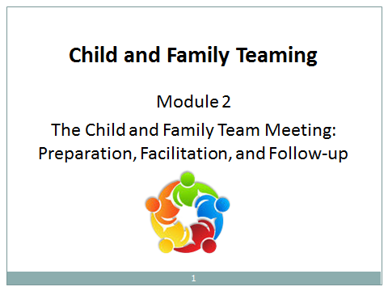  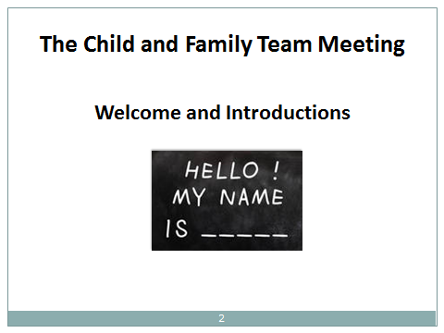
Suggested Group Agreements
- Collaboration: Partnership and trust are fundamental to engagement. Families need to have a sufficient level of trust before they can sincerely engage in addressing family problems through self-reflection. Participants may want to agree to avoid blaming or shaming others, and instead focus on the common concern for the safety and well-being of children. Remind participants that this approach is essential when working with families. Social workers and behavioral health clinicians need to be skilled in fostering collaboration in order to perform meaningful assessments.
  - Ask questions: Point out that the trainer needs the involvement of participants in the learning process in order to make the training relevant, given that people in the room have different experiences and learning needs. Asking questions allows participants to take responsibility for their learning and to benefit from the training.
  - Enjoy and have fun: Explain that being relaxed and present facilitates the group process and individual learning, which makes the day more meaningful and productive.
  - “What the heck” attitude: As professionals, we generally feel more comfortable and competent sticking to what we know. Sometimes it feels uncomfortable to consider new ideas. We may think about someone, “She doesn’t know what she’s talking about...she has never worked in our community...” But to learn something new, we may need to step out of our comfort zone. With this “What the heck!” agreement, participants become more willing to explore new ideas and approaches.
  - Make mistakes: As professionals, we don’t like to make mistakes. When we make mistakes, we feel discouraged and become self-deprecating. But mistakes are informative and an inherent part of the learning process. This agreement gives participants permission to make mistakes while exploring new territory.
  - Confidentiality: This is just a reminder that information about families or other participants shared in the training room is confidential.

Segment 2: Review Learning Objectives Knowledge, Skills, and Values

Segment Time: | 10 minutes
Trainee Content: | Learning Objectives
Slides: | 3–6

Description of Activity
The trainer facilitates a discussion about the Learning Objectives.

During the Activity

- Activity 2A  Ask for volunteers from among the participants to read one or two objectives until all the objectives have been read.  - Facilitate a conversation about prioritizing the Learning Objectives. | 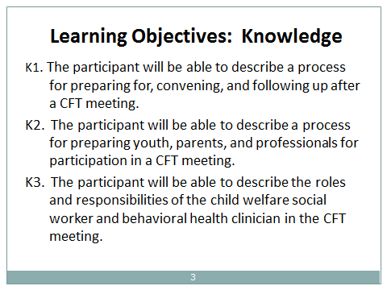  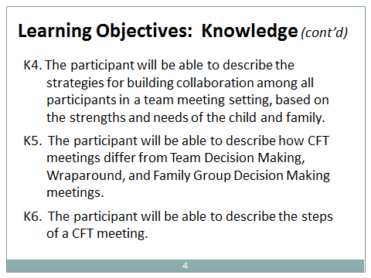  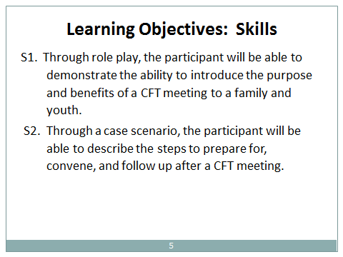  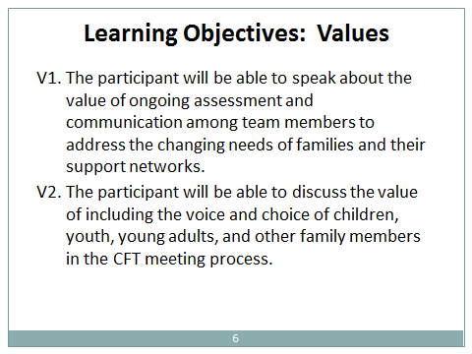

Segment 3: From Teaming Basics to the First Team Meeting

Segment Time: | 15 minutes
Materials: | Handout 3B: Eight Steps to Building a Child and Family Team and Preparing for a Team Meeting
Slides: | 7–9

Description of Activity
This segment is a review of Module 1 and a lead-in to the content in Module 2. If Modules 1 and 2 are provided on the same day, then the review of Module 1 in Activity 3A could be skipped, and the trainer could proceed directly to Activity 3B.

During the Activity

- Activity 3A  Ask participants what they remember as the main points from Module 1. Chart their responses.  - Activity 3B  Refer to the handout (also included in Module 1: “Eight Steps to Building a Child and Family Team and Preparing for a Team Meeting.” As a supplement to the points proffered by participants, provide a brief, interactive overview of Steps 1-6 that solicits audience participation (indicated in Slides 7 through 9). Set the foundation for Module 2 by noting Steps 7 and 8 of the handout.  Steps 7 and 8 of the handout are provided here for convenience.  For a quick wrap-up of this activity, explain that over the course of the teaming process, the team will: discuss initial assessments of the social worker and clinician; cultivate a wider support network for the family comprised of extended family members and community-based partners; create a plan for mental health treatment and other services and interventions; monitor the plan; adjust the plan as needed; and transition the child and family out of the child welfare system through reliance on the support network. | 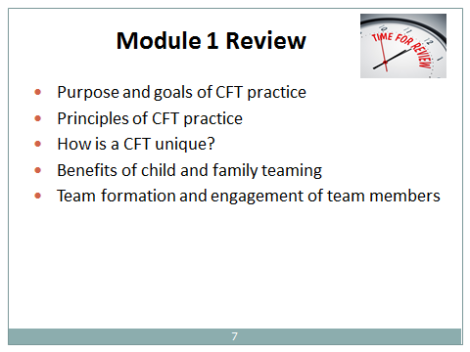  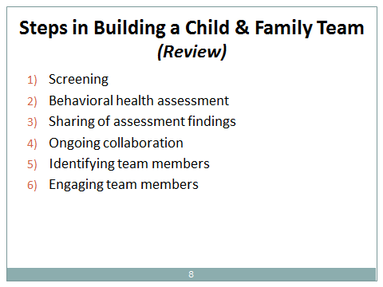  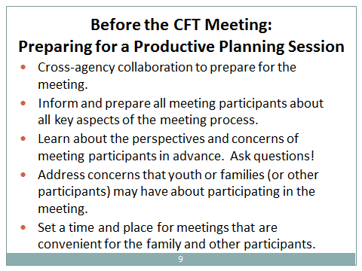

Excerpted from Handout Eight Steps to Building a Child and Family Team and Preparing for a Team Meeting, Steps 7 and 8

Step 7: Preparing for the Child and Family Team Meeting
(CFTs & CFT meetings are mandated for children who qualify for ICC and IHBS)

Cross-agency Collaboration
In preparation for the first Child and Family Team meeting, and as representatives of their respective agencies, the social worker and clinician communicate about priorities and concerns to be addressed by the team. County agencies should have clear guidelines about decision-making authority within the team in cases when there is a lack of consensus among team members. The social worker and clinician need to be aware of their county’s policies regarding decision-making authority and how it may manifest among team relationships and during CFT meetings. The social worker and clinician should also communicate with the coordinator or facilitator, if the coordinator or facilitator is another individual.

Meeting Frequency, Format, and Facilitator Choice
Meetings are held on a regular basis, or as frequently as necessary, in order to integrate the work of team members, ensure accountability, and adjust service plans and interventions according to the current situations and assessed needs of the child and family. Service and treatment plans for members of the Katie A. Subclass are required to be revisited at least every 90 days.

Counties may have a preferred meeting structure drawn from other models of family teaming such as team decision-making, family group conferencing, wraparound, or other teaming formats. In general, family meetings often include agenda components that address child and family strengths, needs and concerns, goal-setting, and conducting a brainstorming session in order to develop a plan to meet the identified goals. The plan specifies informal interventions as well as provider services. In all cases, the plan indicates who is responsible for each aspect of the plan, and the timelines involved – in short, who will do what, and when.

Family needs will also inform the level of formality and structure of team meetings, and the need for a specially trained meeting facilitator. All team members may not need to attend all meetings, providing that the work of the team is not hindered and partnership is sustained among team members. In general, Katie A. subclass members presumably require more structured, formal meetings, while team meetings for children and families with less complex needs may be less formal. For subclass members, meeting facilitators must be a mental health provider, social worker, or probation officer.

Meeting Preparation
The CFT meeting coordinator or facilitator contacts team members in advance to explain the meeting process, guidelines, and format of Child and Family Team meetings, as well as key issues that will be addressed. Team members should understand that goals and plans are developed from discussions at CFT meetings, and that timeframes are set for evaluating progress and adapting or modifying plans. Team members are also informed about the decision-making process for Child and Family Teams that is followed in their county. The agenda for the CFT meeting is distributed in advance.

Below are several explanatory points to cover with team members about the meeting process:

- Each meeting has a clearly defined purpose, goal, and agenda.
    - Family strengths and needs are identified.
    - Meeting participants follow an agreed-upon decision-making process.
    - Meetings include time for brainstorming and generating options for interventions, services, and goal achievement.
    - Meetings involve the development of action plans and timelines using the best ideas of the child/youth, family, and other team members that address:
      - Concerns regarding safety and risk
      - Treatment and services for behavioral health needs
      - Other prioritized concerns related to the well-being of the child/youth and family
      - Alignment of goals with the family and among the service providers
      - Informal interventions and enhancement of the family’s natural support network
      - Supporting the family in the operationalization of the action plan
      - Monitoring progress towards goals and revising action plans accordingly
      - Reunification or other forms of permanency, and the transition out of the child welfare system, with community supports in place
As part of the explanation of the CFT meeting, the coordinator or facilitator engages team members by inquiring about their perspectives regarding the child’s and family’s well-being. The coordinator/facilitator also addresses any concerns that a team member may have about the meeting process.

During the meeting preparation phase, the family and agency staff decide whether or not a young child who is the focus child (or another young family member) should be included in the meeting. This judgment is based on a consideration of the child’s developmental level, the child’s preferences, and whether or not the child would benefit from participating in the meeting. In general, adolescents should be active participants in CFT meetings, providing there is no outstanding concern that meeting participation would be detrimental to the youth. Children and youth who are expected to benefit from meeting participation should be included in the CFT meeting in a way that fits their individual developmental level.

Some questions that a coordinator/facilitator (and the social worker and clinician) can use to engage family members, youth, and caregivers to prepare for a meaningful meeting are provided below. (Staff may want to add other questions that are specific to a family’s situation.) In order to identify the youth’s concerns about the meetings, separate and individualized conversations with the youth are advised. The purpose of having such discussions before the meeting is two-fold: (1) to provide the team member a chance to articulate her/his viewpoints in advance and become acquainted with the purpose and process of the meeting; and (2) to provide the staff with important information that can raise their sensitivity and compassion to the needs and concerns of the child and family and promote the effectiveness and efficiency of the meeting process. These preliminary conversations are valuable.

Questions for family members and caregivers (adaptable for youth):

- What do you see as [your] [child and family] strengths?
- What concerns do you have [about the child or family]?
- What types of assistance and support do you think is needed [by the child or family]?
- What would you like team members to know about your family’s experiences, culture and values?
- What would you need in order to feel safe participating in this meeting?
- What results would you like to see from this meeting?
- Describe what success is for your family. What would [a specific family member or support person] be doing differently when you achieve success?
- What are the best place and time to hold the Child and Family Team Meeting (convenience, comfort, etc.)?

Additional questions for youth are:

- What do you need [from family, support network, or other resources]?
- What do you want team members to know about you?
- If we invited all the people who care about you to come to the meeting, what would be some good results that might come from their participation?
Step 8: Scheduling and Locations for CFT Meetings
The coordinator/facilitator is responsible for scheduling the time and place of the meeting in accordance with the family’s preferences. Arrangements should take into account team members’ schedules and time constraints to the greatest extent possible in order to maximize participation. The meeting space should be comfortable, welcoming, and large enough to accommodate the team.

Segment 4: Facilitation of the CFT Meeting

Segment Time: | 25 minutes
Materials: | Handout 4A: CFT Meeting Structure  Handout 4B: Facilitating the CFT Meeting
Slides: | 10–16

Description of Activity
Through a lecture, this segment describes the structure and facilitation of the CFT meeting.

Tip: As a point of clarification: The “coordinator” of the team may also serve as the “facilitator” in some cases. The term “facilitator” will be used in this segment to refer to activities connected to planning and facilitating CFT meetings.

During the Activity

- Activity 4A  Deliver a lecture that briefly highlights the main points in Handout 4A, “CFT Meeting Structure.” Review slide 10.  This activity should be a brief overview, since details of facilitation for each component of the CFT meeting will be addressed more thoroughly in Activity 4B. Devote more time to Activity 4B.  - Activity 4B  Provide a more detailed explanation of the main points in Handout 4B, “Facilitating the CFT Meeting.” (Some of the information in this handout is tailored specifically to the initial meeting.)  Tip: Note that Items #6 and #7 on this handout will be covered in Segments 7 and 8, respectively, so they do not need to be covered here. | 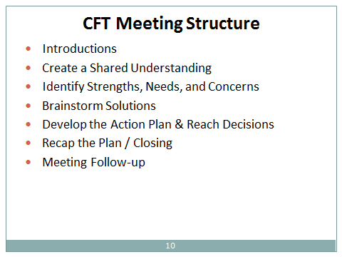  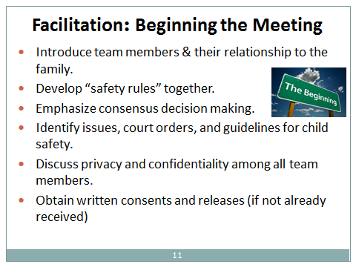  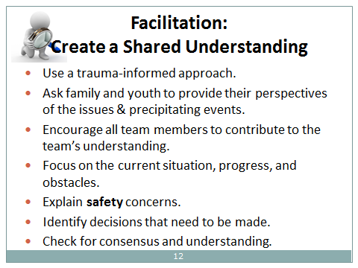  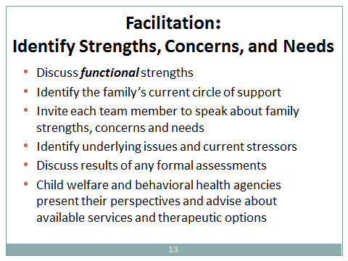  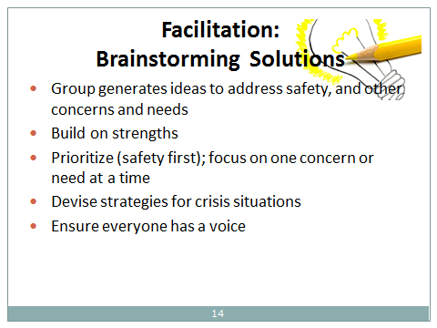  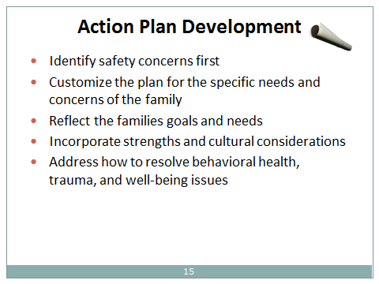  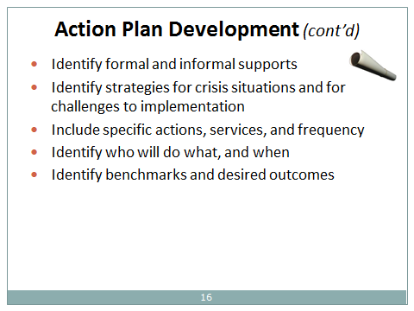

Segment 5: Facilitation Practice

Segment Time: | 55 minutes
Materials | Handout 4A: CFT Meeting Structure, Steps 1-5  Handout 4B: Facilitating the CFT Meeting, Steps 1-5  Handout 5A: Skill Practice for Facilitating Team Meetings
Slide: | 17

Description of Activity
This segment is comprised of experiential role plays. Suggested role plays are found in Handout 5A, “Skill Practice for Facilitating Team Meetings.”

Before the Activity

- Activity 5A: Prepare a sufficient number of copies of the role plays and observer worksheets for distribution to small groups of participants, according to the number of roles in the scenarios. Plan in advance the scenarios you are most likely to use.

During the Activity

- Activity 5A  The trainer instructs participants to conduct a series of role plays, using the steps detailed below. The role plays concern how to conduct an effective Child and Family Team Meeting. Encourage participants to refer to Handout 4A, “CFT Meeting Structure,” Steps 1-5, and Handout 4B, “Facilitating the CFT Meeting,” Steps 1-5, to help them with ideas for their roles.  - Training Tips:  - Introduce the activity and explain the role-play instructions. Emphasize that role-playing provides participants with an opportunity to apply their new knowledge, skills, and tools in situations that simulate actual family interactions. Let participants know that the lead role has been designated “facilitator.” Even if they never act as the team facilitator, these communication skills are critical for all child welfare and behavioral health staff.  - Select the scenarios you will use. Each scenario has different sets of role play participants. Break participants into groups of 3-9, depending upon the number of actors required for each scenario. Assign scenarios to each group. Most scenarios are designed for groups of 3 (#1, #3, #4, and #5). Scenario #2 is for 5-6 participants, and scenario #6 is for 9 participants.  Ask groups to select one participant to be an observer and another to be the facilitator. Direct others as indicated in the scenario. If instructive for the scenario, participants could assume additional non-specified roles as a child, parent, social worker, behavioral health clinician, or other support person to lend those perspectives in the debrief portion of this exercise. Instruct groups to focus on the facilitation steps covered in Handouts 4A, “CFT Meeting Structure” (Steps 1-5) and 4B, “Facilitating the CFT Team” (Steps 1-5) and covered in slides 10-16. Review basic expectations for each type of role with the participants.  - Distribute role-play materials to the actors and the observer. Give each participant a copy of the description of the scenario. Give “observers” the role play observation worksheet describing the case-specific issues they should identify.  - Give the groups 10 minutes to conduct the role play. Circulate among the groups to answer any questions that may arise and provide guidance as needed.  6. Instruct each group to discuss the role play. After the small groups have finished, ask the groups to spend five minutes discussing what happened during the role play. Encourage participants to provide constructive criticism during their discussions and to take a short break, if needed, before resuming the role play with re-assigned roles. The groups should discuss the following questions:  - What transpired between the facilitator and team participants?  - What did the facilitator do that was effective?  - What might the facilitator consider doing differently?  7. Rotate roles and repeat steps 1-6. Participants should rotate roles within their small groups, or substitute a new scenario. If the small groups each work on different role plays, the groups can pass along their role play materials to the neighboring group. In either case, it is preferable that each participant has a chance to play the role of facilitator during the activity. | 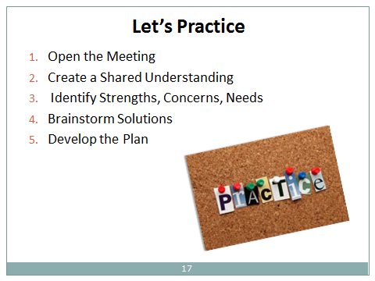

Segment 6: Discussion of Facilitation Exercise

Segment Time: | 20 minutes
Slide: | 18

Description of Activity
In this segment, the trainer facilitates a large group discussion to “debrief” the role plays in Segment 5.

During the Activity

- Activity 6A  Prompt the discussion by asking the following questions:  Process the activity. After the groups have completed three rounds of role plays in Segment 5, conduct a discussion in the large group using the following questions:  While playing the role of the facilitator:  - What was your experience as a facilitator? What challenges did you encounter?  - How did it feel to integrate new content, techniques, and job aids into your interactions? How well were you able to listen for the child/family voice?  - Did the family or team participants raise issues or questions that you did not know how to answer?  While playing the role of the family or team participant:  - Were you able to understand and use the information the facilitator gave you?  - Did the facilitator adequately address your questions related to the CFT meeting?  - Were you comfortable asking questions?  - Did the facilitator address all of your worries related to the CFT meeting?  - Did you feel safe, respected, and heard?  While playing the role of the observer  - Did the facilitator create a comfortable environment?  - Did the facilitator build adequate engagement with the team participants?  - Can you share some examples of interesting interactions and creative solutions that you observed in the role plays?  General – for the entire group  - Did team members experience how it felt to be encouraged?  - Can you name the steps in facilitating a CFT? | 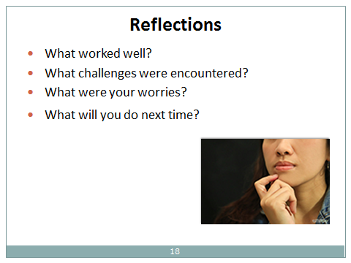

Segment 7: Closing a Meeting

Segment Time: | 5 minutes
Materials | Handout 4B: Facilitating the CFT Meeting, Step #6
Slide: | 19

Description of Activity
In this segment, emphasize that meeting closure is an important part of the meeting process.

During the Activity

- Activity 7A  Lecture on the following points from Handout 4B, “Facilitating the CFT Meeting,” Step #6 (reproduced below).  6. Closing/Recapping the Meeting  a) The facilitator reviews the plan that has been developed by the team. Assigned tasks and time frames should be reiterated and reaffirmed by the responsible members.  b) The facilitator should also remind the team that their work is an ongoing process that includes a series of meetings to address changes over time. Acknowledge that the plan may not get everything “right” the first time. Some things will work; others may not. The team will build on the plans that worked, identify what was not effective, and create new solutions.  c) If copies of the plan or meeting summary can be made and distributed to the members at the close of the meeting, team members should be asked to sign it.  d) The facilitator establishes a schedule for future meetings with team members. Plans for recipients of ICC (including members of the Katie A. subclass) must be revised at least every 90 days.  e) The facilitator asks the team to provide their reflections and evaluation of the meeting.  f) The facilitator closes the meeting by thanking the team members for participating and acknowledging their contributions. | 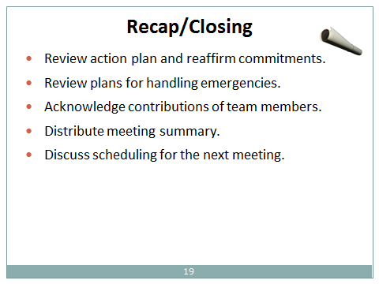

Segment 8: After the Meeting

Segment Time: | 5 minutes
Materials: | Handout 4B: Facilitating the CFT Meeting, Step #720
Slide: | 20

Description of Activity
This segment addresses follow-up and ongoing team collaboration after the completion of a meeting.

During the Activity

- Activity 8A  Lecture on the points listed below which are excerpted from Handout #4B, “Facilitating the CFT Meeting,” Item #7 (reproduced below).  7. CFT Meeting Follow-Up  - A summary of the meeting, including the details of the family’s plan, should be written and documented in the respective case files of the child welfare and behavioral health agencies.  - The summary and family plan should be distributed to team members (if copies were not made at the meeting).  - Team members support the youth and family in implementing the action steps.  - As part of the case management process, the social worker maintains contact with team members to monitor progress on the action steps.  - The behavioral health clinician follows up with team members as needed on matters related to the treatment plan.  - The social worker and behavioral health clinician confer to monitor progress on the case plan and treatment plan, and to plan tentative discussion topics for the next meeting. These conversations should be documented in the respective case files.  - The continuity of core team members should be maintained, and team members should be invited to subsequent meetings.  - Family members, support persons, and service providers identify any new issues that arise and communicate about successes to the child welfare and/or behavioral health professionals.  - The facilitator (or other responsible party) arranges for subsequent team meetings at regular intervals, or as needed, according to the needs of the child. Recall that plans for recipients of ICC must be revised at least every 90 days.  - Follow the plan arranged with team members regarding facilitation for future meetings. For example, meetings may be led by the same facilitator, co-led by the social worker and behavioral health clinician, or alternately led by the social worker and behavioral health clinician. Some agencies may have designated staff who serve as facilitators. The facilitator is an integral part and permanent member of the child and family team. Consistency in the facilitator role is important for the success of the team’s process. | 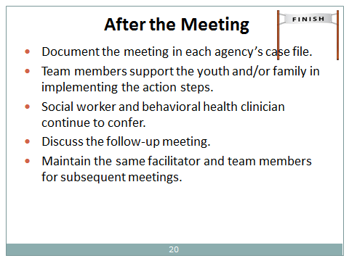

Segment 9: Challenges

Segment Time: | 35 minutes
Materials | Handout 9A: Potential Challenges That May Be Encountered When Conducting CFT Meetings
Slides | 21–24

Description of Segment:
This segment addresses challenges that may arise during a meeting.

During the Activity

- Activity 9A  Sort participants into small groups. Ask them to brainstorm potential challenges related to organizing and facilitating a Child and Family Team Meeting. Allow 10 minutes. Facilitate a report out and write participants’ responses on an easel pad. Then draw attention to Handout 9A: “Potential Challenges That May Be Encountered When Conducting CFT Meetings.”  Lead a large group discussion about suggestions for handling challenges by referring to the participants’ responses and to any additional examples in the handout that were not mentioned (noted on slides 22-24 and listed below).  - Trainer Tips  Logistical challenges:  - Scheduling the meeting for a day, time, and location that meet the needs of the youth and family.  - Providing child care.  Engagement challenges prior to the meeting:  - Getting key people to attend and participate in the meeting: e.g., family members, youth, informal supports, community partners, and service providers.  - Child/youth refuses to attend the meeting.  - Child/youth does not want a parent at the meeting.  Facilitation challenges during the meeting:  - Child/youth does not engage during the meeting.  - Parent or other adults speak for the child and quash the child’s voice.  - Keeping the family voice foremost.  - Relatives or family support persons overwhelm the meeting.  - Family conflicts.  - Disagreements on goals, services or supports.  - Meeting runs long or loses focus.  - Creating the right plan.  Communication Challenges:  - Exercising cultural humility/cultural sensitivity to the child and family.  - Facilitating the family’s understanding of the child welfare and mental health systems without resorting to jargon and acronyms.  - Clarifying the meeting purpose and roles of team members.  - Maintaining confidentiality.  Administrative challenge:  - Meeting the requirements of child welfare case plans and clinical treatment plans in a manner that supports the family’s success but avoids placing undue burdens on family members. | 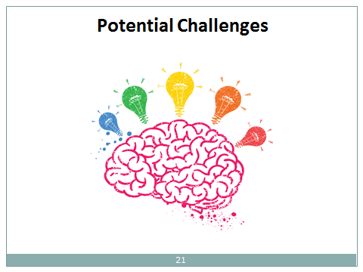  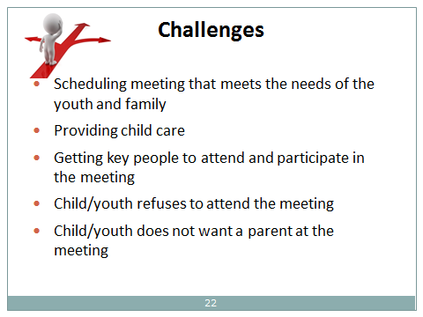  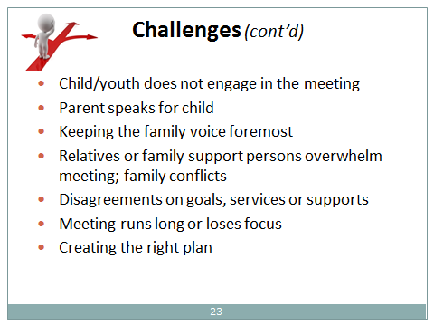  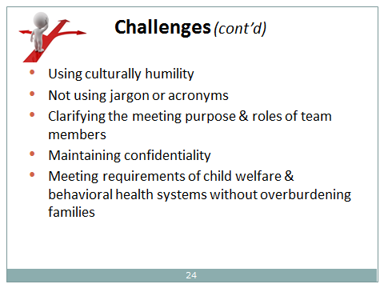

Segment 10: Summary and Evaluation

Segment Time: | 10 minutes
Slide: | 25

Description of Activity
This segment encourages participants to reflect on the information covered in Modules 1 and 2. Participants complete customary course evaluations.

During the Activity

- Activity 10A  Facilitate a conversation regarding the points and questions below. Use the concept of a “Circle of Support” (below) as a place to start the discussion:  - Utilizing the CFT approach is not just about our practice of teaming. It is also about building an ongoing Circle of Support for the family to achieve safety, permanency and well-being for their child(ren). The Circle of Support continues long after the family’s involvement in the child welfare system ends.  Ask participants:  - What other thoughts do you have about the effectiveness of child and family teaming and team meetings?  - What aspects of child and family teaming do you think would be the most challenging for you, and why?  - What additional supports do you think you will need to excel in your work as a team member and facilitator?  - What questions do you have remaining?  - Instruct participants to complete the course evaluation (not included in this guide). | 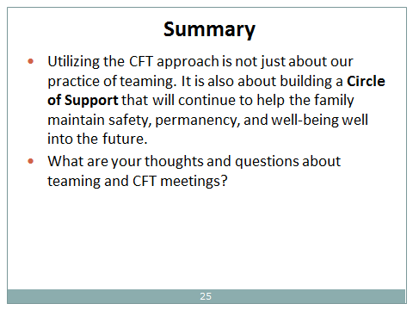

Trainee Handouts

Activity 3B: Eight Steps to Building a Child and Family Team and Preparing for a Team Meeting
Activity 4A: CFT Meeting Structure
Activity 4B: Facilitating the CFT Meeting
Activity 5A: Skill Practice for Facilitating Team Meetings (CFT Role Plays, Observer Worksheet)
Activity 9A: Potential Challenges That May Be Encountered When Conducting CFT Meetings:

Handout for Activity 3B

Eight Steps to Building a Child and Family Team and Preparing for a Team Meeting

Step 1: Screening
All children entering the child welfare system will be screened for mental health needs. This initial screening does not need to be administered by a behavioral health clinician and can be conducted by child welfare practitioners. The screening is used to indicate a possible need for a more in-depth mental health assessment that is conducted by a mental health professional. Each county decides which evidence-based screening tool to use for this purpose. After the initial screening, a mental health screening tool should be administered at least annually for all children with open cases.

If a mental health need is identified by the screening tool, a referral is made to county behavioral health staff for additional mental health assessment services. The social worker engages the family in a discussion about the results of the mental health screening and the need for a referral for further assessment by a mental health professional. Protocols and procedures for referrals vary among counties. At this time, the social worker may introduce the concept of the Child and Family Team to the family and may also encourage them to begin thinking about potential members for their team if mental health services should be needed.

If a child is already known to be receiving mental health services, the social worker engages the family to obtain the necessary releases required before contacting the mental health provider.

(Note that the screening for mental health needs upon entry into the child welfare system is done in conjunction with an overall initial child welfare assessment to identify strengths and needs, and issues that affect the safety, permanency, and well-being of children.)

Step 2: Behavioral Health Assessment
If the initial screening indicates that behavioral health services may be needed, a behavioral health clinician conducts a more comprehensive and in-depth, strength-based assessment of the child and family. The assessment addresses underlying needs and mental health concerns, as well as a broad assessment of psychosocial risk factors related to the child’s environment. The assessment should include a trauma component and a clinical evaluation of current functioning. The clinical assessment establishes the medical necessity for Specialty Mental Health Services (SMHS) required as a criterion for eligibility for intensive behavioral health services (and classification as a member of the Katie A. subclass).

The behavioral health practitioner explains the assessment process to the youth and family so that they know what to expect. Pursuant to ethical and legal mandates, the behavioral health clinician also discusses confidentiality, privacy, mandated reporting and releases of information. During the course of the mental health assessment, the behavioral health clinician promotes understanding of the Child and Family Team approach and encourages the family/youth to share information with the social worker and other members of the team (once formed) in order to attain goals for mental health and well-being and transition out of the child welfare system.

Step 3: Sharing of Assessment Findings
The results of the assessment and recommendations for treatment and/or services will be discussed with the child/youth and family, the social worker (pending releases of information) and the behavioral health clinician assigned to the case. These discussions give the family an opportunity to voice their ideas and perspectives about treatment and services to the social worker and clinician in preparation for drafting an initial plan with all members of the Child and Family Team.

During this phase, the behavioral health professional provides introductory information to the child and family regarding the potential goals of treatment, what to expect generally in the treatment process, and all mandated and customary explanations about legal and ethical issues related to therapy.

The behavioral health clinician also informs the social worker and the youth/family if the in-depth mental health assessment and other criteria indicate that the child qualifies for receipt of intensive care coordination (ICC) and, if medically necessary, intensive home-based services (IHBS) and/or other mental health services, such as Day Treatment Rehabilitative or Day Treatment Intensive, Group Therapy, or Therapeutic Behavioral Services, (TBS). In addition, protocols for the provision of Therapeutic Foster Care (TFC) are currently under development as another treatment option. With the family’s permission (as granted by written releases of information), the clinician may also discuss the results with other agency representatives and team members who participate on the Child and Family Team.

Tip: The social worker and behavioral health clinician should:

- State to family members the importance of meeting the full array of the child’s/youth needs.
- Reiterate the intent to assist the child and family in meeting those needs.
- Inform the family that referrals will be made to the appropriate health care provider or other service provider(s).
- Ask the family and child or youth (if developmentally appropriate) to confirm their understanding of the process for receiving services, and invite them to ask questions.
Step 4: Ongoing Collaboration Between Child Welfare and Behavioral Health Staff
In preparation for the teaming process (and after obtaining the necessary releases of information), the social worker and clinician confer about priorities and concerns for the child and family, based on what each has learned to date through casework and clinical information obtained by their respective agencies. The caseworker and treating clinician confer as needed throughout the teaming process. Their contact is not limited to Child and Family Team meetings.

In addition, child welfare and behavioral health staff each work independently and collaboratively to:

- Establish trusting, helping relationships with and among team members
- Engage the participation, commitment, and accountability of team members
- Engage child and family strengths
- Demonstrate genuine interest in the diverse perspectives and narratives of team members
- Demonstrate respect for the child’s and family’s culture and values
Step 5: Identifying Team Members
The social worker and clinician each work with the youth and family to identify supportive individuals in their social network who would be available and motivated to participate as members of their Child and Family Team. For example, team members may be drawn from maternal and paternal relatives, tribal members, foster parents, school personnel, clergy, parent/family support partners, friends, neighbors, CASAs, substance abuse counselors, youth specialists, and other service providers. Of many possible types of team participants, it is essential to have a coordinator, a facilitator for team meetings, and a family support partner or family specialist for youth. (The coordinator and facilitator may be the same person.) As appropriate, agency staff and the family may also consider inviting team participation from representatives of other child- and family-serving systems, such as education, medical care, developmental disabilities, and juvenile justice. Ask the family and children/youth to state the individuals they want on their team, and how to get in touch with them.

If the child qualifies for Intensive Care Coordination (ICC) services, such services must be managed by a mental health ICC coordinator. Intensive Care Coordination is fully integrated into the Child and Family Teaming process. The Child and Family Team serves as the primary vehicle for delivering services in accordance with the Pathways to Well-Being Core Practice Model (Medi-Cal Manual, 2013, p. 20; currently under revision). ICC services include active participation of ICC staff on the team and oversight of the team’s planning and monitoring process to ensure that the mental health needs of the child or youth are met.

The ICC coordinator secures the participation of the child or youth, family or caregiver, and significant others, and upholds the values and philosophy of the Pathways to Well-Being Core Practice Model in the assessments and planning conducted by the team. The ICC coordinator is skilled at engaging individuals, inspiring the commitment of team members, and identifying resources that will be of assistance to the family. Depending on county protocols, the ICC coordinator may have the chief responsibility for creating the team. The ICC coordinator may also serve as the team’s facilitator. The facilitator must be a mental health provider, social worker, or probation officer. The necessity for a specially trained facilitator is dictated by the needs of the child and family.

Step 6: Engaging Team Members
For all children in need of mental health services, a designated coordinator or facilitator ensures that all team participants, including family members, providers, and new team members, are contacted and provided with an overview of the teaming process. (County procedures may vary regarding which staff are responsible for this task.) During these introductory conversations, agency staff and members of the family’s support network begin building the trusting relationships needed to sustain the Child and Family Team over time.

Team members are informed about their respective roles, the structure of CFT meetings, the decision-making process, and the means for achieving transparent communication within the team. In this initial contact and throughout the teaming process, the importance of drawing on the child’s and family’s strengths and needs is emphasized. An explanation is provided to new team members about how strengths and needs are integrated into planning goals, interventions, and services for the child and family. The process of developing, monitoring and adapting service plans is also discussed. New members are also briefed about the priority for building the family’s informal, community-based support network.

Child and Family Team members “work to reach agreement about services, safety, well-being (e.g., meeting critical developmental, health, education, and mental health needs), and permanency” (Medi-Cal Manual, 2013, p. 8; currently under revision). An effective Child and Family Team communicates in a transparent manner and ensures that services are well coordinated. Ongoing communication among team members may be conducted through telephone calls, conference calls, and/or emails, in addition to in-person meetings (according to confidentiality standards, the Health Insurance Portability and Accountability Act (HIPPA), Protected Health Information (PHI) and Public Information standards) (Core Practice Model Guide, 2013).

Step 7: Preparing for the Child and Family Team Meeting
(CFTs & CFT meetings are mandated for children who qualify for ICC and IHBS)

Cross-agency Collaboration
In preparation for the first Child and Family Team meeting, and as representatives of their respective agencies, the social worker and clinician communicate about priorities and concerns to be addressed by the team. County agencies should have clear guidelines about decision-making authority within the team in cases when there is a lack of consensus among team members. The social worker and clinician need to be aware of their county’s policies regarding decision-making authority and how it may manifest among team relationships and during CFT meetings. The social worker and clinician should also communicate with the coordinator or facilitator, if the coordinator or facilitator is another individual.

Meeting Frequency, Format, and Facilitator Choice
Meetings are held on a regular basis, or as frequently as necessary, in order to integrate the work of team members, ensure accountability, and adjust service plans and interventions according to the current situations and assessed needs of the child and family. Service and treatment plans for members of the Katie A. subclass are required to be revisited at least every 90 days.

Counties may have a preferred meeting structure drawn from other models of family teaming such as team decision-making, family group conferencing, wraparound, or other teaming formats. In general, family meetings often include agenda components that address child and family strengths, needs and concerns, goal-setting, and conducting a brainstorming session in order to develop a plan to meet the identified goals. The plan specifies informal interventions as well as provider services. In all cases, the plan indicates who is responsible for each aspect of the plan, and the timelines involved – in short, who will do what, and when.

Family needs will also inform the level of formality and structure of team meetings, and the need for a specially trained meeting facilitator. All team members may not need to attend all meetings, providing that the work of the team is not hindered and partnership is sustained among team members. In general, Katie A. subclass members presumably require more structured, formal meetings, while team meetings for children and families with less complex needs may be less formal. For Subclass members, meeting facilitators must be a mental health provider, social worker, or probation officer.

Meeting Preparation
The CFT meeting coordinator or facilitator contacts team members in advance to explain the meeting process, guidelines, and format of Child and Family Team meetings, as well as key issues that will be addressed. Team members should understand that goals and plans are developed from discussions at CFT meetings, and that timeframes are set for evaluating progress and adapting or modifying plans. Team members are also informed about the decision-making process for Child and Family Teams that is followed in their county. The agenda for the CFT meeting is distributed in advance.

Below are several explanatory points to cover with team members about the meeting process:

- Each meeting has a clearly defined purpose, goal, and agenda.
    - Family strengths and needs are identified.
    - Meeting participants follow an agreed-upon decision-making process.
    - Meetings include time for brainstorming and generating options for interventions, services, and goal achievement.
    - Meetings involve the development of action plans and timelines using the best ideas of the child/youth, family, and other team members that address:
      - Concerns regarding safety and risk
      - Treatment and services for behavioral health needs
      - Other prioritized concerns related to the well-being of the child/youth and family
      - Alignment of goals with the family and among the service providers
      - Informal interventions and enhancement of the family’s natural support network
      - Supporting the family in the operationalization of the action plan
      - Monitoring progress towards goals and revising action plans accordingly
      - Reunification or other forms of permanency, and the transition out of the child welfare system, with community supports in place
As part of the explanation of the CFT meeting, the coordinator or facilitator engages team members by inquiring about their perspectives regarding the child’s and family’s well-being. The coordinator/facilitator also addresses any concerns that a team member may have about the meeting process.

During the meeting preparation phase, the family and agency staff decide whether or not a young child who is the focus child (or another young family member) should be included in the meeting. This judgment is based on a consideration of the child’s developmental level, the child’s preferences, and whether or not the child would benefit from participating in the meeting. In general, adolescents should be active participants in CFT meetings, providing there is no outstanding concern that meeting participation would be detrimental to the youth. Children and youth who are expected to benefit from meeting participation should be included in the CFT meeting in a way that fits their individual developmental level.

Some questions that a coordinator/facilitator (and the social worker and clinician) can use to engage family members, youth, and caregivers to prepare for a meaningful meeting are provided below. (Staff may want to add other questions that are specific to a family’s situation.) In order to identify the youth’s concerns about the meetings, separate and individualized conversations with the youth are advised. The purpose of having such discussions before the meeting is two-fold: (1) to provide the team member a chance to articulate her/his viewpoints in advance and become acquainted with the purpose and process of the meeting; and (2) to provide the staff with important information that can raise their sensitivity and compassion to the needs and concerns of the child and family and promote the effectiveness and efficiency of the meeting process. These preliminary conversations are valuable.

Questions for family members and caregivers (adaptable for youth):

- What do you see as [your] [child and family] strengths?
- What concerns do you have [about the child or family]?
- What types of assistance and support do you think is needed [by the child or family]?
- What would you like team members to know about your family’s experiences, culture and values?
- What would you need in order to feel safe participating in this meeting?
- What results would you like to see from this meeting?
- Describe what success is for your family. What would [a specific family member or support person] be doing differently when you achieve success?
- What are the best place and time to hold the Child and Family Team Meeting (convenience, comfort, etc.)?

Additional questions for youth are:

- What do you need [from family, support network, or other resources]?
- What do you want team members to know about you?
- If we invited all the people who care about you to come to the meeting, what would be some good results that might come from their participation?
Step 8: Scheduling and Locations for CFT Meetings
The coordinator/facilitator is responsible for scheduling the time and place of the meeting in accordance with the family’s preferences. Arrangements should take into account team members’ schedules and time constraints to the greatest extent possible in order to maximize participation. The meeting space should be comfortable, welcoming, and large enough to accommodate the team.
Handout for Activity 4A
CFT Meeting Structure

The CFT meeting structure provides a problem-solving, solution-focused approach to decision making. The problem-solving approach enables meeting participants to understand fully the situation and examine possible solutions while helping to ensure that decisions are made without haste and personal bias. The perspectives and opinions of family members and youth are essential, and all team members are encouraged to be active meeting participants. An easel pad is generally used to record the discussion while in progress, and typed copies of the meeting summary and family plan are provided to team members after the meeting concludes or as soon as possible thereafter.

The six stages of the meeting and the topics discussed in each are listed below:

(1) Introduction
- Introduction of team members, roles and relationship to child/family/case
- Setting of group agreements for the meeting’s guidelines/safety rules
- Explanation of confidentiality, laws and regulations, and any applicable court orders
- Statement of purpose and goals
- Presentation of concept regarding building on strengths
- Description of decision making: consensus vs. unanimity
- Questions from team members are addressed

(2) Create a Shared Understanding of the Current Situation
- Family/youth perspective of situation
- Usage of trauma-informed approach by professional staff to discuss and address any trauma-related experiences of the child or family
- Descriptions of relevant history and the immediate precipitating event
- Explanation of safety concerns and court orders and their prioritization
- Identification of decisions that need to be made

(3) Identify Strengths, Needs, and Concerns
- Discussion of functional strengths (actual skills and abilities that manifest in actions)
- Identification of external supports among extended family, tribe, and community
- Discussion of needs, concerns, and current stressors
- Identification of underlying issues, incorporating a trauma-informed approach
- Exploration of the effectiveness of services received by the family to date. (If available, existing case plans and treatment plans are discussed.) What has, or has not, worked for the youth/family in the past?
- Discussion of any formal assessments that have been conducted to date.
- Perspective/services of child welfare agency are presented
- Perspective/treatment options of behavioral health agency are presented

(4) Develop Solutions
- Brainstorming of recommendations to provide safety and protection, and ideas for addressing behavioral health and related concerns
- Include strategies for crisis situations, or gaps in implementation
- Ensure everyone participates

(5) Develop the Plan/Reach Decisions
- Safety plans are prioritized and must be addressed
- Using consensus, and with the preference and agreement of family members, action plans are developed and tasks are assigned to team members, noting who will do what, and by when
- The action plan rests on timely linkages to services, including the identification of prioritized services that require immediate referrals and follow-up

(6) Recap/Closing
- Review the plan so that all team members reaffirm their commitments
- Recap how the team will handle any difficulties with implementing the plan or emergencies that might arise before the next meeting
- Discuss scheduling for subsequent meetings
- Acknowledge contributions of team members
- Complete, copy, and distribute CFT Meeting Plan or Summary to team members, or advise team members when they should expect to receive a copy of the plan
- Explain that the plan will be documented in the case files of the child welfare and behavioral health agencies

(7) CFT Meeting Follow-Up
- Team members support the youth and family in implementing the action steps
- Responsible parties monitor the portions of the plan for which they are responsible
- The social worker and behavioral health clinician continue to confer with one another and follow up with team members regarding the case plan and treatment plan
- New issues that arise between meetings should be conveyed to the ICC Coordinator (if the child receives ICC services); the social worker; and the behavioral health clinician
- Arrange for subsequent team meetings. Plans for recipients of ICC services must be revised at least every 90 days.

Handout for Activity 4B
Facilitating the CFT Meeting

Child and Family Team Meetings are considered the family’s meeting. Meetings should be structured and facilitated to ensure that all parties incorporate the family’s strengths and, further, that the family’s goals and preferences drive intervention strategies and plans. Meetings should be conducted in an engaging style that addresses the relevant issues in the most sensitive, respectful manner possible, and yet acknowledges the realities of the situation with honesty and integrity. With respect to court orders and/or issues of child safety, it is imperative that these matters are handled in a forthright manner, with the team’s commitment to support the family in addressing them successfully.

What follows are descriptions of the elements of a CFT meeting, presented in a recommended, typical sequence that helps meetings progress logically and predictably. In the end, however, engaging and ensuring inclusion of the family while making decisions is the primary requirement of a successful CFT meeting. Meetings will likely be more frequent at the start of the services as emergent issues are addressed and the larger context of the family’s needs and strengths are explored and identified. For recipients of ICC services, the team’s plans must be revised at least every 90 days.

It is recommended that easel pad pages are prepared in advance with the meeting’s agenda, purpose and goals. (The purpose and goals of each meeting are identified in advance with input from members of the team and confirmed or adjusted at the start of the meeting.) Headings should be indicated on additional easel pad pages for: immediate concerns, family strengths, family needs, the team’s ideas, and action steps that will be developed and/or evaluated during the meeting. If decisions made in a prior meeting need revision or follow-up for accountability and evaluation of success, they should be included in the agenda. Charting notes on the easel pad during the meeting helps to keep everyone on track and capture vital information that should be shared.

Child and Family Team Meetings should generally include the following activities:

1. Introductions
The facilitator opens the meeting by welcoming all participants, reviewing the agenda, and identifying the purpose and goals of the meeting. There are several critical components to this stage of the meeting:
a) Introduction of all team members and their relationship to the family. Consider having participants state their preferred gender pronouns (PGP).
b) Establishing Safety Rules: The facilitator helps the team develop and agree on guidelines or “safety rules” for the meeting. These are collaboratively developed to help individuals manage strong emotions and to maintain a focus on the purpose and goals of the meeting. Examples include: speaking one at a time; using appropriate language and tone; and being respectful of others’ perspectives, experiences, and cultures. While initially developed at the first meeting, guidelines are reviewed and amended as needed at the start of every meeting.
c) An opening statement emphasizes that the Child and Family Team will seek a consensus decision that meets the needs of the child and family in the least restrictive, least intrusive manner possible. The facilitator provides a reminder that consensus means agreement to support the decision, if that is the family’s expressed preference, irrespective of individual differences regarding the specific course of action to be followed. This allows families to learn from their successes and mistakes and to devise improvements based on what does or does not work. However, the responsibility to ensure the safety of children is always present and is non-negotiable when making decisions. While it is important to recognize legal and ethical mandates, child safety is a shared responsibility of the whole team, not just that of the participating professionals.
d) Additional non-negotiable issues, such as court orders, compliance with laws and regulations, including exceptions to confidentiality protections, should be made explicit in the beginning of each meeting.
e) A brief discussion of confidentiality and family privacy is included in every meeting, specifying the conditions under which professional team members are unable to keep some information confidential. All team members are asked to agree to respect the privacy of the family before the meeting proceeds.
Note: While a signed confidentiality statement is not legally binding, some counties may want team members to sign an agreement that they will maintain the confidentiality of the family and what is discussed at the meeting. After privacy and confidentiality are discussed, each team member can be asked to sign a confidentiality agreement that can be kept in the case record.
f) Team members are encouraged to ask any questions they may have about the meeting or teaming process.
g) Emphasize that the family is the expert on their own needs and their own children (even if they do not presently hold custodial rights), and that the child and family team process is designed to elicit and build upon the family strengths and values.

2. Creating a Shared Understanding
a) Identify the current situation; what precipitated the need for the meeting; and what decisions are needed. The child and/or family should be invited to share their understanding of what has led to this team meeting. If the family is uncomfortable with beginning the conversation, the facilitator or a team member of the family’s choosing can present this information. If the facilitator presents the situation first, the family will be invited to clarify or comment on anything that is presented before moving on. It is important that the family identify their concerns and articulate how they see themselves in this situation. Creating a shared understanding provides some background and history (including what has worked successfully in the past), but should focus on the current situation, the progress made, and the obstacles that remain for achieving safety, stability, and well-being for the child and the family.
b) The facilitator should help professionals integrate information presented in the meeting, mirror what the family has stated about their concerns, and draw connections between the family’s perspective and the contributions of other team members. To the greatest extent possible, child welfare and behavioral health staff should support the child and parents/caregivers in describing their situations, concerns, values, and the results they would like to achieve through the team’s planning process. Staff might also encourage the family to offer a vision of what life would be like in their family if hardships were overcome. The family speaks first, and then professional staff and support persons follow. Emphasis is on the current situation. The facilitator needs to allow adequate time for the team to process different thoughts and perspectives, ask questions of each other, and build group cohesiveness through this discussion. The facilitator should steer the discussion to “drill down” to the underlying issues for the family.
c) It is essential for professional staff (and other team members to the extent possible) to use a trauma-informed approach to guide team discussions and decisions.
c) Every member of the team should be invited to contribute to the team’s understanding of the immediate situation before the meeting progresses to the next stage.
d) Check for consensus that the underlying issues and present situation have been fully identified before moving on.

3. Identify Strengths, Needs, and Concerns
a) Invite the family to identify their strengths, capabilities, and resources to address the identified concerns. Explain why it is important to focus on functional strengths, rather than descriptive strengths. Functional strengths refer to actual skills and abilities that manifest in a person’s actions, rather than states of being or qualities of character that may exist independently of observed behavior. After family members speak, encourage all other team members to contribute to the list of functional strengths they have observed in this family. Assist them in describing behaviors that reflect the skills, talents, and accomplishments of family members. Team members may also consider personal interests that could develop into functional strengths. As each team member speaks, list the functional strengths on an easel pad. The list should be revisited and amplified at every meeting.
b) Ensure that the team fully understands the safety and risk issues associated with the concerns presented. If not already mentioned, identify any current stressors that may exacerbate the problem. Provide a brief history of the family in relation to the current concerns for safety and risk, and explain the protective role of the child welfare system in relation to the child(ren) in this family.
c) Explore any formal services that the family has already utilized and discuss their effectiveness.
d) Help the family to identify any informal or community supports they have or might be able to develop, including affiliations with tribal and faith-based communities and organizations.
e) The facilitator and professional staff assist the child, family, and caregivers to articulate the supports or resources they need to address the concerns. For example, guidance may be needed for reducing conflict in the household; caring for children at home; or maintaining the stability of the child’s out-of-home placement. As in earlier portions of the meeting, the facilitator encourages the family and other team members to explore the underlying needs that may be contributing to the issues or concerns presented.
e) Sensitivity and judgment should be exercised when families or youth are reluctant to discuss certain issues in a group setting. This is particularly applicable to traumatic experiences or historical trauma that the child or family may have endured. It is advisable to identify such issues with family members during the planning phase for the meeting, but sometimes it is not possible to know all of the sensitive issues in advance. When families are not comfortable addressing certain issues during team meetings, provide alternatives for conveying the pertinent information. For trauma-related experiences, a trauma-informed approach is essential.
f) The social worker will be prepared to give her or his initial recommendations at the meeting on behalf of the child welfare department, but explain that alternative approaches will be considered if it is possible to accomplish the same goal in a manner that is more acceptable to the family.
g) The behavioral health clinician or other behavioral health staff will explain initial treatment and service recommendations at the meeting based on the behavioral health assessment and any other available information. The clinician will also express openness to explore alternative treatment approaches, with consideration of evidence-based and trauma-informed practices. The team should engage in additional discussion about which treatment options are the best “fit” and why. The clinician should provide explanations that the family and team can understand.

4. Brainstorming Solutions
- The facilitator guides the team in generating ideas to address the concerns and needs identified. The guidance includes encouragement to think about how to utilize the family’s strengths and resources to meet these needs. These ideas help the team to develop a plan and specific strategies that will address the need or concern and ultimately ensure the safety, permanence and well-being of the child and family.
- The facilitator and team should prioritize concerns or needs for brainstorming solutions. Crisis and safety needs should be addressed first.
- Encourage every member of the team to contribute ideas. List all of the ideas on an easel pad for consideration, worded as closely as possible as they were said. The writer may check to make sure the suggestion was recorded accurately, or perhaps already captured in a prior comment.

5. Develop the Plan/Reach a Decision
- From the brainstormed ideas, the child and family team develops a plan to address the underlying needs of the children and family and achieve the goals of the meeting.
- To maximize the potential for success, the family plays a significant role in plan development and decision making. The child welfare agency must remain open to the ideas of families, while maintaining the responsibility for safety, permanency, and well-being. The behavioral health agency must remain open to individualized solutions that involve alternatives to traditional treatments and services. Decisions and plans should reflect the goals and preferences of the family and the child to the greatest extent possible.
- The team must discuss and ensure that any safety concerns and/or court orders are clearly addressed in the plan. Once the most pressing safety concerns have been addressed, the facilitator directs the team to refer to the list of child and family needs that have been generated and to develop a plan to address those needs.
- When reviewing and assessing the possible solutions under consideration for each need or concern, the facilitator starts by asking the family (youth and parents) which ideas they prefer and how such interventions, services, and supports would assist them. The facilitator should also help the team consider whether the selected ideas meet the criteria for the least invasive and/or least restrictive feasible alternatives, as well as contribute to child protection, permanence, and well-being. The team together identifies the resources that will be needed for success. In the end, the goal is to achieve the best “fit” for the problem and its solution, taking into account family preferences, child protection, level of restrictiveness, practicality, and the ability to achieve the desired goal.
- The plan that is developed will be specific, with tasks assigned to individuals and target dates set for completion (i.e., who will do what, and by when).
- The team may also discuss contingency plans for meeting each of the needs or concerns in the event that a proposed solution is unsuccessful, or if a crisis should occur.
- Should a crisis arise between team meetings, the facilitator will need to convene an emergency team meeting.

6. Closing/Recapping the Meeting
a) The facilitator reviews the plan that has been developed by the team. Assigned tasks and time frames should be reiterated and reaffirmed by the responsible members.
b) The facilitator should also remind the team that their work is an ongoing process that includes a series of meetings to address changes over time. Acknowledge that the plan may not get everything “right” the first time. Some things will work; others may not. The team will build on the plans that worked, identify what was not effective, and create new solutions.
c) If copies of the plan or meeting summary can be made and distributed to the members at the close of the meeting, team members should be asked to sign it.
d) The facilitator establishes a schedule for future meetings with team members. Plans for recipients of ICC (including members of the Katie A. subclass) must be revised at least every 90 days.
e) The facilitator asks the team to provide their reflections and evaluation of the meeting.
e) The facilitator closes the meeting by thanking the team members for participating and acknowledging their contributions.

7. CFT Meeting Follow-Up
  - A summary of the meeting, including the details of the family’s plan, should be written and documented in the respective case files of the child welfare and behavioral health agencies.
  - The summary and family plan should be distributed to team members (if copies were not made at the meeting).
  - Team members support the youth and family in implementing the action steps.
  - As part of the case management process, the social worker maintains contact with team members to monitor progress on the action steps.
  - The behavioral health clinician follows up with team members as needed on matters related to the treatment plan.
  - The social worker and behavioral health clinician confer to monitor progress on the case plan and treatment plan, and to plan tentative discussion topics for the next meeting. These conversations should be documented in the respective case files.
  - The continuity of core team members should be maintained, and team members should be invited to subsequent meetings.
  - Family members, support persons, and service providers identify any new issues that arise and communicate about successes to the child welfare and/or behavioral health professionals. The ICC Coordinator should also be informed.
  - The facilitator (or other responsible party) arranges for subsequent team meetings at regular intervals, or as needed, according to the needs of the child. Recall that plans for recipients of ICC must be revised at least every 90 days.
  - Follow the plan arranged with team members regarding facilitation for future meetings. For example, meetings may be led by the same facilitator, co-led by the social worker and behavioral health clinician, or alternately led by the social worker and behavioral health clinician. Some agencies may have designated staff who serve as facilitators. The facilitator is an integral part and permanent member of the child and family team. Consistency in the facilitator role is important for the success of the team’s process.

Handout for Activity 5A
Skill Practice for Facilitating Team Meetings

Role Play Examples

1. Role Play – Introducing the CFT Meeting
Goal – Explain CFT meeting purpose to a team member prior to the meeting.
3 participants (including observer)
The facilitator is convening the first CFT meeting for the Thompson family. Brad Thompson, age 7, is in foster care, and the Thompson parents have requested that Brad’s foster mother, Jody Sullivan, join the team. The facilitator is meeting with Jody about her role in the upcoming meeting. Jody has never participated in a CFT meeting before and is concerned that her ideas about Brad’s needs and well-being may conflict with those of his parents and make Brad uncomfortable. It is Jody’s impression that Brad’s parents do not understand the full extent of Brad’s sensitivity and symptoms in relationship to his past traumatic experiences. Enact a conversation between the facilitator and Jody, in which the facilitator explains the meeting format, issues to be addressed, the incorporation of strengths and needs, how decisions are made, development of a plan with timelines, evaluation of progress, and modification of the plan as needed. The facilitator also addresses questions or concerns that Jody has about participating in the meeting and about treatment goals for Brad.

2. Role Play – Explaining the Meeting’s Purpose
Goal – Explain the purpose and structure of the CFT meeting; set ground rules and expectations for the meeting.
5-6 participants (including observer)
In the Smith family are Robert, Sarah, and Jillian, age 6. An initial assessment with a behavioral health clinician indicates that Jillian has symptoms of attention deficit hyperactivity disorder. The Smiths are preparing for their first CFT meeting and have asked Robert’s mother, Geri, who is also Jillian’s relative caregiver, to join the team and participate in the meeting. The facilitator is meeting with the family and paternal grandmother in the Smith’s home to answer questions and explain the agenda, purpose and goals of the CFT meeting, the decision-making process, the roles of participants, and the establishment of safety rules.

- Role play – Preparing the Youth
Goal – Create a safe environment for a youth participant and bolster her meaningful participation
3 participants (including observer)
Maria is 14 years old. Her parents divorced four years ago. Maria has recently been cutting school, spending time with older boys, and experimenting with drugs. Her social worker or therapist has told her that she and her mother, father, and foster parents will participate in bi-weekly CFT meetings. The purpose of the meeting is to work on Maria’s treatment plan and safety, in the parents’ homes and in her neighborhood, so she can return to her parents’ (joint) care and resume productivity in school. Maria is fearful that she will be attacked verbally by her parents in the meeting and she is fearful of seeing them fight again. Enact the conversation between Maria and the social worker or therapist, explaining how she will be kept safe and how the social worker’s or therapist’s role as the facilitator will ensure that the discussion is contained and she is not attacked during the meeting. The facilitator also explains the meeting process and how decisions are made. Additionally, the facilitator helps Maria think about how she can effectively express herself during the meeting.

4. Role Play – Collaboration as Meeting Preparation
Goal – Sharing professional expertise
3 participants (including observer)
Refer to role play #5 regarding mother Sheila and daughter Claire. Enact a collaborative telephone (or in-person) discussion between the social worker and the behavioral health clinician regarding how best to support the family for a successful meeting, for strengthening the relationship between Sheila and Mrs. Strom, and for crafting a treatment plan with the larger team that will address Claire’s needs and academic progress.

5. Role Play – Potential Conflicts
Goal – Managing challenges by mutual understanding and a shared purpose
3 participants
Ever since her daughter Claire, age 8, returned home 3 months ago, Sheila has been having problems communicating with Claire’s teacher, Mrs. Strom. Claire is quiet, but often inattentive in class, and frequently neglects to turn in homework assignments. Sheila is a single mother with a high school education and she works at a low-wage job that does not allow flexible hours. Mrs. Strom thinks that Clair’s mother is not parenting Clair in a manner that will promote her daughter’s academic success, but she has little knowledge about the family’s situation. Sheila thinks Mrs. Strom views her negatively and does not want to attend the meeting if Mrs. Strom is going to criticize her. The facilitator is aware of the situation, and decides to meet with Sheila and Mrs. Strom before the child and family team meeting. Enact the conversation between Sheila, the facilitator, and Mrs. Strom, addressing the purpose of the meeting, ground rules, and participant roles.

6. Role Play – Getting to Consensus
Goal – Managing divergent opinions
9 participants (including observer)
The CFT has been meeting regularly with the Sampson family (Jeremy, Sue and Kent (age 12)), cousin Joseph, and Tribal Elder, Charles. Meetings are facilitated by Michelle, the Intensive Care Coordinator. The team is at a key decision point regarding if and under what conditions it would be safe for Kent to return home to his parents. Kent has been living with his cousin Joseph for the last 3 months. Kent is being treated for obsessive thoughts and compulsive behaviors. Joseph has learned from Kent’s therapist how to manage his condition without being punitive, which was a major factor in the original decision to remove Kent from his parent’s home. Paul, the Therapeutic Behavior Services (TBS) worker at the Native American Health Center, is a member of the team and will be attending the meeting as usual. The goal of the meeting is to discuss if the parents and Kent are ready for reunification and to explain the importance of continuing treatment through TBS. In this role play, Cousin Joseph and Elder Charles do not think the parents are ready for reunification. Enact the CFT meeting, discussion of the treatment plan for Kent, and movement towards building consensus.

Activity 5A

Observer Worksheet

While observing the interaction between the facilitator and the CFT meeting participants, pay attention to the list below and note whether the practice behaviors have occurred.

When processing this role play, include items from this list in your group’s discussion.

The facilitator:

- Engaged the team member(s) genuinely, with respect for the child and family’s race; ethnicity; culture; sexual orientation, gender identity and expression (SOGIE); etc., and empathy for the family’s circumstances.
- Listened and did not interrupt.
- Clearly described the meeting purpose and process, with reference to issues concerning the child and family.
- Explained that the focus is on strengths and needs.
- Explained the formation of ground rules.
- When there was conflict, recognized, described, and legitimized emotions with understanding and compassion.
- Provided information about how decisions are made (e.g. consensus is the goal, but the responsible agency will make the final decision if the team is unable to reach consensus).
- Defined and came to agreement on the next steps.
- Was not critical of team members.
- Did not take anything personally.
- Competently answered the participant’s questions.
- Helped the team member to resolve concerns about participating in the meeting.
- Promoted empowerment of team members with respect to their meeting participation.

Handout for Activity 9A

Potential Challenges That May Be Encountered When Conducting CFT Meetings

Logistical challenges:
- Scheduling the meeting for a day, time, and location that meet the needs of the youth and family.
- Providing child care.
Engagement challenges prior to the meeting:
- Getting key people to attend and participate in the meeting: e.g., family members, youth, informal supports, community partners, and service providers.
- Child/youth refuses to attend the meeting.
- Child/youth does not want a parent at the meeting.
Facilitation challenges during the meeting:
- Child/youth does not engage during the meeting.
- Parent or other adults speak for the child and quash the child’s voice.
- Keeping the family voice foremost.
- Relatives or family support persons overwhelm the meeting.
- Family conflicts.
- Disagreements on goals, services or supports.
- Meeting runs long or loses focus.
- Creating the right plan.
Communication Challenges:
- Exercising cultural humility/cultural sensitivity to the child and family.
- Facilitating the family’s understanding of the child welfare and mental health systems without resorting to jargon and acronyms.
- Clarifying the meeting purpose and roles of team members.
- Maintaining confidentiality.
Administrative challenge:
- Meeting the requirements of child welfare case plans and clinical treatment plans in a manner that supports the family’s success but avoids placing undue burdens on family members.

Glossary
366.26: Refers to California Welfare and Institutions Code (WIC) section 366.26, which specifies the court hearing for children who are dependents of the juvenile court when it is presumed that the child is likely to be adopted and family reunification services may no longer be provided to the parents. The court may make findings and orders to terminate the rights of the parent or parents and order that the child be placed for adoption.
California Wraparound: Wraparound is an intensive, individualized care planning and services management process. The Wraparound process aims to achieve positive outcomes by providing a structured, creative and individualized team planning process that results in plans and services that are effective and relevant to the child and family.
CBO: A Community-Based Organization (CBO) is a provider within the community that offers concrete services to individuals and families, such as Wraparound and other therapeutic services, to resolve issues and provide support as needed.
C-CFSR: The California Child and Family Services Review (C-CFSR) is the Child Welfare Services Outcome and Accountability System, which focuses primarily on measuring outcomes in the areas of safety, permanency, and child and family well-being. By design, the C-CFSR closely follows the federal emphasis on safety, permanency and well-being. The C-CFSR applies the philosophy of continuous quality improvement, interagency partnerships, community and/or tribal involvement, and public reporting of program outcomes.
CDSS: The California Department of Social Services (CDSS) is the state agency charged with serving, aiding, and protecting needy and vulnerable children and adults in ways that strengthen and preserve families, encourage personal responsibility, and foster independence.
CFT: The Child and Family Team (CFT) is a group of people comprised of staff from the child welfare and behavioral health agencies as well as other individuals identified by the family who work with the child and family to achieve positive outcomes of safety, permanency and well-being. Team members also work towards a successful transition for the family out of the formal child welfare system by developing a sustainable circle of support for the family within their community. Individuals working as part of the CFT have respective roles and responsibilities, and they work together as members of a team. The CFT is an integral part of the CPM.
CPM: The Pathways to Mental Health Core Practice Model (CPM) defines the values, principles, teaming model and standards of practice and activities for all child welfare and mental health agencies, service providers and community/tribal partners working with child welfare children, youth and families.
CSOC: Children’s System of Care (CSOC) is an organizational philosophy and framework that involves collaboration across agencies, families, and youth for the purpose of improving service access and quality, and expanding the array of coordinated, community-based, culturally and linguistically competent services for families and supports for children and youth who have a serious emotional disturbance.
DHCS: The California Department of Health Care Services (DHCS) is the state agency charged with preserving and improving the health status of all Californians. DHCS works closely with health care professionals, county governments and health plans to provide a health care safety net for California’s low-income families and persons with disabilities. Beginning in FY 2012/13, some programs of the Departments of Mental Health, Public Health, Alcohol and Drug Programs and California Medical Assistance Commission became a part of DHCS.
DR: Differential Response (DR) is a strategy that allows a California child welfare services (CWS) agency to respond in a more flexible manner to reports of suspected child abuse or neglect. DR affords a customized approach based on an assessment of safety, risk and protective capacity that recognizes each family’s unique strengths and needs, and addresses these in an individualized manner rather than with a “one size fits all” approach. DR has three referral paths, which are assigned by the social worker based on information taken from the initial call or intake report from the CWS hotline:
• Path 1: Community Response, referral is closed in the child welfare system
• Path 2: Child Welfare Services and Agency Partners Response, joint response
• Path 3: Child Welfare Services Response, most similar to the Child Welfare Services traditional response
Juris/Dispo: Jurisdiction and Disposition Hearings are often held together; however, they have separate functions. Jurisdiction Hearings determine whether or not abuse and neglect allegations are true and if intervention is warranted under W&IC 300. At a Disposition Hearing, the court determines a child’s placement and establishes a service plan.

EPSDT: Early and Periodic Screening, Diagnosis, and Treatment (EPSDT) is a Medi-Cal benefit for individuals under the age of 21 who have full-scope Medi-Cal eligibility. This benefit allows for periodic screenings to determine health care needs. Based upon the identified health care need, diagnostic and treatment services are provided. EPSDT services include all services covered by Medi-Cal. In addition to the regular Medi-Cal benefits, a beneficiary under the age of 21 may receive additional medically necessary services. These additional services are known as EPSDT Supplemental Services, and include mental health-related diagnostic services and treatment (other than physical health care). These services are available under the Medi-Cal program only to persons under 21 years of age pursuant to Title 42, Section 1396d(r), United State Code; are services that have been determined by the State Department of Health Care Services to meet the criteria of Title 22, Section 51340(e) (3) or (f); and are not otherwise covered as specialty mental health services. EPSDT services include rehabilitative mental health services for seriously emotionally disturbed children: collateral, assessment, individual therapy, group therapy, medication services, crisis intervention, day care intensive, and day care habilitation offered in local and mental health clinics or in the community. EPSDT services include Therapeutic Behavioral Services (TBS) for children/youth with serious emotional challenges, as well as mental health evaluations and services. www.dhcs.ca.gov
EQR: External Quality Review (EQR) is an independent evaluation conducted by persons or organizations external to the entity, practice, or service being reviewed.
FGDM: Family Group Decision Making (FGDM) is a decision-making process to which members of the family group are invited and joined by members of their informal network, community groups and/or tribe, and the child welfare agency that has become involved in the family’s life. FGDM acknowledges the rights and abilities of the family group to make sound decisions for and with its children and youth and actively engages the community and/or tribe as a vital support for families.
Foster Care Placement: 24-hour substitute care for all children placed away from their parent(s) or guardian(s) and for whom the State agency has placement and care responsibility (Section 1355.20 Code of Federal Regulations).
ICC: Intensive Care Coordination (ICC) is a Medi-Cal-covered service that is responsible for facilitating assessment, care planning and coordination of services, including urgent services for children/youth who meet the Katie A. subclass criteria or medical necessity through the EPSDT Medi-Cal benefit.

IHBS: Intensive Home-Based Services (IHBS) are intensive, individualized, strength-based mental health treatment interventions designed to address mental health conditions that interfere with a child’s functioning. Interventions are aimed at helping the child build the skills necessary for successful functioning in the home and community, and improving the family’s or caregivers’ ability to assist in this goal.
Integrated Practice Components: Integrated Practice Components are the essential elements of collaborative practice. They provide the overarching framework for what multiple agencies or systems do, based upon and driven by fundamental values and principles.
Implementation Science: Implementation Science is the study of methods to promote the integration of research findings and evidence into policy and practice.
Katie A. Lawsuit: The Katie A. Lawsuit, Katie A. et al. v. Bonta et al., refers to a class action lawsuit filed in Federal District Court in 2002 concerning the availability of intensive mental health services to children in California who are either in foster care or at imminent risk of coming into care. A Settlement Agreement was reached in the case in December 2011. www.cdss.ca.gov
MHP: A Mental Health Plan (MHP) is an entity that enters into a contract with the DHCS to provide directly or arrange and pay for specialty mental health services to beneficiaries in a county. An MHP may be a county, counties acting jointly, or another governmental or non-governmental entity.
MHSA: The Mental Health Services Act (MHSA) is a voter-approved initiative to develop a comprehensive approach to providing community-based mental health services and supports for California residents. To accomplish its objectives, the MHSA applies a specific portion of its funds to each of six system-building components:
• Community program planning and administration
• Community services and supports
• Capital facilities (buildings) and information technology
• Workforce education and training (human resources)
• Prevention and early intervention
• Innovation
None of the funds can substitute for existing fund allocation and all funds have to be allocated towards expansion or creation of programs and services.
MHSA FSP: The Mental Health Services Act Full Service Partnership (MHSA FSP) is defined in the California Code of Regulations, Title 9, Section 3200.130 as “the collaborative relationship between the County and the client, and when appropriate, the client’s family, through which the County plans for and provides the full spectrum of community services so that the client can achieve the identified goals.” FSPs provide a “whatever it takes” approach to service delivery.
Open Child Welfare Case: A child with an open child welfare case is defined as any of the following: a) child is in foster care; b) child has a voluntary family maintenance case (pre or post, returning home, in foster or relative placement), including both court ordered and by voluntary agreement. It does not include cases in which only emergency response referrals are made.
Parent Partners and Youth Advocates: Parent partners and youth advocates are key individuals who work with children and families within the public child welfare, juvenile probation or behavioral health systems. Parent partners and youth advocates are often previous recipients of services who can inform social service systems about the effective use of family-centered and family-driven principles to engage children, youth, and families.
Practice Activities: Practice activities are the strategies and behaviors that carry out the standards of practice on a daily basis.
Standards of Practice: Standards of practice are the guidelines that govern how the workers in an organization perform their work. Integrated standards of practice are the guidelines that govern how systems, organizations, communities, and tribes work together.
SMHS: Specialty Mental Health Services (SMHS) – Per Title 9, Chapter 11, Section 1810.247, is defined as:
(Rehabilitative Mental Health Services, including:
(1) Mental health services;
(2) Medication support services;
(3) Day treatment intensive;
(4) Day rehabilitation;
(5) Crisis intervention;
(6) Crisis stabilization;
(7) Adult residential treatment services;
(8) Crisis residential treatment services;
(9) Psychiatric health facility services;
(b) Psychiatric Inpatient Hospital Services;
(c) Targeted Case Management;
(d) Psychiatrist Services;
(e) Psychologist Services;
(f) EPSDT Supplemental Specialty Mental Health Services; and
(g) Psychiatric Nursing Facility Services.

SOGIE: Sexual Orientation, Gender Identity and Expression (SOGIE). Sexual Orientation refers to a person’s emotional, romantic, and sexual attraction to individuals of the same and/or a different sex (e.g. lesbian/gay, heterosexual/straight, bisexual). Gender Identity is a person’s internal, deeply felt sense of being male, female, both, or neither, regardless of the person’s assigned sex at birth. Gender Expression is the manner in which a person expresses their gender through their clothing, appearance, speech, and/or behavior. Every person has a sexual orientation, gender identity, and gender expression.

TBS: Therapeutic Behavioral Services (TBS) are available for eligible children who need short-term behavioral support in addition to any other mental health services they are receiving. TBS focuses on changing a child’s behavior, while emphasizing the child’s strengths. TBS works in collaboration with the child, the child’s caregivers and the primary mental health provider to address one to three behaviors that jeopardize the child’s ability to remain in his or her current home. TBS services are provided in the child’s home and other environments where the child’s behaviors occur. Services are approved for 30-60 days at a time and are expected to produce the desired changes within a few months.

TCM: Targeted Case Management (TCM) services are provided as part of a comprehensive specialty mental health services program available to Medi-Cal beneficiaries who meet medical necessity criteria based on the beneficiary’s need for targeted case management established by an assessment and documented in the client plan. Targeted Case Management services are defined as services furnished to assist individuals, eligible under the State Plan, in gaining access to needed medical, alcohol and drug treatment, social, educational and other services. Targeted Case Management includes a comprehensive assessment and periodic reassessment, development and periodic revision of a client plan, referral and related activities, and monitoring and follow-up activities.

TDM: Team Decision Making (TDM) is one of four core strategies articulated in the Annie E. Casey Family to Family Initiative. TDM is a process of decision making that involves child welfare workers, foster parents, birth families and community and/or tribal members in all placement decisions to ensure a network of support for children and the adults who care for them
TFC: Therapeutic Foster Care (TFC) , also known as Treatment Foster Care, consists of intensive and highly coordinated mental health and support services provided to a foster parent or caregiver in which the foster parent/caregiver becomes an integral part of the child’s treatment team.

WIC: The California Welfare and Institutions Code (WIC) contains Section 300, which provides the legal basis for juvenile court jurisdiction and authorizes the court to remove children from the care and custody of their parents if it is necessary for their safety.

References

State of California. (2013). Medi-Cal manual for intensive care coordination (ICC), intensive home-based services (IHBS) & therapeutic foster care (TFC) for Katie A. subclass members. Sacramento, CA: DHCS and CDSS. [This manual is currently under revision.]

State of California. (2013). Pathways to mental health services: core practice model guide. Sacramento, CA: DHCS and CDSS.

State of California Health and Human Services Agency, Department of Health Care Services. (2016, February 5). MHSUDS Information Notice No.: 16-004, Provision of ICC and IHBS as medically necessary through EPSDT. Sacramento, CA.

Group agreements provided courtesy of Betty Hanna, Trainer.

