CMS DATA ENTRY INSTRUCTIONS FOR RESOURCE FAMILY APPLICATIONS AND PLACEMENTS
The following instructions have been developed to instruct counties on how to enter data regarding Resource Family Approval (RFA) applicants and placements with approved Resource Families.
RFA APPLICANT INFORMATION should be entered at the beginning of the process on all applicants, including relatives. It is also vital that the state developed Special Project Code (SPC) for RFA be used for every applicant. This will enable us to track the application process from beginning to end in CWS/CMS and eliminate the need for counties to submit separate quarterly data reports to CDSS. Additionally, the SPC will enable us to look at data around placement stability and permanency outcomes for children placed with Resource Families to evaluate the effectiveness of the RFA process. A SPC for out of county placements has also been developed.
These instructions address items specific to RFA and do not include the normal steps for creating a placement home, etc. All of those required steps and data fields are still necessary. The following grid shows the data elements that are being used to evaluate the RFA process.
1 | Date Application Received | Resource management - county license case "application received" date field
2 | Disposition of Application | Assumed pending until License status is entered as “provisional”
3 | Date Comprehensive  Assessment Completed | Date of “provisional” license
4 | Date Annual Update Completed | Resource management - county license case "annual visit completed" field
5 | Annual Update Disposition | "annual visit completed" date. License status field
6 | Marital Status | Resource management - Placement home - substitute care provider page
7 | Primary Race/Ethnicity | Same page
8 | Age | Same Page (DOB)
9 | Educational Level | Same page
10 | Criminal Exemptions | Resource management - Placement home - background check page
11 | Other adults in the home | Resource management - Placement home – other adults page (use if applicable)
12 | Date child placed in home | Client Services - case - Placement - ID tab - "start date" field
13 | Relationship to applicant | Client Services - case - Placement ID tab "care provider relationship to child" field
14 | Emergency Placement | Client Services-case – Placement – ID tab – placement information - check "emergency placement"
15 | Complaints/fair hearings | Resource Management - County license case – issues tab – see instructions.
16 | RFA Relative homes | Placement home special project page and caregiver provider relationship field

RESOURCE MANAGEMENT APPLICATION
Placement Home/Substitute Care Provider page
- Enter all necessary information to create a Placement Home notebook. Select facility type of “FFH” for all applicants (see page 7 for additional relative info). The fields (highlighted) in the screen shot include the demographic information being collected for all RFA applicants (elements 6-9). Enter applicant information when the application is received. This will enable us to have data on withdrawn and denied applicants as well.
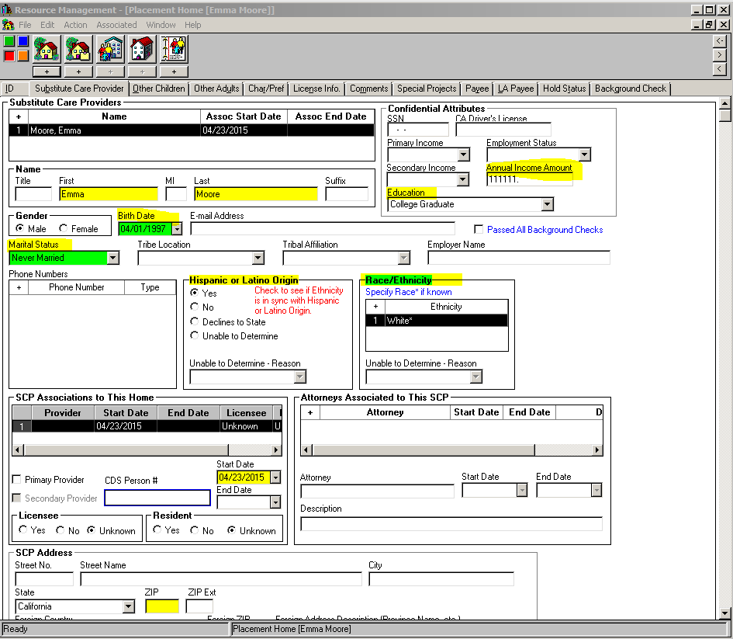

Placement home (cont’d) /Special Projects page
- For all applicants enter the RFA Special Project Code (SPC) in the drop down menu – “Resou Family Appvl Placmt Home” or “S-RFH – out of county”
Note: All counties must enter the same code. If you want to use additional county specific codes, that is fine, but you must use the appropriate state developed code first.

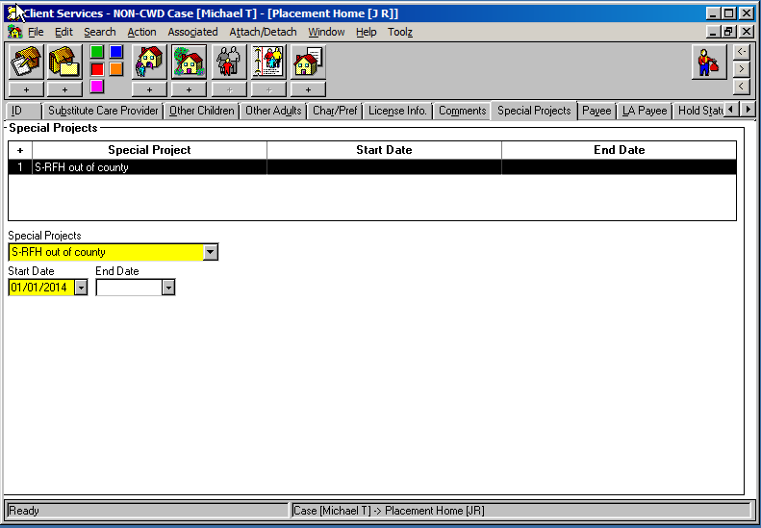

Placement Home (cont’d)/Background Check page & Other Adults page
- Exemptions (element 10): under background checks, add “type”, select exemption granted from dropdown and enter date. If exemption denied, enter that.
- Other Adults (element 11): use the other adults page to add other adults who live in the home or would have significant contact with the child.
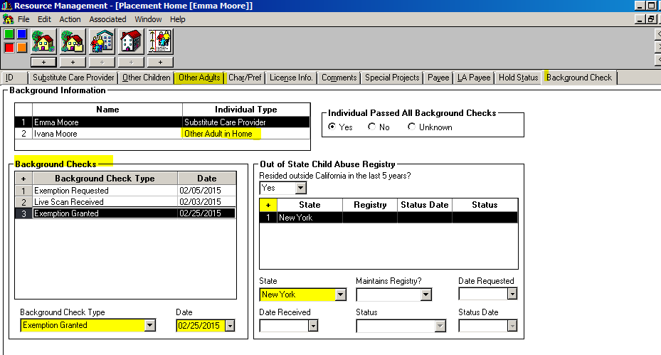

County License Case Notebook/ID Page

- Enter date in “Application Received” field to identify when the application was received or the relative placement process began (element 1).
Enter the unique applicant/family ID number. Application assumed pending until license status field is completed after approval.

- (a) When the applicant is fully approved –
under Application Status and select “Application Approved” and under License Status select “Provisional License” and enter the date (element 3). See page 6 for emergency placements.
- The annual visit due date will auto fill.
(b) If application is withdrawn, or assessment ends in a denial, under Application status select “withdrawn” or “denied” from the dropdown menu (element 2).
- In the Priority Information text box write RFA denied (or withdrawn) and the reason.
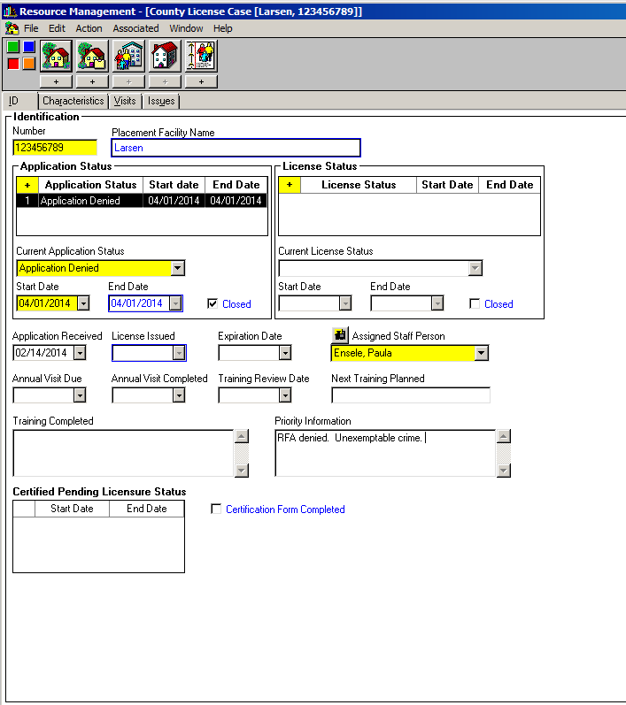
County License Case Notebook/ID Page (cont’d)

- (a) For Emergency Placements: under Application Status add row for “Application Approved” and date. Under License Status and row for “Probationary License.”
(b) Once the relative is fully approved under License Status and a new row to change license status to “Provisional License” and date.
- The annual visit date will auto-fill based on full approval date.
(c) If the assessment exceeds the 90-day time frame under the Priority Information text box briefly document the reason it was not completed on time (e.g. relative cancelled two meetings).
Regarding the identification of relative homes (element 16): CDSS and the California Child Welfare Indicators Project (UC Berkeley dynamic data website) will identify relative Resource Family placements by using the “care provider relationship to child“ field along with the RFA special project code.

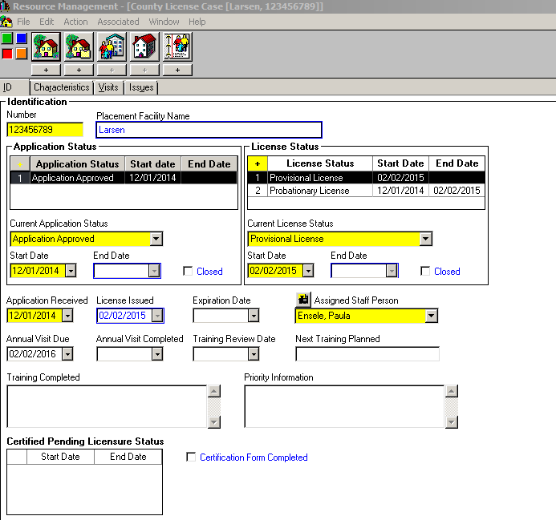

County License Case Notebook/ID page
For the annual update (elements 4&5)
- Enter date in “Annual Visit Completed” box. Annual update process should be completed no later than 30 days of the due date. Once completed, enter the date (this will auto fill the next annual due date). Under License Status:
  - If no changes in the RFH status - nothing further needs to be done.
  - If family decides they do not want to continue to be a RF - add row for “Licensee Initiated Closure” and date.
  - If approval is being rescinded - add row for “Unlicensed” and date.
Note: Only a county administrator has the privileged to used “Revoked” status. If you have this privilege still select “Unlicensed” as we need consistent data.
Note: if the annual visit is past the due date, once completed the date auto fills based on the original date of approval (e.g a due date of Jan 1, 2012 that it is completed on Feb 1, 2012 will have a next due date of Jan 1, 2013).
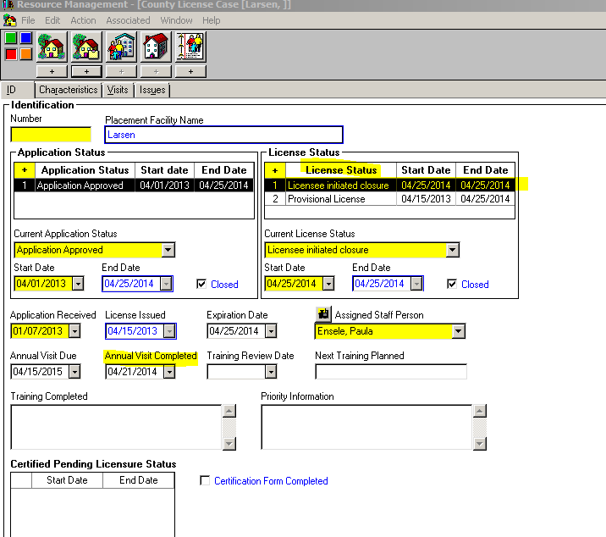
County License Case notebook/Issues page
Element 15 – Complaints/Fair Hearings
- For a Fair Hearing - under “category”– click incident; enter the date of the fair hearing; for “Issue Type” select “Other”; use the Issue Notes box – write “fair hearing complaint” or “fair hearing denial”. After the hearing, write in the outcome – “affirm” or “reverse” and date.
- For a complaint – click “Complaint”, enter date, Issue Type and Complaint Finding.
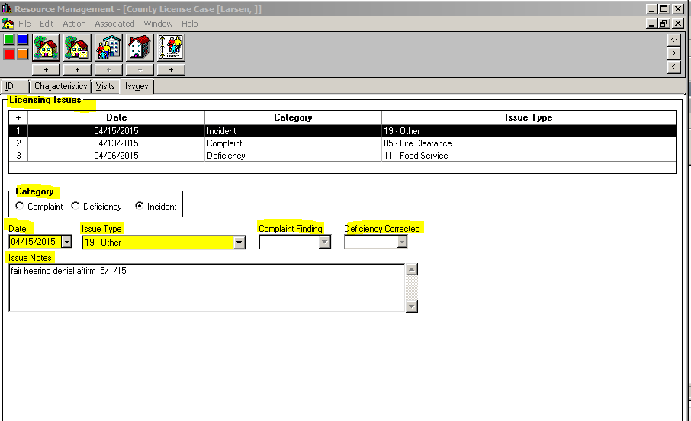

CLIENT SERVICES APPLICATION
Placement/ID page
- Complete necessary information to create a new placement.
For data elements 12-14 (information regarding children placed in with a Resource Family):
- Enter start date (element 12);
- Enter Care Provider Relationship to Child (element 13); This field is vital for identifying relatives
- If applicable, check emergency placement box (element 14).
