Critical CPM Outcomes

Child welfare agencies in California are actively pursuing system improvement strategies to impact long-term child and family outcomes. CPM implementation is an important part of this picture, providing a framework for quality practice and implementation to impact safety, permanency, and well-being outcomes.
Long-Term Outcomes reflect changes for children and families as a result of being served by a complex and dynamic child welfare system. These outcomes are affected by many extraneous factors along the way – in the region, the community, the policy environment, and the broad system of supports and services. When there are changes or trends in safety, permanency, and well-being, long-term outcome data does not help us understand what caused or contributed to those changes. More nuanced and timely data is needed to meet adaptive challenges, make course corrections and improvements, and achieve local system improvement goals and outcomes.
Short-Term Outcomes are observed sooner and provide a more sensitive gauge of whether agency implementation and system improvement efforts are having the intended impact on children and families, the agency, and its partnerships.
Short-term outcomes are key to navigating change and improving child welfare
Short-term outcomes are changes in knowledge, skills, attitudes, and behaviors. The families being served and the staff and partners who are serving them have the best perspectives on whether expected changes are occurring. For instance,
- Families can best tell us if they have been engaged in safety planning for their children;
- Partners provide the best perspective on whether the agency shares open, transparent communication with them;
- Staff are in the best position to help us understand whether and how their work is being supported.

Because short-term outcomes are so significant in implementation and system improvements efforts, and because it is so important to hear from families, partners, and staff to assess progress on short-term outcomes, the critical short-term outcomes on the following page have been identified. Counties and their partners are encouraged to use or adapt these outcomes in implementation and system improvement efforts.

CRITICAL CPM SHORT-TERM OUTCOMES
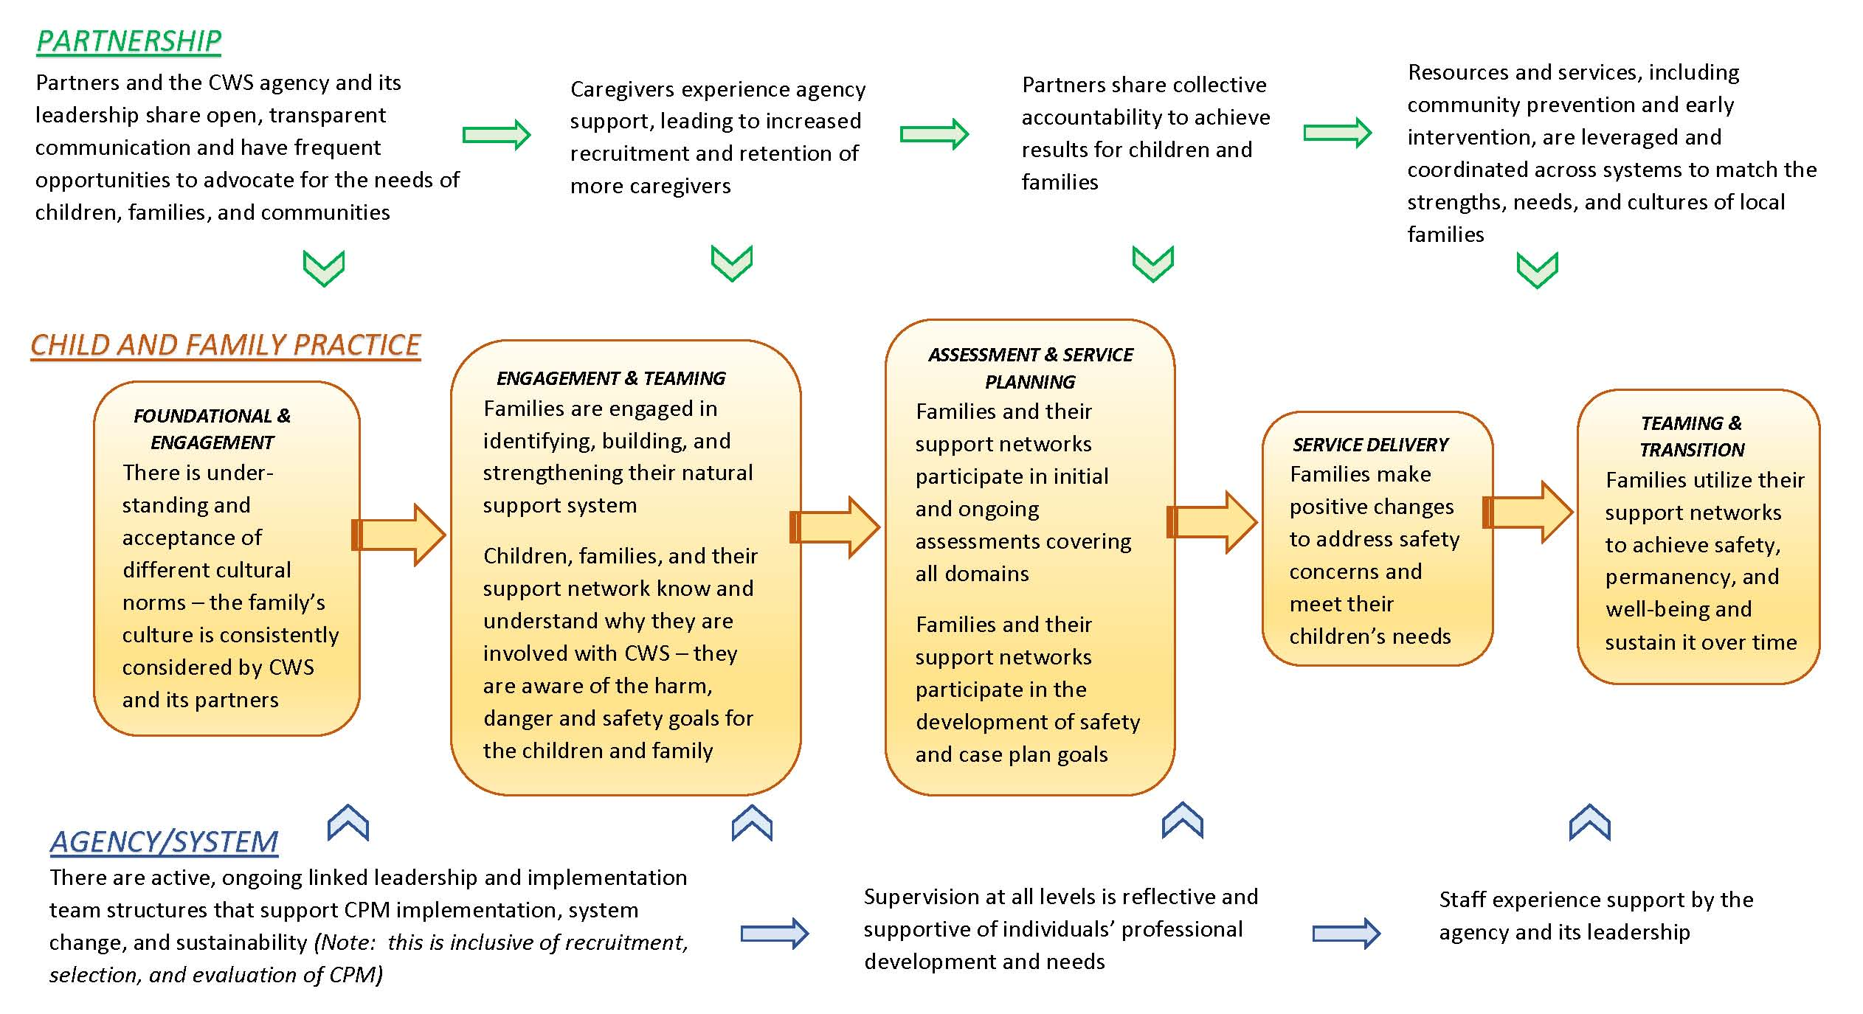
These 14 Critical CPM Outcomes were prioritized from approximately 50 short-term outcomes by considering 3 criteria:
- the outcome is a good early gauge that the expected positive changes are happening
- the outcome is key to understanding progress/areas for improvement
- the outcome is predictive of other important outcomes

