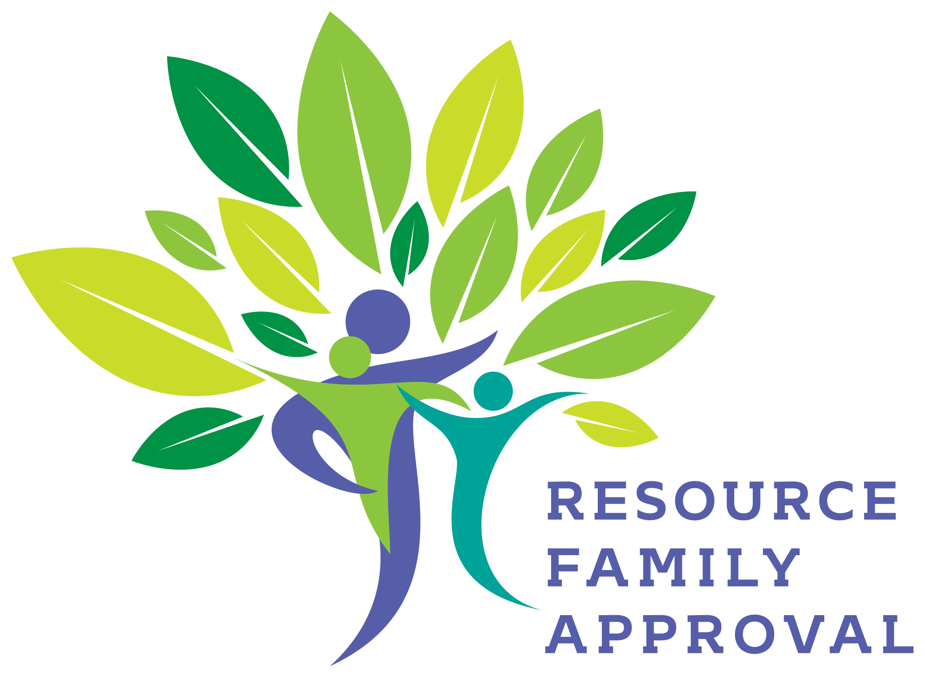

Attachment B

RESOURCE FAMILY APPROVAL (RFA)
COMPREHENSIVE IMPLEMENTATION PLAN
Stanislaus County
April 1, 2016-Implementation Date

Contact Staff: Nenita Dean, Manager IV
Deanne@stancounty.com
Julian Wren, Manager III
WrenJ@stancounty.com

INTRODUCTION
The Resource Family Approval Comprehensive Implementation Plan (RFACIP) template has been created to assist counties with organizing and documenting their transition to the RFA process. Its intended goal is to provide a framework to assist county staff with memorializing county-specific RFA policies and procedures. It is recommended that the full range of staff participate in the RFACIP process to ensure that a systemic approach is used in developing a comprehensive method of approving care providers for the care and supervision of children, youth and non-minor dependents (NMD) in the foster care system.
Each county is required to submit to CDSS, 30 days prior to implementation, a completed RFACIP for review and approval.
RESOURCE FAMILY APPROVAL (RFA) COMPREHENSIVE IMPLEMENTATION PLAN
County of Stanislaus 2015/2016

I. PROGRAM STATEMENT AND VISION
Brief Overview:
The Stanislaus County Community Services Agency Adult, Child and Family Services Division (ACFSD) in collaboration with our partners is committed to implementing a unified, strength-based, child oriented Resource Approval Process (RFA) for current and potential relatives, non-related extended family, and other non-related caregivers. Stanislaus County values all the caregivers that provide care to dependent children and youth and will provide support, training and resources to strengthen the care provided to these children and youth. The children/youth will be living in a least restrictive setting and will meet the goal of safety, permanency and well-being.

II. PROGRAM GOALS, OBJECTIVES AND OUTCOMES
GOAL: | Successfully Implement the RFA program by April 2016
Objectives
1. | Organize a RFA Steering Committee composed of Child Welfare and Probation Leadership Team and community partners that include  current caregivers and youth. Articulate the RFA Steering Committee’s purpose and responsibilities and meet regularly.
2. | Organize several workgroups composed of Child Welfare Leadership Team, social workers, probation staff, CWS staff and community  partners. Articulate the purpose and responsibilities of the workgroup and meet regularly.
3. | Review the CDSS written Directives to analyze the changes in the process and the required workload.
4. | Review the RFA implementation plan of Cohort 1 counties and participate in peer technical assistance.
5. | Participate in RFA cohort two counties’ Executive Meeting and group meeting via conference call.
6. | Prepare the Stanislaus County’s Implementation Plan.
7. | Send the Stanislaus County RFA plan to CDSS for review and final approval.
8. | Assess the organizational structure of the Adult, Child and Family Services Division (Child Welfare); examine current resources  and supports available as well as needed resources, for a successful implementation of RFA process.
9. | Engage with staff and caregivers throughout the process to identify barriers for completion of the process and placement. Develop  strategies to resolve these barriers.
10. | Develop a system or methods to evaluate the RFA implementation.
11. | Develop a data base for data information and tracking outcomes such as: numbers of RFA applicants; number of approvals/denials;  compliance performance and other outcome measures.
12. | Complete a CWS handbook on the RFA process that includes new forms; new RFA Home Application packet; new Resource Family  Permanency assessment forms.
13. | Provide training on RFA process to all CWS staff, caregivers, and other community partners.
14. | Apply Continuous Quality Improvement process in evaluating the county’s implementation of RFA.
15. | Build a network of permanent families for children.
16. | Develop a strategy for implementation of psychosocial assessments.
17. | Request the Board of Supervisors to approve and sign the Memorandum of Understanding (MOU) with CDSS.
18. | Develop a Memorandum of Understanding (MOU) with Probation Department.

Proposed Outcome(s)

Proposed Outcome(s)
N
Resource Families will be better prepared to help children transition home or achieve self-sufficiency.

Resource Families will be able to be a resource and support for birth parents.

To achieve permanency, barriers will be removed for Relatives and Non-Relative Extended Family Members.

Increase the percentage of children placed in the least restrictive level of care (Relative/NREFM) homes if they are not able to return home. This
correlates with the County’s SIP goal of increasing relative/non relative placements, outcome 4B.

Children will be safe and will not experience abuse and neglect in a Resource Family Home.

Children will meet the permanency goal of family reunification, guardianship, adoption and decrease the rate of children entering foster care within 12
months of post permanency.

Children will be able to transition home more quickly as the caregivers work with the birth parents to encourage them to fully participate in their
case plan. This integrates with the Quality Parenting Initiative (QPI) and correlates with the County’s SIP goal of improving outcome 3-P1, Reunification within 12 months.

In addition, this outcome correlates to the Children’s Family Services Review (CFSR) outcome 3-S1, Maltreatment in foster care and this will be
monitored.
GOAL: | Develop a unified approval and renewal process for the resource families providing care for child (ren) in out-of-home placement (Relative, NREFM, licensed and adoptive homes).  Rev ised the current process incorporating the new process as defined in CDSS Written Directives
Objectives
1. | Review the CDSS Written Directives
2. | Replace existing multiple processes with a unified process that will eliminate duplication. Create a visual representation of the new process.
3. | Develop and provide a comprehensive evaluation on all resource families.
4. | Have tools, forms, and resources prepared.
5. | Develop a transition plan for current caregivers into the new RFA process. Review AB 403 for guidance in the development of these  strategies.
6. | Develop a system or tool to get feedback from resource families on the implementation process.

Proposed Outcome(s)
Ensure safety, permanency and well-being of children placed in RFA homes. Stanislaus County will implement RFA process that is safe and protective,
is family focused, and results in permanent families for children with the absolute minimum number of placements and moves.
Fewer placement moves (per 1,000 days) for children and improved permanency outcomes. More stability in placement and improved caregiver
satisfaction. This correlates to the County’s SIP goal of improving outcome 3-P5, Placement stability. Data will evaluate progress and areas for
improvements.
GOAL:  CDSS Required Document |  |  | Develop and provide training to Child Welfare staff and partners.
Objectives
1. |  | Prepare staff, youth, other partners and prospective resource families for the implementation of RFA via RFA brochure and other forms of  information.
2. |  | Create a comprehensive training for CWS staff and partners on policies, procedures, roles, responsibilities and use of new forms.
3. |  | Develop-on-going training and coaching for new CWS staff.
4. |  | Ensure that Child Welfare staff understands their roles and responsibilities under RFA.
5. |  | Explain how staff will collaborate and work together with RFA families.
4. |  | Provide opportunity to all staff to provide feedback –strengths and areas for improvement of county’s implementation of RFA.
Proposed Outcome(s)
All child welfare and probation staff will understand the new processes, policies, procedures and regulations of the RFA program and ensure compliance. RFA social workers and social workers from emergency response to on-going programs will understand their roles and responsibilities for the resource family approval process and determining eligibility and suitability for placement.

GOAL: |  | 1. Resource families providing care for children in out-of-home care will receive professional training and support.  2. Improve the County’s current recruitment/retention/support process for resource families.
Objectives
1. | CSA and Modesto Junior College Foster Care Program will collaborate in developing a comprehensive training for all individuals interested in  becoming Resource Families. These individuals will be required to complete the required classes.
2. | Provide all Resource Families access to additional knowledge, skill building and support.
3. | Provide a system of evaluation to be completed by resource families (new and current) to ensure on-going improvement of training.
4. | Eliminate barriers by providing support to achieving permanency and stability of placement for children in out of-home care. An example of  support is providing financial assistance to meet some needs to meet the requirements of certification such as: fence around the pool etc.  5
5. | Improve collaboration between social workers and resource families by scheduling a regular get together such as the monthly “Coffee  Connection”.
Proposed Outcome(s)
Resource Families will have the skills and information necessary to provide a safe, nurturing and permanent home for foster children, youth and Non-
minor dependents.
Decrease placement changes and improve placement stability.
Increase the number of relatives providing care for the out-of-home children and youth.
Increase the number of children placed in the least restrictive level of care. This is in line with the county’s Self Improvement Plan (SIP) and goal of
increasing relative/non relative placements- Outcome B.

The children will be safe and will not experience abuse and neglect at Resource Family Home. The data will show no reports of abuse and neglect.

Children will meet the goal of permanency (Family Reunification, Guardianship, and Adoption) and decrease the rate of children entering into foster
care within 12 months of post permanency.

Children will be able to transition home quicker as the caregivers work with the birth parents to encourage them to fully participate in the case plan.
This is In line with county’s Self Improvement Plan (SIP) and goal of No recurrence of maltreatment 3.52 and reunification within 12 months, 3.P1.

Please provide a RFA-specific org chart that delineates job titles and reporting structure: (Do not include specific names)
Stanislaus County implementation phase is a collaborative effort between Community Services Agency Adult, Child and Family Service Division (Child Welfare), community partners such as Modesto Junior College, Family Connections and Probation Department.
The RFA Manager IV and Manager III of Adult, Child and Family Services Division (Child Welfare) oversee the implementation and evaluation of
the RFA program.
The RFA program unit is comprised of the following: One social worker supervisor II, three RFA social workers, five Adoption social workers,
and one administrative clerk II. The RFA Social Workers will be responsible for completing the RFA process and certification of the Resource
Families.
The Emergency Response Program after hour social worker will continue to conduct all emergency relative and NREFM placement assessment.
This staff will complete the pre-approval process. This social worker will transfer the other approval requirements to the Court Unit
social workers (Placement Specialists) when the case goes to the Court Unit. The Court Unit social workers (Placement Specialists) will
continue the process and will be responsible to complete the exemptions/exceptions if needed. This social worker will transfer the remaining
approval requirements to the RFA unit for completion which will include orientation and training as well as the psychosocial risks and
permanency.
The Emergency Response Unit social worker (Placement Specialist) will continue to conduct relative and NREFM placement assessment for Emergency Response social workers. This social worker will transfer the other approval requirements to the Court Unit social worker (Placement Specialist) for cases going to court. The Court Unit social worker (Placement Specialist) will continue the process for placement. This social worker will transfer the remaining approval requirements to the RFA unit for completion that will include orientation and training as well as psychosocial risks and permanency.

The Court Unit social workers (Placement Specialists) will continue to conduct all relative and NREFM placements including exceptions/exemptions when the child is open in the Court Unit and a relative or NREFM was found as possible placement. They are also responsible for emergency placements. The Court social workers (Placement Specialists) will pass the application to the RFA Unit for completion of the process that include orientation and training as well as psychosocial risks and permanency.

The Family Reunification and Permanent Placement social workers will identify possible relative or NREFM for placement. The social workers will provide the information to the RFA Unit. The RFA social workers will complete all the RFA process including exemptions/exceptions. Any emergency placements will be completed by the FR and PP social workers including exemptions/exceptions.

All placement social workers will continue to be responsible in monitoring placements.

The RFA unit will maintain a list of certified resource families.

The Probation Department and CSA will have a Memorandum of Understanding (MOU) for RFA program. Probation and CSA have a very collaborative relationship for many years. CSA will conduct the initial and annual RFA process.

III. ORGANIZATIONAL STRUCTURE
PROJECT MANAGEMENT (Per Written Directives 04-03(b), a county must designate a manager responsible for the day-to-day program administration as
well as function as the primary point of contact.) The Child Welfare Assistant Director, Program Managers, Supervisors and Social Workers have Masters
Degree in Social Work and have many years of experience in Child Welfare programs. The Social Worker III’s in the RFA Unit have Bachelor’s Degree
and experience in Child Welfare programs.
Title: Manager IV – Reports to Assistant Director of Adult, Child and Family Services Division (Child Welfare).
Role: To ensure the RFA program operates in accordance with agency policies and procedures as well as CDSS RFA written directives and regulations.
Responsibilities:
1. Leads the implementation of the RFA process and Chair of the Steering committee and Oversight Committee.
2. Assists workgroups and ensures that the work group accomplishes its goals in the time allotted.
3. Participates in all decision making process.
4. Monitors the continued implementation and progress of the RFA program.
5. Participates in CDSS RFA Executive Team Meeting on policies and technical assistance for development, implementation and maintenance of the
program.
6. Reviews policies and procedures and internal handbook documents for implementation.
7. Provides on-going communication regarding RFA to agency’s leadership team.
8. Reviews outcomes developed by the team and analyze the effectiveness of the program and areas for improvements.
9. Reviews complaints and investigations sent by Manager III.
10. Monitors recruitment, support, and retention of resource families.
11. Collaborates with the agency’s leadership team, RFA unit and stakeholders.
Title: Manager III
Role: To ensure the RFA program operates in accordance with agency policies and procedures as well as CDSS RFA written directives and regulations.
Responsibilities:
1. Assists the Manager IV in the successful implementation of the RFA program, approvals of policies and procedures, and monitoring the progress of
the program.
2. Monitors the program’s resource family approval process that includes the application process, assessment process, and psychosocial risk and
permanency assessment guidelines.
3. Monitors the work of the RFA supervisor, RFA social workers and Adoption social workers.
4. Has primary oversight of the Quality Parenting Initiative (QPI) and provide guidance in modifying the QPI plan to incorporate the RFA program for
enhanced recruitment and retention of quality resource families.
5. Participates in all decision making process.
6. Participates in CDSS RFA Executive Meeting.
7. Responsible in developing outcomes with RFA team and partners and achieving program outcomes.
8. Reviews complaints and investigations and confer with Manager IV on Harris Hearing if needed.
9. Approves exemptions and reviews exceptions prior to sending to the Assistant Director for approval.
10. Monitors recruitment support and retention of resource families.
11. Maintain collaborative relationships with internal and external partners.
Reporting Relationships: Reports to Manager IV of Adult, Child and Family Services Division (Child Welfare).

LEADERSHIP
Title: Assistant Director Adult, Child and Family Services Division (Child Welfare )
Role: Provide overall leadership and oversight of the program.
Responsibilities:
1. Oversees the RFA implementation process and provide guidance to Manager IV and Manager III
2. Monitors the RFA implementation and progress.
3. Review and approve policies and procedures developed by the RFA Steering Committee.
4. Participates in all decision-making process.
5. Provides support to staff.
6. Analyzes program outcomes and process for continuous quality improvement.
7. Reviews exceptions sent by Manager III for approval or denial.

Reporting Relationships: Reports to Community Services Agency Director.

Title: Community Services Agency Director
Role: Provide overall leadership to Community Services Agency. Responsible for the development of agency’s strategic plan, objectives and requirements.
Direct, organize, manage, and supervise the activities, program and services of Stanislaus County Community Services Agency.

Reporting Relationships: Reports to County’s CEO.

STAFF
Title: RFA /Adoptions Social Worker Supervisor
Role: Oversees day-to-day program operations, responsible for planning, assigning, and directing the work of the RFA
social workers and monitors the RFA program implementation.
Responsibilities:
1. Provides direct oversight of the RFA staff, including ensuring that the RFA and adoption staff follows RFA written
directives, policies and procedures.
2. Receives application packets from social worker and assign the application on rotation to the RFA social workers.
3. Plans, assigns, and distributes workload, sets priorities and monitor deadlines.
4. Reviews approvals and denials and consult with the RFA Manager III when needed.
5. Monitors the effectiveness of the RFA program and share information with the RFA Manager III.
6. Meet regularly with the RFA unit, discuss strengths/challenges of the RFA program and develop goals and
expectations.
7. Communicates any information regarding the RFA program and lead the revision of handbook of policies and
procedures and other RFA documents.
8. Provides RFA training to the RFA unit on an-going basis, as well as training refresher to other units to ensure
compliance.
9. Assists the RFA Manager III in handling all resource family denial grievances.
10. Monitors the RFA satisfaction survey.
11. Performs other supervisor functions such as completing evaluations, monitoring staff performance; participate in
agency committees and a member of the CWS leadership team.

Reporting Relationships: Reports to RFA Manager III.
Title: RFA Social Workers
Role and Responsibilities:
- Review the applicants’ application packet. Ensure that all documentation and paperwork needed are complete.
- Complete the RFA application process with the applicant (Part A and B).
- Schedule and conduct face to face interviews as part of the application process.
- Schedule and complete a home environment assessment using RFA-03A: RFA Home Environment Checklist that include:
- A health and safety assessment of the building and grounds, outdoor activity, space, and storage areas to determine compliance.
- Fire clearance. Fire clearance is required when the applicant intends to provide care for a non-ambulatory child or non minor dependents and care for more than six children or non minor dependents in the home.
- Capacity determination.
- Complete Risk Assessment (RFA04).
- Conduct background checks of an applicant and all adults in the home which include:
- Completion and submission of RFA 01B: Resource Family Criminal Records Statement.
- A finger-based criminal records check to obtain state and federal criminal record information pursuant to Family Code Section 8712.
- Child Abuse Central index check pursuant to Health and Safety Code.
- Complete a registry check using LIC 198B for any applicant or any adult living in the home who has lived in another state within five years before seeking RFA approval.
- Child Welfare Services/Case management System check.
- Megan’s Law registered sex offender check.
- DMV check on applicant and any adults in the home who may frequently transport a child or non minor dependent.
- Legal Administration Action Records System (LAARS) check and Licensing Information System (LIS).
- Complete the comprehensive packet and documentation into CWS/CMS.
- Complete the psychosocial assessment and conduct and write the family assessment.
- Determine approval/denial of the application and send the Notice of Action. If denied include information on the appeal process. Notify the social worker of the approval or denial. If approved add the applicant to the list of Approved Resource Family.
- Support and provide appropriate services to the resource family to assist them in the approval process.
- Complete exemptions/exceptions in accordance to guidelines.
- Investigate compliance complaints and complete the process (NOTE: The RFA social workers will not investigate the application they completed and processed)
- Process annual renewals. 14. Participate in Team Assessment process (TAP staffing).
Reporting Relationships: Report to RFA/Adoption Supervisor.
Title: Adoption Social Workers
Roles and Responsibilities:
- Complete the psychosocial assessments for RFA.
- Work with Family Reunification and Permanent Placement social workers in permanency process that includes finalization of adoption.
- Complete adoption paperwork.

Reporting Relationships: Report to RFA/Adoption Supervisor

Title: Emergency Response (ER) Social Workers
Role and Responsibilities:

ER- After Hours placement and Day Time Placement- Complete the prior approval process listed below:
- Assess the RF applicant’s suitability and willingness to provide care.
- Conduct criminal records check of all the adults-W&I Code 16504.5
RFA -02:Resource Family Criminal Background Check
- Conduct Child Abuse Central Index; CWS/CMS check: Megan Law; DMV.
- Complete home inspection and grounds.
RFA-03 (A): Resource Family Home Environment Checklist
- Provide RFA application RFA-01 for submission within 5 days.
- Provide RFA-01 (B) Criminal Record statement for completion within 5 days.
- Talk about funding options
- TAP staff case the following day/ Referral to RFA supervisor for RFA SW assignment (ER After Hour placement)
- Transfer the case and RFA documents to the Court Unit social workers (Placement Specialists) for cases moving to the dependency court.

Reporting Relationships: Report to the ER Supervisor.

Title: Social Workers (FR) Family Reunification (PP) Permanent Placement
Role and Responsibilities:
- Emergency Placement
- Assess the Resource Family applicant for suitability and willingness to care.
- Complete the pre-approval process (see above list under ER Social Worker) including exemptions and exceptions.
- Send a referral to the RFA supervisor for assignment to RFA social worker.

- Regular Placement
- Assess the RFA applicant’s suitability and willingness to provide care.
- Send a referral to the RFA supervisor for assignment to RFA social worker.

Reporting Relationships: Report to Social Worker Supervisor.
Title: Probation Officers
Role and Responsibilities:

- Assess the RFA applicant’s suitability and willingness to provide care.
- Send a referral to CSA RFA supervisor for assignment to RFA social worker.
- Collaborate with CSA RFA social worker in the completion of the process.

The CSA Child Welfare RFA social worker will provide the probation officer updates and notification of the result of the application.

Reporting Relationships: Report to Probation Supervisor.
Title: Information Technology Staff
Role and Responsibilities:

The RFA Database Workgroup will work with the Internet Technology (IT) Staff to review the database that will
accommodate the tracking and reporting requirements of the RFA program.

Reporting Relationships: Reports to Information Technology Supervisor.
RFA Foster Care Unit
Role and Responsibilities:

- Family Services Specialists II (Eligibility Staff)
- Review all the RFA paperwork received from social workers to ensure that all information are correct and complete prior to releasing payment: SOC 158A, FC2, Saws 1/ARC 1, Minute Order, Stan 42a (transmittal sheet), EA1, RFA 01A, RFA 01B, RFA 02, RFA 03A, RFA 03B, RFA 04.
- Return incomplete paperwork to the social worker for completion and correction.
- Mail Miller v Youakim/NREFM packet to the payee.
- Determine if the relationship is within 5th degree relationship.
- Determine Federal or State eligibility.
- Process timely payments to Resource Family.
- Complete annual review for continuous payment.

Reporting Relationships: Report to the Foster Care Supervisor
- Family Services Supervisor
- Performs quality assurance review of the paperwork completed by the Family Services Specialists to ensure compliance.
- Provides guidance to staff on RFA process.
- Monitors the day to day operation of the Foster Care unit.
- Participates in RFA Steering Committee.

Reporting Relationships: Reports to Foster Care Unit Manager III.
- Foster Care Manager III
- Monitors the work of the Foster Care unit and provide guidance to staff on RFA process.
- Participates in RFA Steering committee.

Reporting Relationships: Reports to Manager IV.

CDSS Required Document

V. PLAN FOR HIRING AND MAINTAINING PROGRAM STAFF QUALIFICATIONS AND SKILLS
CDSS Required Document
Requirement | How will you accomplish this requirement?
Ensure and Maintain Minimum Staff Qualifications | - Must have Bachelor’s Degree for SW III and Master’s Degree for SW IV/V.  - Requires one year experience as social worker in a social services agency.
Develop and Maintain Staff Skills (Describe staff training plan.) | - Social workers will receive comprehensive training on RFA process and written directives prior to implementation.  - On-going training on RFA will be provided.  - Receive on –going coaching from supervisor.  - Agency leadership team and project leads will participate in RFA Executive Team.  - RFA supervisors and staff will participate in RFA implementation workgroups.  - RFA leaders and staff will consult with CDSS on implementation issues.
Develop and Maintain program expertise | - Training needs will be continually monitored through RFA steering/oversight committee.  - Continue to evaluate in-house training for continuous improvement. RFA manager will take the lead in the evaluation and improvements as needs are identified and modify tools and policies as needed.  - RFA managers, supervisors and staff will continue to be involved with RFA discussion with CDSS to keep abreast of updates and revisions.  - Request technical assistant from CDSS if needed.

VI. RESOURCE FAMILY APPROVAL PROCESS
CDSS Required Document
Please describe the approval process for Resource Families: (Please ensure that incoming ICPC requests and out-of-county placement procedures are included in the approval
process. A flow chart is acceptable.)
Incoming ICPC: Request will be given to the ICPC coordinator and given to the RFA supervisor for assignment and will follow the Community track.
Incoming Out of County placements: If a Resource Family moves to a nonparticipating county, the new county of residence shall deem the family
approved for licensing, relative or nonrelatives extended family member approval, guardianship, and adoption purposes, under the following
conditions: The new home and grounds, outdoor activity areas, and storage areas meet applicable standards, unless the family is subject to a
corrective action plan. (1) The new home and grounds, outdoor activity areas, and storage areas meet applicable standards, unless the family
is subject to a corrective action plan. 2) There has been a criminal record clearance of all adults residing in the home and exemptions granted
using the exemption criteria currently used for foster care licensing, as specified in Health and Safety Code section 1522(g).

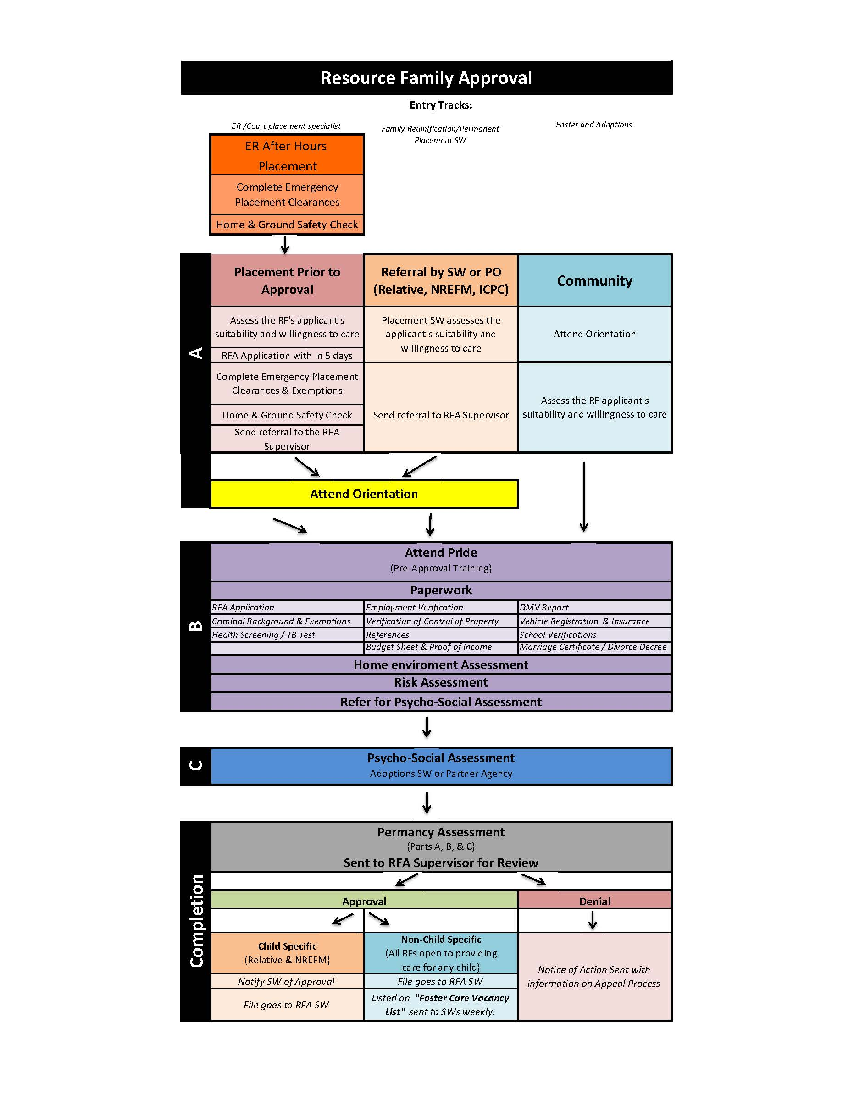
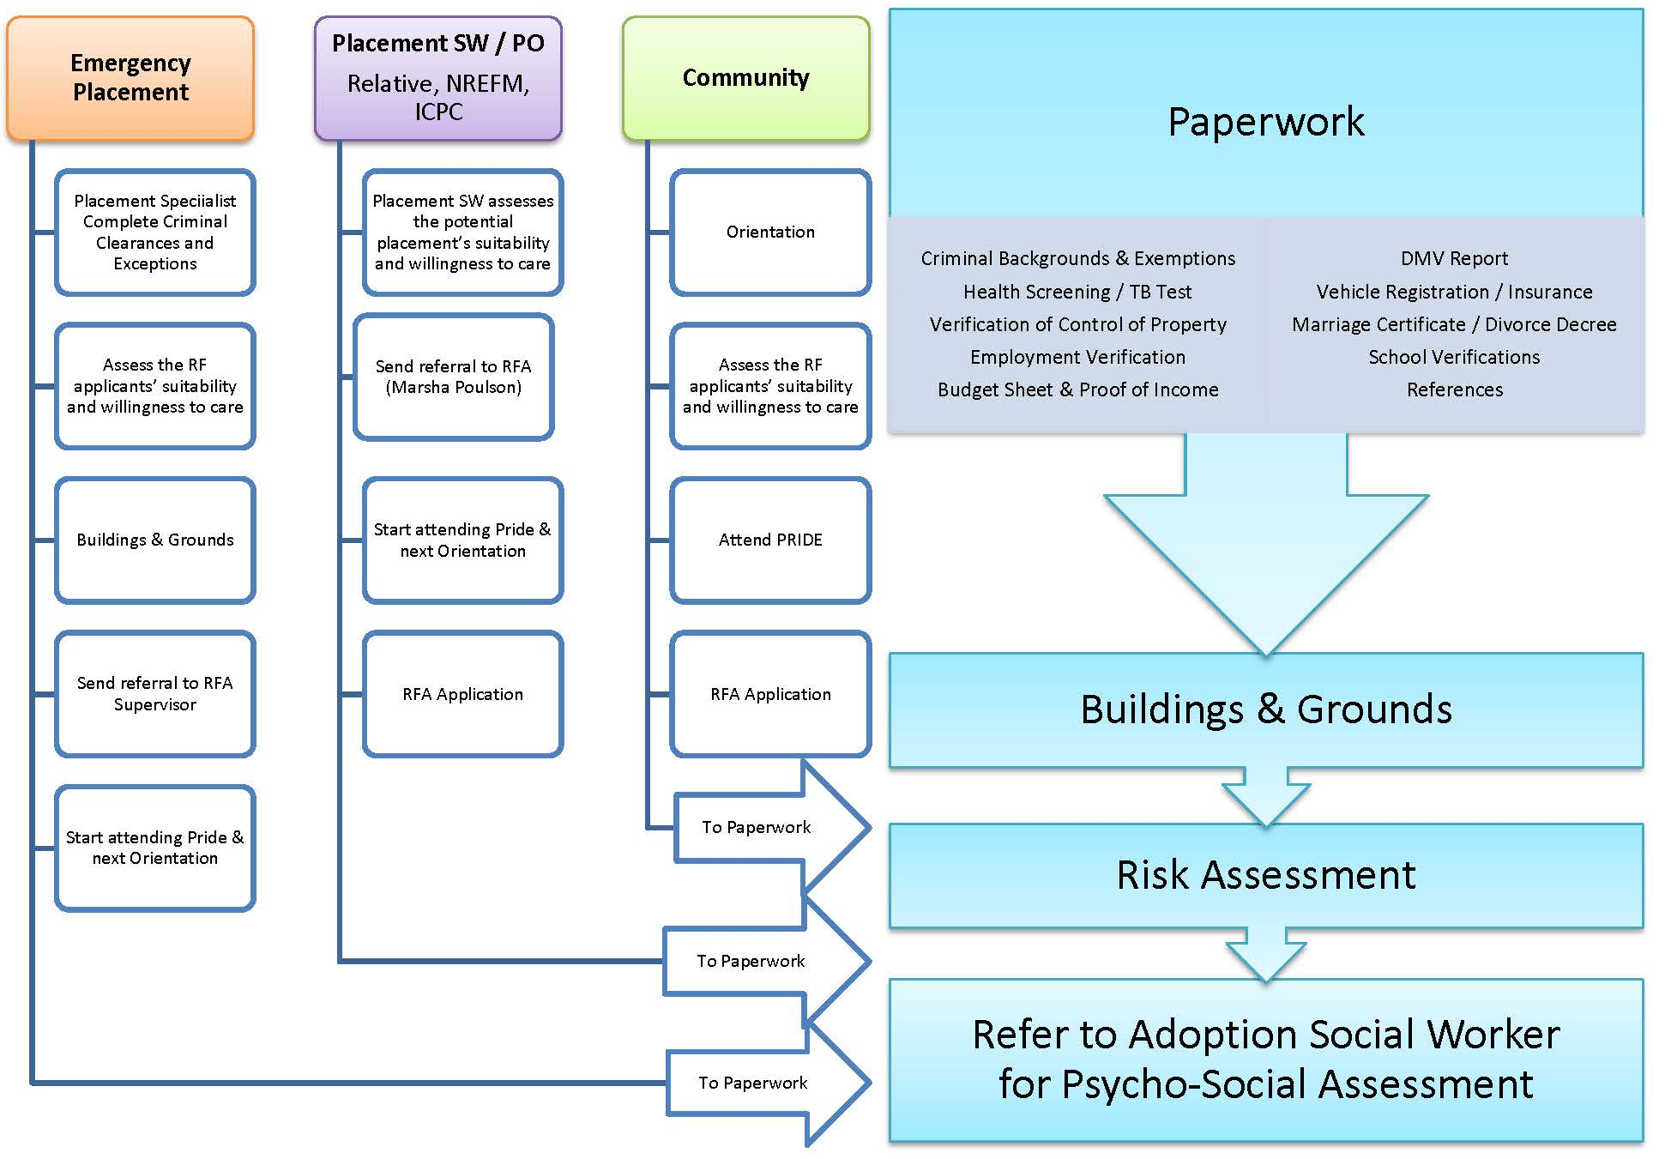

VII. NON-COUNTY STAFF/AGENCY PROGRAM INVOLVEMENT

Please describe how county will utilize partner agencies, if applicable: (Please include detailed information regarding how you will communicate with your
partner agencies if they are assisting in the approval process? How will the impact on the family of having more than one worker be minimized?)
PROBATION:
- A Release of Information will be obtained from the placement home allowing Probation to release information to the Adult, Child & Family Services (ACFSD -Child Welfare)) and the Cooperative Agencies.
- Probation will refer possible resource families for probation youth to Child Welfare RFA unit. MOU will be developed between Probation and Adult, Child and Family Services Division (ACFSD-Child Welfare).
- The RFA database will allow Probation to view only data pertaining to Probation cases. Probation will not have access to Child Welfare non-probation cases.
- Probation staff will be trained in and will follow Confidentiality Guides as outlined in ACFSD (Child Welfare) policies and procedures. This includes, but is not limited to, use of encryption when e-mailing confidential information to DSS or Cooperative Agencies.

COOPERATIVE AGENCIES:
Family Connections Adoption Agency
- Cooperative Agencies will be trained in and will follow Confidentiality Guides as outlined in ACFSD (Child Welfare) policies and procedures. This includes, but is not limited to, use of encryption when e-mailing confidential information to DSS or Probation. Cooperative Agencies will not have access to the Child Welfare RFA database.
- Under no circumstance will Cooperative Agencies share information regarding RFA applicants or RFA homes with anyone other than the
assigned Child Welfare Social Worker or Social Worker Supervisor.
- Stanislaus County Community Services Agency has current MOU with Family Connections Adoption Agency.
- The Family Connections Adoption Agency will provide assistance in completing the psychosocial assessments.

VIII. PROPOSED RESOURCE FAMILY ASSESSMENT TOOLS

Assessment Tools (e.g., SAFE)
Tool | Description
RFA Database Reports/Monthly  RFA data report | Existing database reports and data gathering processes will be produced to identify the number of RFA applicants,  the number of approvals/decline/denials, compliance performance (e.g. 90 days from application to approval), the  number of relative placements versus placements with non relatives, and the average length of time to approve and  permanency outcomes (legal guardianship, reunification, adoption).
Resource Family Satisfaction  Survey | The use of this tool will provide information regarding the Resource Families’ experience with the RFA program. CDSS is developing a consistent tool for counties.
Comprehensive Permanency  Assessment | Comprehensive Permanency Assessment Tool will be completed by RFA social worker (Part A and B) and Adoption  social worker or Cooperative Agency if referred to (Family Connections adoption social worker) will complete Part C.
QPI Partnership Plan | This plan is used as a tool to provide a framework to discuss collaboration and recruitment strategies, support and  retention.
Minutes of monthly RFA  Steering/Oversight Committee  meeting | This committee will continue to meet monthly through the implementation for at least a year from the date of  implementation to ensure smooth transition to the new process, identify strengths and barriers. After a year, the  frequency of the meeting will be reevaluated.

IX. TRAINING PLAN FOR RESOURCE
Please describe the plan for training Resource Families: (i.e. curriculum, number of sessions/hours)
- Provide an eight session pre-service training.
- Conduct four pre-service trainings from April 2016-June 2016.
- Conduct eleven pre-service training starting the 2016—2017 fiscal year.
- Provide CPRR and First Aid training once a month.
- Increase the numbers of pre-service trainers.
- Offer a mandatory three hour follow up training for newly certified families after their first placement.
- Increase mandatory annual training hours to 10 hours per year.
- Pre-service training will use The National Child Traumatic Stress Network’s Caring for Children Who Have Experienced Trauma: A Workshop for Resource Parents curriculum along with components from the PRIDE curriculum.
- Topics covered in the pre-service training include:
  - Orientation and Overview of the child welfare system
  - Personal Rights of foster youth.
  - Roles and responsibilities of the resource family
  - Child development, the effects of child abuse and neglect on development, and developmental delays
  - Trauma and trauma informed care
  - Positive discipline
  - Health issues of foster children and including administration of psychotropic medications
  - Educational issues for foster children
  - Working as a team member: the importance of working cooperatively with the agency, service providers, and birth parents
  - Shared parenting
  - The importance of maintaining birth parent relationships for foster children
  - Cultural competency and sensitivity, including how to provide safe, positive care for lesbian, gay, bisexual, and transgender foster youth
  - Options for permanency
- By the end of the pre-service training resource families will demonstrate competencies in:
  - Understanding the child welfare system.
  - Understanding the personal rights of foster youth and respecting their rights and cultural identity.
  - Understanding the roles and responsibilities of resource family and working with a team.
  - Trauma Informed Care;
  - Protecting and nurturing children;
  - Meeting developmental needs and addressing developmental delays;
  - Supporting family reunification and relationships between children and their families;
  - Connecting children to safe, nurturing relationships intended to last a lifetime;

X. TRIBAL PARTICIPATION
CDSS Required Document
Please describe the plan for tribal outreach and participation:
Stanislaus County has no local tribes. In situations where the county is placing a child with tribal family, the county will comply with ICWA regulations.

XI. QUALITY PARENTING INITIATIVE (QPI)
Please describe how county will integrate QPI with RFA process, if applicable.
QPI is a statewide initiative on recruiting and retaining high quality caregivers. RFA is a unified approval process for all prospective caregivers for children in
out-of-home care. RFA is a unified, family, and child centered approval process. QPI is a unified, family friendly, and child centered collaboration between
caregivers and child welfare staff and birth parents. RFA ensures quality caregivers are approved and QPI’s goal is to recruit high quality caregivers, retain
and support them. Integrating QPI goals with RFA will strengthen the RFA program
RFA pre-service training includes an introduction of QPI.
The pre-service component for resource families will support the goal of quality parenting and will solidify quality as expectation for resource families.
Resource families will provide quality parenting and Child Welfare staff will support them in this goal. Quality parenting requires a loving commitment to the
child and child’s safety and well-being. It demonstrates appropriate supervision, positive methods of discipline, encouragement of the child’s strengths,
respect for the child’s individuality and likes and dislikes, providing opportunities to develop the child’s interest and skills, awareness of the impact of trauma
on behavior, equal participation of the child in family’s life, involvement of the child with the community and commitment to enable the child to lead a
normal life.
The resource families will have access to all training needed to improve their skills as caregivers to children who have experience trauma due to neglect,
abuse or separation from home, to meet their special needs and to work collaboratively with child welfare agencies, the courts, schools and other
community and governmental agencies.
The unified process will ensure that children will be placed only with resource families who are appropriate and willing to accept the responsibility of
providing care to a child and respecting the child’s culture, religion and ethnicity, sexual orientation and other physical and psychological needs.
The QPI strategies for recruitment, support and retention will be incorporated into the county’s RFA program. The goals of both programs will be link and
integrated and will be part of on-going discussion at the RFA Steering Committee and QPI committee. These two committees will be merged.

XII. MONITORING OF RESOURCE FAMILIES
Process | Responsible Staff | Procedures
Periodic Evaluations and Onsite Visits | RFA social workers | Annual update will take place for reassessment and to ensure continued compliance using the  Resource family Annual Update (RFA4). All internal forms will be updated to reflect the RFA  requirements and language. The update shall include annual home visit, verification of  background clearance, interviews of all individuals living in the home and documentation of  why an individual in the home was not available, determining if training is current and up-to-  date. The Resource Family will receive a copy of the update.
Case management, support  of resource families | Child Welfare social  workers in Court,  Family Reunification  (FR) and Permanent  Placement (PP) | Case carrying Child Welfare social workers will continue to do case management to ensure the  safety of the child and provide support to the resource families.
Corrective Action Plans (Describe how plans will be developed and monitored) | RFA Social workers | When deficiencies are found, the RFA social workers will engage and guide the RFA families in  developing a corrective action plan (CAP). The development of the CAP is a team effort  between the RFA SW and the Resource Family. The CAP will describe how the deficiency will be  corrected and the timeline for completion. The RFA social workers are responsible for  monitoring the plan.
Resource Family mentor | Contract staff | If funding permits, this mentor will provide support and coaching. Providing support is a  strategy to retain quality resource e families and will reduce placement changes for children,  thus providing placement stability.

XIII. INVESTIGATION OF COMPLAINTS AND INCIDENTS INVOLVING RESOURCE FAMILIES
Process | Responsible Staff | Procedures
Investigating Complaints | ER SW, , RFA SW  and RFA Supervisor | Upon receipt of the complaint, the RFA supervisor will log in the complaint in the tracking log  and will assign to a RFA SW (the RFA SW who initially approved the family will not be assigned  to do the investigation). In situations where the complaints and incidents involve abuse and  neglect, the ER social worker will do the investigation accompanied by the case carrying social  worker.
Investigating Incidents | RFA SW | Resource Families are responsible for reporting incidents to Stanislaus County. All incidents will  be documented in the tracking log and investigated if appropriate.
Corrective Action Plan (CAP) | RFA SW, RFA  Supervisor | When deficiencies are noted, the RFA SW will assist the Resource Families in developing and  submitting a CAP. The CAP will describe the deficiency, how it will be corrected, and the  timeline of the correction of the deficiency. The RFA Supervisor will review the plan. The RFA  SW will monitor the plan and ensure that corrections are done timely.  If the deficiency is severe that could result to rescinding the home’s certification, the RFA SW  will consult with the RFA Supervisor and RFA Manager to determine the final action. The County  will inform the resource family in writing of the action taken and appeal rights. The County must  ensure the safety of the child (ren) placed in the home and placement moves must be done in  accordance to the County’s business practice.
Fair Hearing | RFA Manager | If the complaint investigation results in a substantiated finding, the Resource Family will receive  information on how to file a Fair Hearing request. After the Fair Hearing, notices will be sent to  the Resource Family and the RFA unit to be filed in the Resource Family’s case file.
Notifications | RFA Manager | The RFA Manger will take the lead in ensuring that appropriate notifications are sent within 72  hours as well as updates regarding the status and disposition of serious complaints, serious  incidents, or any incidents involving the Resource Families that fall within the definition of Penal  Code section 11165.5

XIV. DUE PROCESS FOR DENIAL OR RESCISSION OF APPROVALS AND OTHER ADVERSE ACTIONS
Process | Responsible Staff | Procedures
Negative action taken on an RFA application and client wishes to pursue due process. | RFA SW, RFA  Supervisor, RFA  Manager | All denials will be reviewed by the RFA supervisor with consultation with RFA Manager before  sending the notice of denials. Resource Families will be provided information regarding  requesting a hearing. If an application is denied. The information will be provided in writing  (the notice of action will include appeal rights).
Process for Resource Family  Placement Denials | RFA SW, RFA  Supervisor, RFA  Manager | Upon initial inquiry regarding RFA, potential Resource Families will be provided information  regarding requesting an administrative hearing. If a placement is denied or removal of a child  from the home, this information will be provided again by the RFA social worker. A hearing will  be scheduled as per Section 16519.5 of the WIC Code and 31 Regulations 31-020.
Process to Rescind Approval | RFA SW, RFA  Supervisor, RFA  Manager | All RFA denials will be reviewed by the RFA Supervisor in consultation with RFA manager. The  County will inform the resource family in writing and provide appeal rights information. The  County will ensure the safety of the child (ren) placed in the home and if the children are to be  moved, these moves must be in accordance to current county business practice.
Process for other adverse actions | RFA SW, RFA  Supervisor | During the initial application process, procedures on how to resolve grievances and how to  request a hearing will be provided to all RFA Families.
XV. TIMELINE FOR IMPLEMENTATION

2015
TASK/STEP | JULY | AUGUST | SEPTEMBER | OCTOBER | NOVEMBER | DECEMBER
Organize the RFA Steering Committee implementation | x
Steering/Implementation Committee  Meeting | x | x | x | x | x | x
Organize several workgroups/on-going meeting | x | x | x | x | x | x
Gather baseline data |  |  |  |  |  | x
Review of CDSS  Directives and revision of  process |  | x | x | x | x | x
Handbook development  on new process |  |  |  |  |  | x
Complete draft of the RFA plan for CDSS feedback |  |  |  | x
Revise Plan incorporating feedback from CDSS, staff, partners and steering committee |  |  |  |  | x | x
Finalize the RFA organizational structure |  |  |  |  |  | x
Participate in CDSS RFA Executive Team |  |  |  |  |  | x
Participate in CDSS/Counties RFA Implementation group |  | x | x | x | x | x

2016
TASK/STEP | JANUARY | FEBRUARY | MARCH | APRIL | MAY | JUNE
**Steering Committee  Meeting | x | x | x | x | x | x
Participate in CDSS RFA Executive Team Meeting | x | x | x | x | x | x
Participate in CDSS/Counties RFA Implementation gWoWorkgroups | x | x | x | x | x | x
Handbook development  on RFA process | x | x | x | x
Gather baseline data | x
Communication on RFA to  current approved homes  and other partners  including youth | x | x | x
County’s RFA  Comprehensive Plan sent  for review to CWS  leadership team and  Steering Committee to  finalize. | x
Finalize the County’s  Comprehensive Plan |  | x
Submit the County’s RFA  Plan and MOU between  CDSS and Stanislaus  County to the Board of  Supervisors |  |  |  |  | x
Complete all the training  materials |  | x
All staff Training on RFA |  |  | x
Submit the County’s RFA  Comprehensive Plan and  MOU to CDSS |  |  | x
Implementation of RFA |  |  |  | x
Review of  implementation** |  |  |  |  | x | x
RFA Database finalized. |  |  |  |  |  | x

**Steering Committee will meet monthly from date of implementation to a year (4/30/17). The frequency will be evaluated after one year of implementation.
A method of review will be developed and review of Implementation will be on-going for a year and will be reevaluated.

XVI. TRANSITION PLAN (Please discuss coordination strategy/transition strategy from licensing to RFA)

Requirement | How will you accomplish this requirement?
Minimize disruption to families | Stanislaus County will:  - Continue to operate a RFA, Adoption and FFH programs.  - Continue to train and maintain staff who can handle licensing, complaints and  investigation.  3. Maintain social workers who have experience in processing relative and non  relative approvals including the exemption and exception process.
Maximize child safety | Stanislaus County will:  - Maintain social workers who are experienced in assessing relatives and non relatives for suitability and willingness to provide care.  - Maintain adoption social workers to do psychosocial assessment until all the RFA social workers are trained to do this task.  - Maintain current practice of investigating complaints and reports of child abuse and neglect occurring at Resource Family Homes.  - Ensure that investigations are done timely and assess the child’s safety. If the child needs to be moved, ensure the placement move is in accordance to county’s business practice.  2.
Ensure that Resource Families will operate in accordance with Welfare and Institutions Code section 16519.5, W&I section 309, 362.7 and Health and Safety Code. | Stanislaus County will continue to maintain and train social workers on expectations  regarding the approval process for relatives and non relative, licensing and adoption.  2.
Ensure that eligibility for foster care payments will not be interrupted | Stanislaus County will:  - Ensure that there is no disruption in foster care payments.  - Ensure that social workers and eligibility staff are communicating and collaborating.  - The RFA Manager and Foster Care Manager will collaborate in ensuring there is no disruption in payments.

