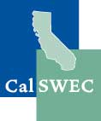 |  | Organizational Readiness  Self-Assessment Tool | 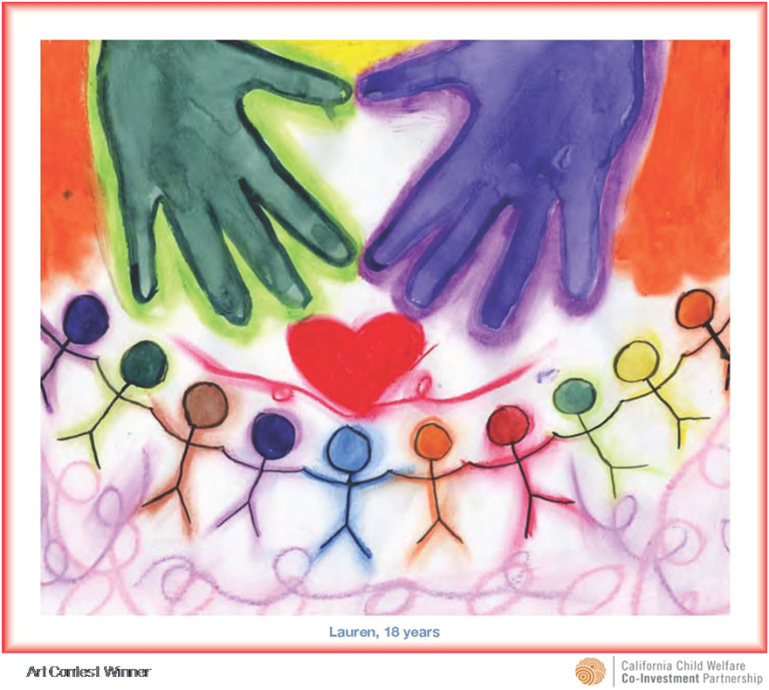

Introduction
This template is provided to support child welfare service agencies in the assessment of their organizational strengths and challenges related to the implementation of a specific program, intervention, or initiative. The results from the organizational self-assessment should be used by agencies to develop a comprehensive action plan that includes:
- An assessment of organizational readiness for implementation,
- An initial target population (if necessary),
- An implementation plan, and
- An evaluation plan.
Guidelines for Use
The information contained in this document is intended to be used as suggested guidelines. This template may be revised to meet organization needs. The categories of an organizational assessment may differ, but should always include:
- Information gathering,
- Data collection,
- Shared values and common language,
- Training, and
- Family and youth engagement.
Other categories may be added based on the needs of a particular program, intervention, or initiative. Development of a logic model will assist in determining which categories should be included in the organizational self-assessment.

A. Information Gathering
Information obtained for a self-assessment may be gathered from many sources. For example, it will be helpful to gather information from the following sources:
- Peer Quality Case Review (PQCR)
- County Self-assessment (CSA)
- System Improvement Plan (SIP)

Counties can determine if this program, intervention, or initiative was mentioned as an area identified as needing improvement. If it was included in any of the processes (PQCR, CSA, or SIP), use the Notes column to add relevant information. If it was not included, use the Notes column to explain reasons for its omission.

1. PQCR | Yes | No | Notes:
2. CSA | Yes | No | Notes:
3. SIP | Yes | No | Notes:
Use the following two spaces to record additional things the county might consider related to gathering information, and specific next steps for gathering information.
4. Things to consider:
5. Next steps:

B. Data Collection
The outcomes that were identified as part of the logic model should be clearly stated.

The child welfare services outcomes for each specific county and the state are available online from The Center for Social Services Research (CSSR) at UC Berkeley. Counties can track outcomes through the CSSR’s dynamic reporting system at http://cssr.berkeley.edu/ucb_childwelfare.
The template is useful in illustrating specific outcome information (Steps 6 through 11 can be duplicated for each outcome measure that is identified).
6. Outcome Measure:
7. This measure answers the following question or addresses the following concern:

8. County child welfare service’s current performance:
a. Most recent start date | b. Most recent end date | c. Most recent numerator | d. Most recent denominator | e. Most recent performance | f. Direction | g. Percent change

9. Is the current performance (check only one response):
a. Below the State standard?
b. Congruent with the State standard?
c. Above the State standard?
d. Below the Federal standard, if applicable?
e. Congruent with the Federal standard, if applicable?
f. Above the Federal standard, if applicable?

Use the following two spaces to record additional things the county might consider related to data collection and specific next steps for collecting data.
10. Things to consider:
11. Next steps:

C. Shared Values and Common Language
There may be different stakeholders at the table with different values and understandings of similar words. One might ask the following questions: Who are the stakeholders? Have the stakeholders been identified and engaged? Are their thoughts about how to effectively engage stakeholders? This part of the organizational assessment examines shared values and common language.
It may be necessary to conduct focus groups and administer surveys to obtain this information.
12. Have the stakeholders (broadly defined) identified shared values regarding this initiative?
Not yet | Starting to | Somewhat | Just about | Complete

13. Have the stakeholders (broadly defined) identified a common language regarding this initiative?
Not yet | Starting to | Somewhat | Just about | Complete

- Have all the stakeholder roles been clearly defined in the implementation of this initiative?
Not yet | Starting to | Somewhat | Just about | Complete
Use the following two spaces to record additional things the county might consider related to shared values and common language, and specific next steps for identifying shared values and common language.
15. Things to consider:
16. Next steps:

D. Staff Training and Engagement
A baseline assessment of training needs should be established and an analysis of gaps identified. For each stakeholder below, training may be necessary. For example, participants can be asked about their knowledge, skills, values, and attitudes regarding implementation of the initiative. Further, questions may be considered to solicit thoughts about additional items to make implementation more successful.
Assess the information below through a review of county policies, case reviews, focus groups, surveys, or training needs assessments to determine if the implementation participants need additional training.

17. Please provide a response to each of the boxes in the matrix below:
Stakeholder/ Group | Have Key Knowledge, Skills and Values been identified? | Has a written Curriculum been developed? | Have Coaching Tools been developed? | Have Transfer of Learning Tools been developed? | Does the training need to be standardized? | Does training need to be mandated?
Management | Not yet  Starting to  Somewhat  Just about  Complete | Not yet  Starting to  Somewhat  Just about  Complete | Not yet  Starting to  Somewhat  Just about  Complete | Not yet  Starting to  Somewhat  Just about  Complete | Yes  No | Yes  No
Supervisors | Not yet  Starting to  Somewhat  Just about  Complete | Not yet  Starting to  Somewhat  Just about  Complete | Not yet  Starting to  Somewhat  Just about  Complete | Not yet  Starting to  Somewhat  Just about  Complete | Yes  No | Yes  No
Staff | Not yet  Starting to  Somewhat  Just about  Complete | Not yet  Starting to  Somewhat  Just about  Complete | Not yet  Starting to  Somewhat  Just about  Complete | Not yet  Starting to  Somewhat  Just about  Complete | Yes  No | Yes  No
Other Agencies | Not yet  Starting to  Somewhat  Just about  Complete | Not yet  Starting to  Somewhat  Just about  Complete | Not yet  Starting to  Somewhat  Just about  Complete | Not yet  Starting to  Somewhat  Just about  Complete | Yes  No | Yes  No
Stakeholders | Not yet  Starting to  Somewhat  Just about  Complete | Not yet  Starting to  Somewhat  Just about  Complete | Not yet  Starting to  Somewhat  Just about  Complete | Not yet  Starting to  Somewhat  Just about  Complete | Yes  No | Yes  No
Other identified participants | Not yet  Starting to  Somewhat  Just about  Complete | Not yet  Starting to  Somewhat  Just about  Complete | Not yet  Starting to  Somewhat  Just about  Complete | Not yet  Starting to  Somewhat  Just about  Complete | Yes  No | Yes  No
Use the following two spaces to record additional things the county might consider related to staff training and engagement, and specific next steps for training and engaging staff about the program, intervention, or initiative.
18. Things to consider:
19. Next steps:

F. Family Engagement
Children, youth, parents, and relatives are integral partners in programs, interventions, and initiatives, and must be included in every aspect of child welfare agency planning and decision-making.

This information can be gathered through management information systems, review of county policies, case reviews, focus group’s or surveys to determine the level of family participation.

20. Has the child welfare agency engaged the following groups in planning for this initiative, program, or intervention?
- Children
Not yet | Starting to | Somewhat | Just about | Complete
- Youth
Not yet | Starting to | Somewhat | Just about | Complete
- Families
Not yet | Starting to | Somewhat | Just about | Complete

21. Has the child welfare agency engaged the following groups in decision making for this initiative, program, or intervention?
a. Children
Not yet | Starting to | Somewhat | Just about | Complete
b. Youth
Not yet | Starting to | Somewhat | Just about | Complete
c. Families
Not yet | Starting to | Somewhat | Just about | Complete

22. Have family members had an opportunity to provide feedback to the agency on their perception about how the initiative, program, or intervention is practiced in the county?
Not yet | Starting to | Somewhat | Just about | Complete
Use the following two spaces to record additional things the county might consider related to family engagement and specific next steps for engaging families.
23. Things to consider:
24. Next steps:

