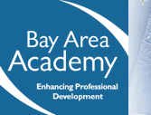
Meeting Agenda
http://bayareaacademy.org/
May 28, 2010

- Resources
  - Discuss the Boot camp for Dads – Merced County

- Organizational Assessment Tool
  - Discuss strategy for administration
  - Napa County’s implementation plan

- Training
  - San Francisco

- Focus Groups
  - (teen) Father vs. staff focus groups
  - Participants
  - Time
  - Location
  - Duration
  - Refreshments
  - Facilitator(s)
  - First session

- Project Timelines
  - Tasks
  - Roles
  - Time frames

- Next Steps
  - Administer the father friendly organizational self-assessment

