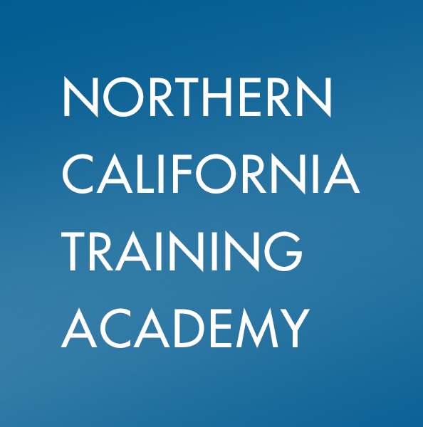

**Resource Family Approval 4-Day Academy**

The Resource Family Approval (RFA) Academy is a four-day training that has been developed for county staff who will be implementing or using the RFA process. The training provides an overview of RFA and Continuum of Care Reform (CCR). The training will also focus on providing a unified, family-friendly, child-centered Resource Family Approval process to replace the existing multiple processes for licensing foster family homes and approving relatives and non-relative extended family members as foster care providers, and approving families for legal guardianship or adoption. The following key content areas will be addressed:

• Overview of RFA and CCR

• Application Requirements

• Assessing the Resource Family

• Comprehensive Assessment Components

• Child Trauma

• Reasonable and Prudent Parent Standards

• Quality Parenting Initiative

• Pre-Approval Process / Emergency Placement

• The Written Assessment

• Approving the Resource Family

• Relative/NREFM Families Out of County/Jurisdiction

• Post Approval

• Post Approval Training

• Child’s Personal Rights

• Complaint Process

• Administrative Actions

• Statement of Facts

• Practicing Cultural Humility

• Teaming & Collaboration

iNSTRUCTORS

***Mary Tarro,*** LCSW, trains for the Northern California Training Academy, specializing in concurrent planning, adoption, Safety Organized Practice and coaching. She is an adjunct faculty member for California State University, Sacramento, School of Social Work, Title IV-E field practicum. She has worked in the field of child welfare since 1993, including 16 years with the Sacramento County Department of Health and Human Services, Child Protective Services, retiring as adoption manager in 2009. For three years, she worked with a community-based FFA/adoption agency, serving as adoption and kinship program director until 2012.

***Stephani Lynch*** MSW, is an Adoptions Program Manager for Sacramento County Child Protective Services and a Field Advisor for Boston University's online MSW program. She has more than four decades of experience in human services, including more than ten years as Adoptions Program Manager. In 2010, Lynch received the "Social Worker of the Year" award from the California State Foster Parent Association.

dateS And timeS

Part 1: September 20 – 21, 2017

Part 2: September 27 – 28, 2017

Daily 9:00 a.m. – 4:00 p.m.

location

Sacramento

Sutter Square Galleria

2901 K Street

Instructors

Mary Tarro, LCSW

Stephani Lynch, LCSW

SECTION NUMBER

Part 1: 171SSA110

Part 2: 171SSA111

subject area

CCR/RFA and Adoptions

professional credit

2.4 CEUs, 24 BRN, 24 BBS

*Course meets the qualifications for 24 credit hours for California Board of Registered Nursing, Provider Number 00046 and also meets qualifications for 24 hours of continuing education credit for LMFTs, LCSWs, LPCCs, and/or LEPs as required by the California Board of Behavioral Sciences. California Association of Marriage and Family Therapists.* *Provider number 050148*

Need help enrolling or have questions about this course? Contact us at (530) 757-8725 or academy@ucdavis.edu

To Enroll:

Please visit this website [humanservices.ucdavis.edu/academycourses](https://humanservices.ucdavis.edu/academycourses). You will need to use the search feature to find this specific course (you can search using the section number on the right side of this flier). Click on the “Enroll Now” button and follow the prompts.